COMPREHENSIVE DEPOSIT POLICY

15/12/2023

Strategy & Partnerships Division
Corporate. Headquarters, M.A.Road Srinagar
0194-202649
sp.chq@jkbmail.com

Deposit Liability Management
Corporate. Headquarters, M.A. Road Srinagar

dlm@jkbmail.com

\

Strategy & Partnerships Division
Corporate. Headquarters, M.A.Road Srinagar
0194-202649
sp.chq@jkbmail.com
Strategy & Partnerships Division
Corporate. Headquarters, M.A.Road Srinagar
0194-202649
sp.chq@jkbmail.com
Strategy & Partnerships Division
Corporate. Headquarters, M.A.Road Srinagar
0194-202649
sp.chq@jkbmail.com
Strategy & Partnerships Division
Corporate. Headquarters, M.A.Road Srinagar
0194-202649
sp.chq@jkbmail.com
Strategy & Partnerships Division
Corporate. Headquarters, M.A.Road Srinagar
0194-202649
sp.chq@jkbmail.com
Strategy & Partnerships Division
Corporate. Headquarters, M.A.Road Srinagar
0194-202649
sp.chq@jkbmail.com
Strategy & Partnerships Division
Corporate. Headquarters, M.A.Road Srinagar
0194-202649
sp.chq@jkbmail.com
Strategy & Partnerships Division
Corporate. Headquarters, M.A.Road Srinagar
0194-202649
sp.chq@jkbmail.com

Document Control

Title | Comprehensive Deposit Policy | Version | 3.0
Created By | Deposit& Liability Management | Date of Origin | 2018
Date of Last Review | 10-06-2022 | Due Date of Renewal
Reviewed By | Deposit& Liability Management | Date of Review | 05-09-2023
Approved By | Board of Directors | Date of Approval | 15-12-2023
Date of Next Review |  |  | 15-12-2024
Frequency of Review |  |  | Annual

Table of Contents

S.No | Chapter No. | Content | Page No
 | Chapter-I | Types of Deposit Accounts | 9-15
 | Chapter-II | General Guidelines (Interest Rates on Deposits ) | 16-19
 | Chapter-III | Basic Saving Bank Deposit Account | 20-22
 | Chapter-IV | Term Deposit Accounts | 23-31
 | Chapter-V | Rupee Deposits of Non-Residents | 32-41
 | Chapter-VI | Foreign Currency Deposits | 42-58
 | Chapter-VII | Other Guidelines | 59-60
 | Chapter-VIII | Prohibitions and Exemptions | 61-62
 | Disclosure of the policy / Ownership & Review of the Policy / References |  | 63

S.No | List of Annexure | . | Para No. of Policy Document | Page No.
 | Form –I (auto renewal term deposits) | Annexure- 1 | 4.8 | 64
 | Auto Renewal Plans. | Annexure -2 | 4.11 | 65
 | Account Opening Forms | Annexure -3 | 1.3 | 66-90
 | Brief Features of Deposit Products | Annexure -4 | --- | 91-96
 | Form 15G | Annexure -5 | 2.6 | 97-98
 | Form 15H | Annexure -6 | 2.6 | 99-100
 | Schedule –I  (Entities permitted to open SB Account) | Annexure -7 | 8-J | 101
 | Nomination Forms | Annexure-8 | ----- | 102-108
 | Nomination | Annexure-9 | ----- | 109-115
 | Case studies | Annexure-10 | ----- | 116-121

GLOSSARY

Abbreviation/ Jargon/ Acronym | Explanation
AD | Authorized Dealer
ADR | American Depository Receipt
ALM | Asset Liability Management
AOF | Account Opening Form
ALCO | Asset Liability Management Committee
AUD | Australian Dollar
BSBDA | Basic saving bank deposit account
CAD | Canadian Dollar
CBS | Core Banking System /Solution
CDM | Cash Deposit Machine
CD | Certificate of Deposit
CHF | Swiss Franc
DD | Demand Draft
DEAF | Depositor Education & Awareness Fund
DICGC | Deposit Insurance & Credit Guarantee Corporation of India
DLM | Deposit Liability Management
EEFC | Exchange Earners Foreign Currency
EUR | Euro
FCNR (B) | Foreign Currency Non-resident (Banks)
FD | Fixed Deposit
FEMA | Foreign Exchange Management Act
GBP | Great Britain Pound
GDR | Global Depository Receipt
HUF | Hindu undivided Family
IBA | Indian Banks Association
IRDAI | Insurance Regulatory & Development Authority of India
JPY | Japanese Yuan
LIBOR | London Interbank Offered Rate
LR | Liquidity Report
NEFT | National Electronic Fund Transfer
NRE | Non-resident External
NRI | Non-resident Indian
NRO | Non-resident Ordinary
PIO | Person of Indian Origin
PMLA | Prevention of Money laundering Act
PO | Payment Order
POS | Point of Sale
RBI | Reserve Bank of India
RFC | Resident Foreign Currency
RTGS | Real Time Gross Settlement
SOLVAL | Service Outlet Validation
TDS | Tax Deduction at source
USD | United States Dollar

Definitions

The terms used in the policy document shall bear the meaning as under;
“Bulk Deposit” means Single Rupee term deposits of Rupees Two Crores and above.
“Current Account” means a form of non-interest bearing demand deposit wherefrom withdrawals are allowed any number of times depending upon the balance in the account or up to a particular agreed amount and shall also be deemed to include other deposit accounts which are neither Savings Deposit nor Term Deposit;
“Daily product” means the interest applied on the end of day balance
“Demand deposit” means a deposit received by the bank which is withdrawable on demand;
“Domestic Rupee Deposits” mean rupee deposits maintained in India in the form of current account, saving deposit or term deposit;
“Family” includes members as mentioned in the bank’s Service Manual;
“FCNR(B) account” means a Foreign Currency Non-Resident (Bank) account referred to in Foreign Exchange Management (Deposit) Regulation, 2000, as amended from time to time;
“Individual” means a natural person;
“Member of the bank’s staff” means a person employed on a regular basis, whether full-time or part-time, and includes a person recruited on probation or employed on a contract of a specified duration or on deputation and an employee taken over in pursuance of any scheme of amalgamation, but does not include a person employed on casual basis;
“Notice deposit” means term deposit for specific period but withdrawable on giving at least one complete banking days’ notice;
“NRE account” means a Non-resident External deposit account referred to in Foreign Exchange Management (Deposit) Regulations, 2000, as amended from time to time;

“NRO account” means a Non-resident ordinary deposit account referred to in Foreign Exchange Management (Deposit) Regulations, 2000, as amended from time to time;
“Reinvestment Deposit” means a deposit invested in a particular scheme is further carried over in the same scheme or any other scheme yielding the desired income.
“Retired member of the bank’s staff” means an employee retiring whether on superannuation or otherwise as provided in the bank’s Service/Staff Regulations;
“RFC account” means a Resident Foreign Currency account referred to in Foreign Exchange Management (Foreign currency accounts by a person resident in India) Regulations, 2000, as amended from time to time;
“Savings deposit” means a form of interest bearing demand deposit which is a deposit account whether designated as “Savings Account”, “Savings Bank Account”, “Savings Deposit Account”, “Basic Savings Bank Deposit Account (BSBDA)” or other account by whatever name called which is subject to the restrictions as to the number of withdrawals as also the amounts of withdrawals permitted by the bank during any specified period;
“Scheduled commercial Bank” means banks other than co-operatives banks included in second schedule of Reserve Bank of India Act, 1934;
“Small Saving Accounts” means saving bank accounts opened with relaxed KYC norms and are valid initially upto a period of 12 months which can be extended up to 24 months. The account is subjected to certain restrictions on deposits as well as withdrawals.
“Term deposit” means interest bearing deposit received by the bank for a fixed period and shall also include deposits such as Recurring /Flexi Recurring Deposit / non-cumulative term deposits (FDR), cumulative term deposits (CCR) /Childcare Deposit /Mehandi deposit, Tax Saver Term Deposit, Monthly Yield Deposit etc. Brief features of various types of term deposits are as per Annexure-4 of this policy document.
All other expressions unless defined herein shall have the same meaning as have been assigned to them under the Banking Regulation Act or the Reserve Bank of India Act, or any statutory modification or re-enactment thereto or as used in commercial parlance, as the case may be.

Introduction

One of the important functions of the Bank is to accept deposits from the public for the purpose of lending. In fact, depositors are the major stakeholders of the Banking System. The depositors and their interest form the key area of the regulatory framework for Banking in India and this has been enshrined in the Banking Regulation Act, 1949. The Reserve Bank of India is empowered to issue directives / advices on interest rates on deposits and other aspects regarding conduct of deposit accounts from time to time. Post liberalization in the financial system and deregulation of interest rates, banks are now free to formulate deposit products within the broad guidelines issued by RBI.RBI directives mandate the banks to have a Board-approved policy on deposits and payment of interest thereon, and accordingly this policy has been formulated, reflecting exhaustively the regulatory prescriptions relating the deposit products offered by the bank to its various categories of customers.
Objective

This policy document on deposits outlines guiding principles behind formulation of various deposit products offered by the bank and terms and conditions governing the conduct of the deposit Accounts.
Scope

The document recognizes the rights of the depositors and aims at dissemination of information for the benefit of customers with regard to various aspects of acceptance of deposits from the members of the public, conduct and operations of various deposit accounts, payment of interest on various deposit accounts, closure of deposit accounts, method of disposal of deposits of deceased depositors etc. It is expected that this document will guide the customers properly as regards selection of the product and create awareness among them about their rights. The ultimate objective is that the customer will get services they are rightfully entitled to receive without demand.
While adopting this policy, the bank reiterates its commitments to individual customers outlined in the Fair Practice Code of Bank’s Commitment to Customers adopted by the bank lastly updated in June 2020 available on Bank’s official website. This document is a broad framework under which the rights of common depositors are recognized. Detailed operational instructions on various deposit schemes and related services are being issued from time to time.

CHAPTER-I
TYPES OF DEPOSIT ACCOUNTS

- Account Opening and Operation of Deposit Accounts

The bank before opening any deposit account will carry out due diligence as required under “Know Your Customer” (KYC)/ e-KYC guidelines issued by RBI and PMLA and or such other norms or procedures adopted by the bank. If the decision to open an account of a prospective depositor requires clearance at a higher level, reasons for any delay in opening the account will be informed to the customer and the final decision of the bank will also be conveyed at the earliest.
1.1 The due diligence process, while opening a deposit account will involve satisfying about the identity of the person, verification of address, satisfying about his occupation and source of income. Obtaining introduction(if required) of the prospective depositor from a person acceptable to the bank and obtaining recent photograph of the person/s opening/operating the account are part of due diligence process.
  - In addition to the due diligence requirements, under KYC norms the Bank will obtain Permanent Account Number (PAN) or alternatively declaration in Form No. 60 or 61 as specified under the Income Tax Act / Rules.
  - The account opening forms are as perAnnexure-3 and other material would be provided to the prospective depositor by the Bank that will contain detailed information to be furnished and documents to be produced for verification and / or for record. It is expected of the bank official opening the account to explain the procedural formalities and provide necessary clarification sought by the prospective depositor when s/he approaches for opening a deposit account.

1.4 The regulatory guidelines require banks to categorize customers based on risk perception and prepare profiles of customers for the purpose of transaction monitoring.

1.5. Inability or unwillingness of a prospective customer to provide necessary information/details could result in the bank not opening an account.

1.6 Inability of an existing customer to furnish details required by the bank to fulfil statutory obligations could also result in closure of the account after due notice(s) is/are issued to the customer.
1.7. For deposit products like Savings Bank Account and Current Deposit Account, the bank will normally stipulate certain minimum balances to be maintained as part of terms and conditions governing operation of such accounts. Failure to maintain minimum balance in the account will attract levy of charges as specified in service charges schedule issued by the bank from time to time. For Saving Bank Account, the Bank may also place restrictions on the number of transactions, cash withdrawals etc. during given period. Similarly, the bank also specifies charges for issuance of cheque books, ATM & Debit Cards, additional statement of accounts, duplicate passbook, account maintenance charges etc. All such details regarding terms and conditions for operation of the account and schedule of charges for various services provided will be provided to the prospective depositor while opening the account.

1.8 Savings Bank Accounts can be opened for eligible person/s and certain organizations / agencies (as approved by Reserve Bank of India from time to time).

1.9 Current Accounts can be opened by individuals / Proprietorship concerns/ Partnership firms / Private and Public Limited Companies / HUFs / Specified Associates / Societies / Trusts/Government Departments / Authority/ies created by Government (Central or State), Limited Liability Partnership etc.

1.10 Term Deposits Accounts can be opened by individuals / Proprietorship concerns/ partnership firms / Private and Public Limited Companies / HUFs/ Specified Associates / Societies / Trusts/ Government Departments / Authority/ies created by Government (Central or State), Limited Liability Partnership etc.

1.11 Deposit accounts can be opened by an individual in his own name (known as account in single name) or by more than one individual in their own names (known as Joint Account).

1.12 Saving bank account can also be opened by a minor jointly with natural guardian /legal guardian (known as minor’s account). Minors above the age of 10 years will also be allowed to open and operate a saving bank account independently, if he/she can sign uniformly.

1.13 A statement of account will be provided by the bank to Savings Bank as well as Current Deposit Account holders periodically as per terms and conditions of opening of the account. Alternatively, the bank may issue a Pass Book to Savings Bank account holders.

1.14 The deposit accounts may be transferred to any other Branch of the Bank at the request of the depositor. However, under Account portability facility, the customer is allowed to transfer his/her current / saving account from one Branch to another Branch. Branches will not insist to obtain fresh documents of the customer when the customer approaches it for transferring his/her account from one Branch to another Branch. Branches will ensure that KYC verification once done by the transferor Branch will be valid for the transferee Branch if full KYC verification has been done for the concerned account and its not due for periodic updation.

1.15 If an existing KYC compliant customer desires to open another account in the bank, there is no need for submission of fresh proof of identity and/or address.

1.16 Opening of new Bank Accounts of customers with previously blocked or terminated relationships.
- Accounts that are not closed: In case of blocked accounts, i.e accounts which are subject to debit/ total freeze in view of any regulatory direction, garnishee order etc. and are not closed, the account is restored as and when revocation order is received in line with extant guidelines.
- Accounts that are closed :In case of accounts that have been closed or the relationship has been terminated upon the directions from Ministry of Home Affairs, enforcement agencies, Central / State Government, the Bank may re-enter into relationship with such customers as per the following procedure:
- Wherein the bank had previously failed to establish CDD process, new account shall be opened by the branches only after the customer provides valid OVD documents as per KYC/AML policy of the Bank.
- In the event wherein the MHA, Central/State government revokes the order against individual whose account had been previously closed/terminated by that order, new account of the customer shall be opened at his/her request.
While closing the accounts for reasons stated above, branches shall capture the relevant remarks in the closure field.

1.17 Operation of Joint Account –

The joint account holders can give any of the following mandates for the disposal of balance in the above accounts:

- Joint mode of operation: The Joint Account opened by more than one individual can be operated by more than one individual jointly. The mandate for operating the account can be modified with the consent of all account holders.

- Either or Survivor: if the account is in the name of two individuals say, A & B, the final balance along with interest, if applicable, will be paid to either of account holders i.e. A or B, on date of maturity or to the survivor on death of any one of the account holders.

- Anyone or Survivor: If the account is in the name of two or more individuals say, A, B & C, the final balance along with interest if applicable, will be paid to any of accountholders i.e. A or B or C, on the date of maturity. On the death of any one of account holder say A, the final balance along with interest if applicable, will be paid to the surviving account holder/s i.e. B or C. On the death of any two of account holder say A and B, the final balance along with interest if applicable, will be paid to surviving accountholder i.e. C.

- Former or Survivor: If the account is in the name of two individuals say, A & B, the final balance along with interest, if applicable, will be paid to the former i.e. A on date of maturity and to the survivor on death of anyone of the account holders.

- Later or Survivor: If the account is in the name of two individuals say, A & B, the final balance along with interest, if applicable, will be paid to the latter i.e. B on date of maturity and to the survivor on death of anyone of the account holders.

- The above mandates will be applicable to or become operational only on or after the date of maturity of term deposits or upon death of any joint account holder. These mandates can be modified by the consent of all the account holders.

- If the joint depositors prefer premature withdrawal of deposits in accordance with the mandate of ‘Either or Survivor’, ‘Anyone or Survivor’ or ‘Former or Survivor’, bank may allow premature withdrawal of term deposits to the surviving depositor/s in the event of death of either of the depositor as the case may be on submission of the death certificate of the deceased depositor/s along with application without seeking concurrence of legal heirs of the deceased deposit holder, provided all the depositors have given a specific joint mandate for the said purpose at the time of opening the account or any time subsequently during the tenure of the deposit.

- At the request of the depositor, the bank will register mandate/power of attorney given by him authorizing another person to operate the account on his behalf.

- The term deposit account holders at the time of placing their deposits can give instructions with regard to closure of deposit account or renewal of deposit for further period on the date of maturity.

1.18 Nomination

Nomination facility is available on all deposit accounts opened by individuals as also to an account opened as sole proprietary concern. Nomination can be made in favour of one individual only, who can be a minor as well but in such cases the depositor has to give name of a major person (called appointee) who will receive the amount of deposit on behalf of the nominee in the event of death of the account holder during the minority of the nominee. The nomination can be cancelled or changed by the account holder/s any time. While making nomination, cancellation or change thereof in the account of an illiterate person, it is required to be witnessed by a third party.

While opening a deposit account, the depositor must be informed of the advantages of the nomination facility. In the event of death of the depositor/s, the nominee would as a trustee of the legal heirs receive the amount lying in the account.

A detailed information with case studies on Nomination is given in the annexures-9 & 10 of the policy.

1.19 Minor’s Account

    - The minor can open Savings Bank Account to be operated by his/her natural guardian/legal guardian or by minor himself / herself, if he/she is above the age of 10 years. The account can also be opened jointly with natural guardian or legally appointed guardian. No overdrafts be allowed in minor accounts.

    - On attaining majority, the minor should confirm the balance in his/her account and in case the account was till then operated by the natural guardian / legal guardian, specimen signature of the account holder duly verified by the natural guardian/legal guardian be obtained and kept on record for all operations.

1.20 Account of Illiterate Persons

The bank may at its discretion open deposit accounts other than Current Account of an illiterate person. The account of such person may be opened provided he/she calls on the Bank personally along with a witness who is known to both the depositor and the Bank. The Bank will explain the need for proper care and safe keeping of the passbook etc. given to the account holder. The bank official shall explain the terms and conditions governing the account to the illiterate person.

Normally, no cheque book facility is provided for such Savings Bank Account. At the time of withdrawal/repayment of deposit amount and/or interest, the account holder should affix his / her thumb impression or mark in presence of the authorized officer who should verify the identity of the person.

1.21 Account of Visually Challenged Persons

Bank will facilitate opening of Saving Bank accounts as well as Term Deposit accounts of persons with visual impairment. The Bank official shall explain the terms and conditions governing the account.

Such accounts will be operated by the account holder personally and the account holders shall have to be present before the branch official to affix thumb impression. They will be identified through their photograph to facilitate withdrawal of the amount from the account. Bank is also committed to customize technology basedbanking facilities progressively via ATM & Internet banking for visually challenged persons to enable them to operate their own accounts with least difficulty.

1.22 Account of persons with autism, cerebral palsy, mental retardation &multiple disabilities

Savings bank and term deposits in the name of persons with autism, cerebral palsy, mental retardation and multiple disabilities can also be opened by the legal guardian appointed by the District Court under Mental Health Act, 1987 or by the Local Level Committees set up under the National Trust for welfare of persons with such disabilities under Disabilities Act, 1999. Legal guardian, so appointed, will furnish the bank an indemnity-cum-undertaking bond duly stamped as per the local laws in force along with Guardianship Certificate at the time of opening of account.

1.23 Addition or Deletion of the Name/s of Joint Account Holders

The bank may at the request of all the joint account holders allow addition or deletion of name/s of joint account holder/s or allow an individual depositor to add the name of another person as a joint account holder, if the circumstances so warrant. However, the first holder cannot be deleted from any account at all.

1.24 Accounts of Third Gender

In case a person claiming to be transgender (Third gender) wants to open account or to do any banking transaction, the person will be recognized as “Third Gender” and the details shall be accepted in the Account Opening Form (AOF) or other applicable forms as such. The salutation of such persons shall be “Mx”. All transgender customers shall be treated without any discrimination equally like customers of any other gender.

1.25 Customer Information

The bank, its subsidiaries, affiliates and other third-party product providers shall not use customer information collected from the customers for cross selling of products or services without their consent.

1.26 Secrecy of Customer’s Accounts

The bank shall not disclose details/particulars of the customer’s account to a third person or party without the expressed or implied consent from the customer, exceptas required under law, and where interest of the bank requires disclosure..

1.27 Accidental Insurance Cover on Deposit Schemes

The bank offers free Personal Accidental Insurance cover on certain deposit schemes such as Mehandi Deposit Scheme, Childcare Deposit Scheme, Pink Saving Scheme, Premium Saving Bank Deposit Scheme and Special Bach at Deposit Scheme. The bank reserves the right to offer free accidental insurance facility on any other deposit scheme or withdraw at any time such facility on any deposit scheme.

1.28 Extension of Alternate Delivery Channels to Savings Bank & Current Deposit account holders:

The Bank offers choice of electronic channels to customers for conducting their banking transactions. The electronic channels include, Internet banking (e-banking) and mobile banking (JKB m-Pay). Wherever such electronic facilities are offered as a part of the basic account/product, bank will obtain specific consent of the customers for availing the facility.

1.29 ATM Card / Debit Card Hot Listing

The bank will accept ATM card / Debit card hot listing instructions from customers through Phone banking channel - 24 hours a day and from branch channel during working hours. Phone-banking numbers are made available to customers whenever a Card is issued.

Hyperlink:

Master Directions on Interest Rate on Deposits:-

Master Direction DCBR.Dir.No.1/13.01.000/2015-16 (Updated as on October 26, 2023)
(Updated as on September 16, 2022)

Chapter –II

General Guidelines

- Interest Rate Framework on Deposits

Bank shall pay interest on deposits of money (other than current account deposits) accepted by them or renewed by them in their Domestic, Ordinary Non-Resident (NRO), Non-Resident (External) Accounts (NRE) and Foreign Currency (Non-resident) Accounts (Banks) Scheme {FCNR(B)} deposit account on the terms and conditions specified in the policy as under;

- The rates shall be uniform across all branches and for all customers and there shall be no discrimination in the matter of interest paid on the deposits, between one deposit and another of similar amount, under a particular product accepted on the same date, for same tenor at any of its offices.
- Interest rates payable on deposits shall be strictly as per the schedule of interest rates prevailing then. The bank is always maintaining the bulk deposit interest card rate in Core Banking System (CBS) to facilitate supervisory review.
- The rates shall not be subject to negotiation between the depositors and the bank.
- All transactions, involving payment of interest on deposits shall be rounded off to the nearest rupee for rupee deposits.

2.1 Payment of Additional Interest on domestic deposits

Bank shall allow additional interest of 1% per annum, over and above the rate of interest mentioned in the schedule of interest rates, to savings or term deposits of its staff and their exclusive associations as well as on deposits of Chairman, Managing Director & CEO, Executive Director or such other Executives appointed for a fixed tenure, subject to the following conditions:
- The additional interest is payable to the employee till he is eligible for the same and in case of his ceasing to be so eligible, till the maturity of a term deposit account.
- In case of employees taken over pursuant to the scheme of amalgamation, the additional interest is allowed only if the interest at the contractual rate together with the additional interest does not exceed the rate, which could have been allowed if such employees were originally employed by the bank.
- In case of employees taken on deputation from another bank, may allow additional interest in respect of the savings or term deposit account opened with it during the period of deputation.
I
- n case of persons taken on deputation for a fixed tenure or on a contract of a fixed tenure, the benefit will cease to accrue on the expiry of the term of deputation or contract, as the case maybe.

- The additional interest shall be paid on the following deposits after obtaining a declaration from the depositor concerned, that the monies deposited or which may be deposited from time to time into such account belong to the depositor:
- member or a retired staff, either singly or jointly with any member or members of his/her family; or
- the spouse of a deceased member or a deceased retired member of the bank’s staff; and
- Association or a fund, which has Bank staff as its members;

  - Senior Citizens shall be provided additional interest as per an existing guideline which is at present 0.50% per annum, over and above the rate of interest mentioned in schedule of interest rates on term deposits only.

Provided that this facility is not offered on the term deposits standing in the name of an HUF or the Karta of the Hindu Undivided Family (HUF), even if the Karta is a resident Indian senior citizen.
2.3 Resident Indian retired Bank Staff who are Senior Citizens shall be provided additional interest as per existing guidelines at 1% p.a. in respect of Saving Bank Deposits and 1.50% per annum in term deposits over & above rate of interest mentioned in the schedule of interest rates.
2.4 Deposits maturing on non-business working day:

- If a term deposit is maturing for payment on a holiday/ non-business working day, the Bank shall pay interest at the originally contracted rate on the original principal deposit amount for the non-business working day, intervening between the date of the maturity of the specified term of the deposit and the date of payment of the proceeds of the deposit on the succeeding working day.
- In case of reinvestment deposits and recurring deposits, Bank shall pay interest for the intervening holiday/non-business working day on the maturity value.

2.5 Consequence of transfer of Deposit from one bank to another Bank
Transfer of Deposits accounts from other bank to our bank on account of takeover of that bank or its branches , shall be subject to the condition that the terms of contract as regards interest and maturity period agreed to between the customer and the bank / branch that is being taken over, shall be adhered to by our bank;

2.6 Interest Payments on Domestic Rupee Deposits

- No interest shall be paid on current accounts or its variants. Provided that balances lying in current account standing in the name of a deceased individual depositor or sole proprietorship concern shall be paid interest from the date of death of the depositor/account holder till the date of payment to theclaimant/s at the rate of interest applicable to savings deposit as on the date of payment.
- Uniform Interest shall be paid on savings bank accounts at the rate specified by ALCO from time to time. The interest on domestic rupee savings deposit accounts are calculated on the daily product basis and paid as per the periodicity decided by the bank.
However, ALCO may decide differential rate of interest on Saving Bank Deposits for balances exceeding Rs.1.00 lac as per business requirement at any point of time during currency of the policy.
- Interest rates shall be calculated at quarterly intervals on term deposits decided by ALCO within the general guidelines issued by the Reserve Bank of India from time to time.
- The interest is calculated at quarterly intervals on term deposits and paid at the rate decided by the bank depending upon the period of deposits. In case of monthly yield deposit scheme, the interest shall be calculated for the quarter and paid monthly at discounted value.
- Interest rates on deposits will be prominently displayed in the branch premises. Changes, if any, with regard to deposit schemes and other related services shall also be communicated upfront and displayed on bank’s website.
- Interest rates for Term Deposits of less than Rs.5.00 Crores are decided by Asset Liability Management Committee (ALCO) and for deposits of Rs. 5.00 Crores and above are decided by Treasury Operations. Bank does not discriminate in the matters of payment of interest on deposits, between one depositor and another, accepted on the same date and for the same maturity, whether such deposits are accepted at the same office or at different offices of the bank.

- Bank has statutory obligation to deduct tax at source if total interest paid/ payable on all term deposits held by a person exceed the amount specified for exemption of tax under the Income Tax Act. The bank will issue a tax deduction certificate (TDS Certificate) for the amount of tax deducted. The depositor, if entitled to exemption from TDS, can submit declaration (15G/15H) in the prescribed format at the beginning of every financial year. The formats for these declarations are annexed as Annexure-5 & Annexure-6 respectively.

  - Review of Interest Rates

Based on the requirement of funds and changing interest rate scenario, rates of interest on deposits is reviewed from time to time. In order to determine the interest rates on term deposits of different maturities, the following factors are taken into consideration by Asset Liability Committee (ALCO):
    - Mismatches in Liquidity Report (LR)
    - Target set for financial year
    - Cost of deposits
    - Contractual/Residual maturity of Term Deposits portfolio
    - Interest rates offered by competitors
    - Guidelines, if any, issued by the regulator.

2.8 Interest Payments – Mode of Calculation:

    - Savings Bank Accounts:
Interest is paid on Savings Bank Account at the rate decided by ALCO. It is calculated on daily product basis but credited in the SB A/C at quarterly intervals, or at the time of closing of the Saving Bank A/C. Any change/ revision in interest rate on Savings Bank Deposits is notified to functionaries through intranet and to the customers through Bank’s website i.e. https://www.jkbank.com/ as also prominently displayed in the branches
  - Term Deposit Accounts:
Interest on Term Deposits is paid at rates applicable on the date of issue/renewal of the Term Deposit. Interest would be calculated at Quarterly intervals. The Bank computes interest based on the actual number of days in a year. In case, the deposit is spread over a leap and a non-leap year, the interest is calculated based on the number of days i.e., 366 days in a leap year & 365 days in a non-leap year respectively.

Chapter – III
Basic Saving Bank Deposit Account (BSBDA)

3 The bank is committed to provide basic banking services to economically disadvantaged sections of the society. Banking services is being offered to them through Basic Savings Bank Deposit Accounts (BSBDA) and Small Saving Accounts which are opened with relaxed customer acceptance norms (KYC) as per regulatory guidelines. Basic Saving Bank Deposit Accounts are KYC Compliant accounts. The holders of BSBD Account will not be eligible for opening any other savings bank deposit account in the Bank. If a customer has any other existing savings bank deposit account in the bank, he/she will be required to close it within 30 days from the date of opening a BSBD Account. Further, before opening a BSBD account, bank shall take a declaration from the customer that he/she is not having a BSBD account in any other bank. The following basic minimum facilities in the BSBD Account are provided free of charge, without any requirement of minimum balance:

- The deposit of cash at bank branch as well as CDMs.

- Receipt/ credit of money through any electronic channel or by means of deposit /collection of cheques drawn by Central/State Government agencies and departments.

- No limit on number and value of deposits that can be made in a month

- Four withdrawals in a month, including ATM withdrawals

- ATM Card or ATM-cum-Debit Card.

- Bank shall provide additional value-added services, including issue of cheque book, beyond the above minimum facilities, which may / may not be priced, in non-discriminatory manner, subject to disclosure. The availment of such additional services shall be at the option of the customers. However, while offering such additional services, bank shall not require the customer to maintain a minimum balance. Offerings such additional services will not make it a non BSBD account, so long as the prescribed minimum services are provided free of charge. The minimum free withdrawals available to the BSBD Account can be made at all ATMs (own-bank / other bank ATMS).

Salient features of BSBDA Scheme

Eligibility | Any Individuals (Sole or Joint) or HUF provided HUF is not engaged in any business activity
Rate of Interest | As applicable to Savings Bank Accounts
Operation in the account | Using withdrawal forms at Branches or through ATMs.  ATM-cum-debit card  Issuance of Cheque Book as per request of the customer as an additional service (charges as per Banks service charges for that particular service)
Initial deposit | There is no requirement of any initial deposit at the time of opening of account
Limits on Deposit | Minimum balance / amount : Nil  Maximum Balance / amount: No upper limit
Minimum balance Charges | The operations in the accounts shall be permitted without the requirement of maintaining minimum balance. No penalty shall be levied even in accounts with ZERO balance.
Debit Card/ATM Card | ATM-cum-Debit Card to be provided free of issuance charges  No Annual / Renewal Fee to be levied.
Cheque Book facility | Cheque Book allowed (On the request of the customer as per bank’s service charges).
SMS Alert Facility | Free 5 Alerts per month  Following transactions will not be charged for SMS Alerts:  1. Debit / ATM Card at ATM/ POS.  2. Internet Banking / Mobile Banking / e-Commerce.  3. NEFT transactions once funds are credited to beneficiary account.
Transaction limits | For Deposits: No limit on number of deposits  For Withdrawals: Four withdrawals free in a month including ATM withdrawals.
Nomination Facility | The Account holder shall be encouraged to provide nomination details  in the prescribed account opening form.
Free Services (mandatory) | The deposit of cash at bank branch as well as CDMs.  Receipt/ credit of money through any electronic channel or by means of deposit /collection of cheques drawn by Central/State Government agencies and departments.  No limit on number and value of deposits that can be made in a month.  Four withdrawals in a month, including ATM withdrawals.  ATM Card or ATM-cum-Debit Card.
Free Services offered by the Bank | No charge on activation of inoperative accounts  No account closure charges.  Passbook facility free of charge  Monthly Account statement
Chargeable (as per extant Service Charges Schedule). | The following services may be offered to a customer (optional):-  Withdrawals beyond the free stipulated 4 debit transactions including ATM withdrawals  Cheque Book Facility  E-banking/m-banking  SMS alert facility (over & above the free SMS’s)  Duplicate account statement  Duplicate Passbook

Small Accounts:
A Small Account means a saving bank account where simplified measures are applied for verifying the identity of the customer who do not possess an ‘Officially Valid Document’ viz. passport, driving licence, proof of possession of Aadhaar number, Voter's Identity Card, job card issued by NREGA and letter issued by the National Population Register containing details of name and address. Further these accounts are subject to the following restrictions:-
- the aggregate of all credits in a financial year does not exceed rupees one lakh;
- the aggregate of all withdrawals and transfers in a month does not exceed rupees ten thousand and;
- the balance at any point of time does not exceed rupees fifty thousand.

Hyperlink:
Financial Inclusion-Access to Banking Services-BSBDA
bsbda DBR.LEG.BC.No.47.09.07.005 2018-19 dated June 10, 2019

Chapter-IV
Term Deposit Accounts

4. Owing to the revision in interest rate structure and further bifurcation of term deposits into Withdrawable And Non-Withdrawable Segments, the guidelines issued by Risk Management Department shall be applicable to Term Deposits contracted under Withdrawable & Non-Withdrawable Segments as under:-

4.1 Withdrawable Term Deposits (with premature payment option)

- Less than Rs 2 Crores
- Rs.2 Crores to less than Rs.5 Crores
- Rs 5 Crores & above

On the request of the account holder, the bank shall allow withdrawal of rupee term deposits, before completion of the period of the deposit agreed upon at the time of making the deposit. The interest rate payable on such prematurely withdrawn deposit shall be 0.50% below the rate applicable for the period the deposit remains with the bank, provided the deposit has remained with the bank for at least 7 days. In case of reinvestment deposits, such Interest may be compounded on a quarterly basis. No interest shall be payable if the deposit is withdrawn before completion of 7 days from the date of opening and 15 days for Interbank Deposits.
No additional interest over and above the published interest rates shall be paid to any depositor.

4.2 Non-Withdrawable Term Deposits (Without Premature Payment Option)
a) Rs 2 crore to less than Rs 5 crores
b) Rs 5 Crores & above.

- As the name implies such deposits have to invariably complete the tenor decided` at the time of acceptance of such term deposit account and cannot be withdrawn prematurely. It is opened for bulk deposits only.
- Bank shall contract Non-Withdrawable deposits in the maturity segment of 91 days to 3 years only, as per requirement in order to increase stability quotient.
- Any change / review of interest rates prescribed under Withdrawable / Non-Withdrawable segment shall be decided by ALCO or any other Executive/Committee to which powers are delegated by ALCO.

- In no case, Non-Withdrawable Deposit facility shall be offered to those depositors who are already enjoying the benefits of additional interest such as Staff/Senior Citizen/Employees Provident Fund Trust/Employees Gratuity Fund and National Pension Scheme.

- Bank reserves right to refuse premature withdrawal of all deposits of Rs 5 Crores and above. The Bank also reserves right to refuse premature withdrawal of all interbank term deposits. Terms and conditions related to premature/part withdrawal are intimated to depositors at the time of accepting the term deposit.

- Non-Withdrawable deposits are not allowed the facility of premature withdrawal/partial withdrawal/Sweep in. However, the Bank may allow premature withdrawal of these deposits in exceptional circumstance such as in the event of any direction from Court of Law /Statutory / Regulatory Authorities or deceased claim settlement cases. In the event of premature withdrawal of these deposits under above mentioned exceptional circumstances, the same shall be allowed after due approval from concerned Zonal Heads. The interest rate payable on such prematurely withdrawn deposit shall be 50bps below the interest rate applicable for the withdrawable deposits for the period the deposit remains with the bank. No Interest shall be payable if the deposit is withdrawn before completion of 7 days from the date of opening.

- The interest / card rates on deposits of Rs5.00 Crores & above in both Withdrawable & non-Withdrawable will be given by Treasury Operations and are uploaded in Core Banking System by the FINACLE DESK on daily basis.

In exceptional cases where the depositor, at the time of contract, insists on waiver of penalty in case of premature withdrawal, the power to waive off the penalty clause shall be vested with General Manager/Divisional Head (Credit & Business Operations)

  - Review of Interest Rates on Term Deposits

- Less than Rs.5.00 Crores

Review reports on Term Deposit (Domestic/NRO/NRE) interest rates for amounts upto less than Rs 2.00 Crores with Withdrawable facility and for the amounts from Rs 2.00 Crores to less than Rs 5 Crores, both Withdrawable & Non-Withdrawable, are submitted by ALM Department to ALCO for its approval. Interest rates as approved by ALCO are communicated to Branchs and other operative levels by ALM Department through circulars on monthly basis.

- Rs.5.00 Crores & Above

Interest rates are fixed on daily basis by Treasury Operations as per market dynamics and ALM matrix. These rates, applicable to Domestic /NRE &NRO deposits are not negotiable and are duly approved by General Manager (Treasury).Treasury Operations quotes rates on daily basis for deposits of Rs5.00 Crores and above in following two categories, in different lots and different maturity buckets ranging between minimum 7 days to maximum10 years:-

- Domestic/NRE/NRO Deposits with Premature withdrawal facility
- Domestic /NRO/NRE without Premature withdrawal facility.

Note: For inter-bank deposits minimum maturity shall be 15 days.

  - Penalty on premature withdrawal of Domestic Term Deposits

For premature withdrawal of deposits, a penalty of 0.50% shall be imposed provided it has been conveyed to the depositor in advance at the time of accepting deposits. In case of no prior agreement on levy of penalty with depositor, no penalty is to be levied.

  - Issuance of Term Deposit Receipt
The term deposits shall be issued in numbered forms only, duly signed by the officer concerned along with branch stamp.

4.6 Issuance of Duplicate Term Deposit Receipt

Duplicate term deposit receipt/s shall be issued after reporting loss of instrument/s and obtaining of indemnity bond from the depositor.

4.7 Automatic Renewal of Term Deposits On Due Date

At the time of opening of a fresh term deposit account or re-investment of an existing one, a customer is to provide written instructions to be followed by the bank at the time of maturity of the deposit account as regards automatic renewal or otherwise.

The instructions may be:
- Payment by credit to a specific account of the depositor.
- Payment through account payee DD/Pay Order/RTGS/NEFT.
- Renewal of the term deposit and the tenure of such renewal. The account cannot be classified as inoperative so long as the mandate of the customer is valid / executable.

4.8 Existing Term Deposits without maturity Instructions

In case of existing accounts without any instructions about the treatment on maturity of the deposit, the Branchs shall invariably seek such instructions at least 1 month before the date of maturity of such deposits by sending intimation letter /e-mail communication/ SMS to the customers. In absence of such mandate, the term deposit shall be auto renewed for the original/initial period unless the customer gives written instructions for non-renewal of term deposit as per Form 1 which forms Annexure-1 to this policy. The term deposit shall continue to be auto renewed as per the clause “Applicability of Mandate for Auto Renewal” explained below at Para 4.9.

The depositor can amend the maturity instructions any time before the maturity of the deposit through written instructions as per Form 1.

4.9 Applicability of Mandate for Auto Renewal

In case of auto-renewal instructions, the account shall continue to be renewed on the basis of initial mandate by customer provided the total tenure of all the successive renewals undertaken through auto-renewal is not more than 10 years. Subsequently, the account shall be transferred to overdue head as per the policy on overdue deposits unless fresh mandate is provided by the account holder/s.
However, Inter-bank deposits shall not be auto-renewed without a written mandate.

4.10 Submission of account opening form in case of auto-renewal

In case of auto-renewal without any change in the existing mode of operation, the respective term deposit opening form shall be treated as current and valid. No fresh account opening form shall be required. In case of change of address or change in the risk categorisation fresh form is to be obtained.

4.11 Auto-Renewal of Accounts under various Deposit Schemes
The various schemes of the bank shall be auto renewed as specified in Annexure-2.

4.12 Treatment of matured term deposits

On maturity of term deposits, the following standard procedure is to be enforced in case of all term deposits which are not tendered for payment by the customers or where written instructions for payment on maturity have not been provided by the customer:

- Auto-renewal batch jobs shall be made active for Branches. This batch job will renew all the matured term deposits where written mandate for the same are provided by the customer or where no mandate for disposal of proceeds on maturity have been provided.
- Batch job for automatic transfer of matured term deposits to Overdue Head shall be put in place in case the customer has provided written instructions for non-renewal of term deposit or the total number of auto renewals has reached the threshold.
- Solval check shall be put in place to enforce the Branchs to clear the daily list of all matured term deposit accounts on day to day basis.

4.13 Premature Renewal of Term Deposit

In case the depositor desires to renew the deposit by seeking premature closure of an existing term deposit account, the bank will permit the renewal at the applicable rate on the date of renewal, provided the deposit is renewed for a period equal to or longer than the balance period of the original deposit. While prematurely closing a deposit for the purpose of renewal, interest on the deposit for the period it has remained with the bank will be paid at lower of the following rates without levy of penal interest:

- Rate applicable on origination date for the period for which the deposit remained with the bank (origination to renewal), or
- The contracted rate for original term.

Premature renewal for a term less than the remaining term of the original deposit shall be construed as ‘Premature Payment’ and shall be subject to penal charges as applicable from time to time.

4.14 Overdue Term Deposits

Term deposit, which is neither closed nor renewed for a further period on the date of maturity, automatically becomes an overdue deposit.

4.15 Renewal of overdue Term Deposits

At the time of opening the account, depositors can give instructions for transfer of maturity proceeds to their accounts or for renewal of the deposit for the period of their choice. In the absence of any instructions from customer, the bank will renew the deposit on due date for the same period for which the matured deposit was placed.

- Renewal within 14 days from date of maturity:

          - Deposits less than Rs 5.00 Crores:
Renew the deposit from the date of maturity at the term deposit rate applicable on the date of maturity, provided that the request for renewal is received within 14 days from the date of maturity and the deposit amount is renewed prospectively for at least minimum tenor available (7 days presently) from the date of tendering the matured deposit receipt for renewal. In respect of overdue deposits renewed after 14 days from the date of maturity, interest for the overdue period will be paid at saving or contracted rate whichever is lower for the overdue period. Back dating of deposits is not allowed where the overdue period exceeds 14 days.

          - Deposits Rs 5 Crore &above:
Renew the deposit from the date of surrendering the deposit receipt at the rate applicable on the date of surrendering the deposit for renewal. In this case, the interest for the overdue period i.e., the period between the date of maturity and the date of renewal shall be paid at the applicable Savings bank account rate or the contracted rate of interest on the matured term deposit, whichever is lower.

- Renewal of deposits after 14 days from the date of maturity.
Term deposits shall be renewed only from the date of tendering the deposit receipt to the bank for renewal at the interest rate prevalent on that date. Rate of interest paid on Savings bank accounts or the contracted rate of interest on the matured term deposit, whichever is lower, as applicable, shall be paid for the overdue period i.e. the period between the date of maturity and the date of renewal.

4.16 Interest Payment on Overdue Deposits.

For Overdue Term Deposits tendered for payment / withdrawal, simple interest at Savings Bank rate or the contracted rate of interest on the matured term deposit, whichever is lower, shall be paid for the overdue period from the date of maturity to the date of payment.

4.17 Tax Deduction on interest for overdue term.

Interest at Savings bank account rate paid on overdue term of overdue Term Deposits is not subjected to tax deduction at source in term of section 194A of the Income Tax Act, 1961. As such, TDS shall not be deducted on the interest paid at savings bank account rate for the overdue term of the term deposit. However, in cases where the said overdue deposits are renewed further, the interest on such renewed term deposits will be subjected to the provisions of TDS applicable in the case of any other new/ fresh term deposits.

4.18 Requests for allowing term deposit rates for broken period.

No request for allowing interest at term deposit rates for broken period or value dating shall be allowed in deviation of the policy. However, in case of accounts wherein copies of letters sent to the customers seeking further mandate along with details of follow up undertaken by the Branch for contacting the customer are on record and the reasons for the inability of the customer in providing mandate thereof, shall be sent to General Manager DLM, Corporate Headquarters for consideration on merits.

4.19 Treatment of interest accrued for overdue period.

- In case of value-dated instances of renewal of term deposits, the interest accrued on the overdue deposits shall be reversed by the system itself by debit to the concerned interest accrued overdue account and crediting the same to concerned interest paid account at the time of renewal of overdue term deposit. No manual intervention shall be involved.

- In case of payment of overdue term deposits, the interest accrued at simple interest at Savings Bank rate or the contracted rate of interest whichever is lower on the matured term deposit, from the date of maturity to the date of payment, shall be reversed by the system itself by debit to the concerned interest accrued overdue account and crediting the proceeds to the account of the depositor. No manual intervention shall be involved.

4.20 Payment of interest on frozen accounts

The procedure to be followed in the case of Term Deposit Accounts of customers frozen under the orders of the Enforcement Authorities shall be as under:

- Request letter may be obtained from the customer on maturity. While obtaining the request letter from the depositor for renewal, Branchs should also advise him to indicate the term for which the deposit is to be renewed. In case the depositor does not specify the term for renewal, Branchs may keep on renewing the same for a term equal to the original term. No new receipt is required to be issued. However, a suitable note should be made regarding renewal in the deposit ledger/ FD Application Form/ Finacle Application (preferably in the freeze remarks field).

- Renewal of deposit should be advised by registered letter / speed post / courier service to the concerned agency under advice to the depositor mentioning therein the rate of interest at which the deposit is renewed.

4.21 Term Deposits pledged to Bank / kept as Margin / Advance against Deposits

- Margin in shape of Term Deposits with Bank
The term deposit lying with the bank as margin money against the facilities (both fund based & Non-fund based) provided to the customers shall always be auto-renewed from the date of their original maturity date for successive renewals undertaken through auto- renewal not more than ten years.

- Term Deposits pledged to Govt. Department, Agency, Bank, etc.

Value dating of overdue deposits shall be allowed in case of renewal of term deposits pledged to Government Department, Agency, Bank, etc, in case the erstwhile pledged TDR is tendered for renewal within 14 days of its release. In case the instrument is tendered for renewal /payment after the expiry of 14 days from release from pledge, Branch shall follow the provisions of this policy as applicable to overdue deposits.

  - Exceptional Cases

No deviations from the policy shall be allowed in case of accounts opened/ renewed / matured from the date of implementation of this policy. Accounts already having overdue status shall also be covered by this policy.

4.23 Mechanism for Loan against Term Deposits / Term Deposit to be kept as Margin with the Bank.

a) The Bank may consider request of the depositor/s for loan / overdraft facility against term deposits after execution of necessary security documents. The Bank may also consider loan against a deposit standing in the name of a minor, however, a suitable declaration stating that the loan is for the benefit of the minor is to be furnished by the depositor-applicant.
b) The existing mechanism shall apply with the only difference that in case of accounts where the account holder has Term Deposit Advice instead of TDR in security form, term deposit advice shall be surrendered at the Branch. The concerned Branch shall accordingly modify the details in system with regard to instructions about crediting the proceeds to operative account and shall mark lien/debit freeze the term deposit against which the loan is granted / disbursed or kept as margin with the Bank.

4.24 Deceased Depositor’s Account/Settlement of Dues in Deceased Depositor's Account

- If the deceased depositor has registered a nomination with the Bank – the amount in his account will be transferred to the account of / paid to the nominee after the Bank satisfies itself about the identity of the nominee, etc.

- The above procedure will be followed even in respect of a joint account where nomination is registered with the Bank.

- In a joint deposit account when one of the joint account holders dies, the Bank is required to make payment jointly to the legal heirs of the deceased person and the surviving depositor(s). However, if the joint holders had given mandates for disposal of the balance in the account in the forms such as either or survivor, former / latter or survivor, anyone or survivors or survivor; etc., the payment will be made as per the mandate.

- In the absence of nomination and when there are no disputes among the claimants, the Bank will pay the amount outstanding in the account of deceased person against joint application by all legal heirs or the person mandated by the legal heirs to receive the payment on their behalf without insisting on legal documents up to the limit approved by the bank’s board. This is to ensure that the common depositors are not put to hardship on account of delays in completing legal formalities.

- In case of death of the primary holder of the term deposit prior to its maturity date, premature termination of the deposit would be allowed as per the terms of contract subject to necessary verifications and submission of proof of death of the depositor. Such premature withdrawals will not attract any penal charge.

4.25 Interest payable on term deposit accounts of deceased depositors.

- In case a depositor dies before the date of maturity of deposit and the amount is claimed by the legal heirs after the date of maturity, the Bank shall pay interest at the contracted rate till the date of maturity. However, from the date of maturity up to the date of payment, savings rate of interest or the contracted rate of interest on the matured term deposit, whichever is lower, shall be paid by the bank. Similarly, in case the depositor dies after the date of maturity of the deposit, the bank shall pay interest at saving bank rate or the contracted rate of interest on the matured term deposit whichever is lower, from the date of maturity till the date of payment to legal heirs.
- In case a deposit holder dies before the date of maturity but the account is subsequently auto-renewed on account of execution of written mandate provided by the depositor before his death, the bank shall pay interest at contracted rate till the date of original maturity (before auto renewal) and subsequently pay savings rate of interest or the contracted rate of interest on the matured term deposit, whichever is lower, from the date of original maturity to the date of payment to legal heirs. Interest applied at Term Deposit rate on such term deposits, on account of auto-renewal, shall be reversed by the Branch.

CHAPTER– V
RUPEE DEPOSITS OF NON-RESIDENTS

5. Non-resident Indians (NRIs) and Person of Indian Origin (PIOs) are permitted to open and maintain Non-Resident Rupee Deposit accounts with Authorised dealers. 'Non-Resident Indian (NRI)' means a person resident outside India who is a citizen of India and 'Person of Indian Origin (PIO)' means a person resident outside India who is a citizen of any country other than Bangladesh or Pakistan or such other country as may be specified by the Central Government, satisfying the following conditions:

- Who was a citizen of India by virtue of the Constitution of India or the Citizenship Act, 1955 (57 of 1955); or
- Who belonged to a territory that became part of India after the 15th day of August, 1947; or
- Who is a child or a grandchild or a great grandchild of a citizen of India or of a person referred to in clause (a) or (b); or
- Who is a spouse of foreign origin of a citizen of India or spouse of foreign origin of a person referred to in clause (a) or (b) or (c)

Explanation: for the purpose of this sub-regulation, the expression 'Person of Indian Origin' includes an 'Overseas Citizen of India' cardholder within the meaning of Section 7(A) of the Citizenship Act, 1955.

5.1. Types of Rupee Deposits Accounts of Non- Residents.
- Non-Resident (External) Rupee Account Scheme - NRE Account
- Non-Resident (Ordinary) Rupee Account Scheme - NRO Account

5.2 Non-Resident (External) Rupee Account Scheme - NRE Account

5.2.1. Eligibility:

Non-resident Indians (NRIs) and Person of Indian Origin (PIOs) are permitted to open and maintain these accounts with authorised dealer (B&C) Branchs of our bank.

The account should be opened by the non-resident account holder himself and not by the holder of the power of attorney in India. However, nomination facility is available in respect of NRE accounts.

5.2.2. Types of accounts:
The accounts may be maintained in any form, e.g. savings, current, recurring or fixed deposit account etc.

5.2.3. Permitted Credits:

a) Proceeds of remittances to India in any permitted currency.

b) Proceeds of personal cheques drawn by the account holder on his foreign currency account and of travellers cheques, bank drafts payable in any permitted currency including instruments expressed in Indian rupees for which reimbursement will be received in foreign currency, deposited by the account holder in person during his temporary visit to India, provided that
- the bank is satisfied that the account holder is still resident outside India,
- the travellers' cheques / drafts are standing / endorsed in the name of the account holder and
- travellers' cheques were issued outside India.

c) Proceeds of foreign currency / bank notes tendered by account holder during his temporary visit to India, provided
- the aggregate value of foreign exchange in form of currency notes, bank notes or traveller’s cheques brought in by such person exceeding USD10000 or its equivalent and/or the aggregate value of foreign currency notes brought in by such person at any one time exceeding USD 5000 or its equivalent should be supported by Currency Declaration Form (CDF)
- The notes are tendered to the authorized dealer in person by the account holder himself and the authorized dealer is satisfied that account holder is a person resident outside India.

d) Transfers from other NRE / FCNR (B) accounts.

e) Interest accruing on the funds held in the account.

f) Current income in India due to the account holder like rent, dividend, pension, interest etc. of NRIs, provided ADs are satisfied that the credit represents current income of non-resident account holders and income tax thereon has been deducted/paid/provided for as the case may be. Income Tax declaration/Chartered Accountant certificate stating that income tax thereon has been deducted/paid/provided for, is to be obtained, subject to payment of applicable taxes in India.

g) Maturity or sale proceeds of any permissible investment in India which was originally made by debit to the account holder's NRE / FCNR (B) account or out of remittances received from outside India through banking channels.

Provided that the investment was made in accordance with the foreign exchange regulations in force at the time of making such investment.

h) Refund of share / debenture subscriptions to new issues of Indian companies or portion thereof, if the amount of subscription was paid from the same account or from other NRE / FCNR (B) account of the account holder or by remittance from outside India through banking channels.

i) Refund of application / earnest money / purchase consideration made by the house building agencies / seller on account of non-allotment of flat / plot / cancellation of bookings / deals for purchase of residential / commercial property, together with interest, if any (net of income tax payable thereon), provided the original payment was made out of NRE / FCNR(B) account of the account holder or remittance from outside India through banking channels and the authorised dealer is satisfied about the genuineness of the transaction.
j) Transfers of balances from EEFC/RFC and from RFC (D) accounts consequent upon change in status from resident to non-resident.

k) Transfer from NRO account of NRI within the overall ceiling of USD one million per financial year subject to payment of tax, as applicable.
l) Proceeds of demand drafts/bankers’ cheques, account payee cheques issued against encashment of foreign currency to the NRE account of the NRI account holder where the instruments issued to the NRE account holder are supported by encashment certificate issued by AD Category-I/Category-II.

m) Any other credit if covered under general or special permission granted by Reserve Bank.

5.2.4. Permitted Debits:

a) Local disbursements.

b) Remittances outside India.

c) Transfer to NRE / FCNR (B) accounts of the account holder or any other person eligible to maintain such account.

d) Investment in shares / securities / commercial paper of an Indian company or for purchase of immovable property in India provided such investment/ purchase is covered by the regulations made, or the general/ special permission granted by the Reserve Bank.

e) Any other transaction if covered under general or special permission granted by the Reserve Bank.

5.2.5. Change of residential status of the account holder
NRE accounts should be re-designated as resident accounts or the funds held in these accounts may be transferred to the RFC accounts (if the account holder is eligible for maintaining RFC account) at the option of the account holder immediately upon the return of the account holder to India for taking up employment or for carrying on business or vocation or for any other purpose indicating intention to stay in India for an uncertain period. Where the account holder is only on a short visit to India, the account may continue to be treated as NRE account even during his stay in India.

5.2.6. Repatriation of funds to non-resident nominee

AD Branchs of the bank may allow remittance of funds lying in the NRE account of the deceased account holder to his non-resident nominee.

5.2.7. Miscellaneous:

- Joint accounts - Joint accounts may be permitted to be opened in the following cases:

i) In the names of two or more NRIs and / or PIOs

ii) With resident relative(s) on 'former or survivor' basis. However, the said resident relative shall be eligible to operate the account as a Power of Attorney holder in accordance with the extant instructions during the life time of the account holder.

Explanation - For the purpose of this regulation, 'relative' means relative as defined in section 2(77) of the Companies Act, 2013.

b) Opening of account during temporary visit: An account may be opened in the name of an eligible NRI or PIO during his temporary visit to India against tender of foreign currency travellers cheques or foreign currency notes and coins tendered, provided the AD Branch is satisfied that the person has not ceased to be a non-resident.

c) Operations by Power of Attorney: AD Branchs may allow operations on an NRE account in terms of Power of Attorney or other authority granted in favour of a resident by the non-resident account holder, provided such operations are restricted to withdrawals for local payments or remittance to the account holder himself through banking channels. In cases where the account holder or a bank designated by him is eligible to make investments in India, the Power of Attorney holder may be permitted by the AD Branchs to operate the account to facilitate such investment.

The resident Power of Attorney holder is not allowed to:

- Open an NRE Account;
- Repatriate outside India funds held in the account under any circumstances other than to the account holder himself;
- Make payment by way of gift to a resident on behalf of the account holder;
- Transfer funds from the account to another NRE account.

d) Special Series of Cheques: For easy identification and quicker processing of cheques drawn on NRE accounts, bank shall issue cheque books containing a special series of cheques to account holders maintaining NRE accounts.

e) Remittances abroad by Resident nominee: Application from a resident nominee for remittance of funds outside India for meeting the liabilities, if any, of the deceased account holder or for similar other purposes, should be forwarded to the Reserve Bank for consideration.

f) Tax Exemption: Income from interest on balances standing to the credit of NRE Accounts is exempt from Income Tax. Likewise balances held in such accounts are exempt from wealth tax.
5.2.8. Prohibition on marking lien:

Bank shall not mark any type of lien direct or indirect against NRE Savings deposits.

5.3. Non-Resident (Ordinary) Rupee Account Scheme - NRO Account

5.3.1. Eligibility
a) Any person resident outside India may open NRO account with an AD (B& C) Branch of the bank for the purpose of putting through bona fide transactions in rupees not involving any violation of the provisions of the Act, rules and regulations made there under.
b) The operations on the accounts should not result in the account holder making available foreign exchange to any person resident in India against reimbursement in rupees or in any other manner.
c) At the time of opening of the account, the account holder should furnish an undertaking to the AD Branch of the bank with whom the account is maintained that in cases of debits to the account for the purpose of investment in India and credits representing sale proceeds of investments, he will ensure that such investments/ disinvestments will be in accordance with the regulations made by Reserve Bank in this regard.
d) Nomination facility is available in respect of NRO accounts.
Notes:
a). Opening of accounts by individuals/ entities of Pakistan nationality/ ownership requires approval of Reserve Bank.
b). Opening of accounts by entities of Bangladesh ownership requires approval of Reserve Bank.
c). Opening of accounts by individual/s of Bangladesh nationality may be allowed by AD Branch of the bank, subject to satisfying itself that the individual/s hold a valid visa and valid residential permit issued by Foreigner Registration Office (FRO)/ Foreigner Regional Registration Office (FRRO) concerned.
d). A person being a citizen of, Bangladesh or Pakistan belonging to minority communities in those countries, namely, Hindus, Sikhs, Buddhists, Jains, Parsis and Christians who is residing in India and has been granted a Long Term Visa (LTV) by the Central Government is permitted to open with the bank only one NRO Account. The said NRO account shall be converted to a resident account once the person becomes a citizen of India within the meaning of the Citizenship Act, 1955.
e). A person being a citizen of Bangladesh or Pakistan belonging to minority communities in those countries, namely, Hindus, Sikhs, Buddhists, Jains, Parsis and Christians who is residing in India and has applied for a Long Term Visa (LTV) which is under consideration of the Central Government is permitted to open with the bank only one NRO Account which will be opened for a period of six months and may be renewed at six monthly intervals subject to the condition that the individual holds a valid visa and valid residential permit issued by Foreigner Registration Office (FRO) / Foreigner Regional Registration Office (FRRO) concerned.
5.3.2. Types of Accounts
NRO accounts may be opened/ maintained in the form of current, savings, recurring or fixed deposit accounts.

5.3.3. Permissible Credits

- Proceeds of remittances received in any permitted currency from outside India through banking channels.
- Any permitted currency tendered by the account-holder during his temporary visit to India provided.
- Foreign currency exceeding USD 5000 or its equivalent in the form of cash should be supported by currency declaration form (CDF).
- Rupee funds should be supported by encashment certificate, if they represent funds brought from outside India.
- Transfers from other NRO/ rupee accounts of non-resident banks.
- Legitimate dues in India of the account holder. This includes current income like rent, dividend, pension, interest, etc.
- Sale proceeds of assets including immovable property acquired out of rupee/foreign currency funds or by way of legacy/inheritance.
- Resident individual may make a rupee gift by way of crossed cheque /electronic transfer, to a NRI/PIO who is his relative* (as defined in clause 77 of section 2 of the Companies Act, 2013).
- The amount shall be credited to the Non-Resident (Ordinary) Rupee Account (NRO) a/c of the NRI / PIO and credit of such gift amount may be treated as an eligible credit to NRO a/c.
- The gift amount should be within the overall limit prescribed under the Liberalized Remittance Scheme (LRS) for a resident individual.
- Resident individual may lend to a Non-resident Indian (NRI)/ Person of Indian Origin (PIO) relative *(relative as defined in clause 77 of section 2 of the Companies Act,2013) by way of crossed cheque /electronic transfer, subject to conditions:
- The amount should be within the overall limit prescribed under the Liberalized Remittance Scheme (LRS) available for a resident individual.
- The loan amount should be credited to the NRO a/c of the NRI /PIO.
- Credit of such loan amount may be treated as an eligible credit to NRO a/c.

*Relative’’, with reference to any person, means anyone who is related to another, if—
- they are members of a Hindu Undivided Family;
- they are husband and wife; or
- one person is related to the other in such manner as prescribed below:(1) Father: (2) Mother: (3) Son: (4) Son’s wife.(5) Daughter,(6) Daughter’s husband.(7) Brother; (8) Sister
5.3.4. Permissible Debits

- All local payments in rupees including payments for investments subject to compliance with the relevant regulations made by the Reserve Bank.
- Remittance outside India of current income in India of the account holder net of applicable taxes.
- Transfers to other NRO accounts.
- Remittance up to USD one million, per financial year (April- March), by NRI, subject to payment of tax and other rules/guidelines, as applicable.
- Transfer to NRE account of NRI within the overall ceiling of USD one million per financial year subject to payment of tax, as applicable.
- Settlement of charges on International Credit Cards issued by authorised dealer banks in India to NRIs or PIOs, subject to the limits for repatriation of balances held in NRO accounts specified in regulation 4(2) of Foreign Exchange Management (Remittance of Assets) Regulations, 2016.

5.3.5. Joint Accounts

The accounts may be held jointly with residents on 'former or survivor' basis.
NRIs and / or PIOs may hold NRO account jointly with other NRIs and / or PIOs.
5.3.6. Operations by Power of Attorney

AD Branchs may allow operations on an NRO account in terms of a Power of Attorney, provided such operations are restricted to
- all local payments in rupees including payments for eligible investments subject to compliance with relevant regulations made by the Reserve Bank; and
- remittance outside India of current income in India of the non-resident individual account holder, net of applicable taxes. The resident Power of Attorney holder shall not repatriate outside India funds held in the account under any circumstances other than to the non-resident individual account holder himself nor shall make payment by way of gift to a resident on behalf of the non-resident account holder nor transfer funds from the account to another NRO account.

Any remittance outside India shall be within the ceiling as may be prescribed by the Bank from time to time and subject to tax compliance.

5.3.7. Change of Resident Status of Account holder

  - From Resident to Non-resident
When a person resident in India leaves India for a country (other than Nepal or Bhutan) for taking up employment, or for carrying on business or vocation outside India or for any other purpose indicating his intention to stay outside India for an uncertain period, his existing account should be designated as a Non-Resident (Ordinary) account.

(b) From Non-resident to Resident
NRO accounts may be designated as resident rupee accounts on the return of the account holder to India for taking up employment, or for carrying on business or vocation or for any other purpose indicating his intention to stay in India for an uncertain period. Where the account holder is only on a temporary visit to India, the account should continue to be treated as non-resident during such visit.

5.3.8. Payment of funds to Non-resident Nominee
The amount due / payable to non-resident nominee from the account of a deceased account holder, shall be credited to NRO account of the nominee with an authorised dealer / authorised bank in India.

5.3.9. Reporting of transactions

- The transaction in the account which may appear to represent reimbursement in rupees against foreign exchange made available to a person resident in India other than authorised dealer, as well as any other transaction of suspicious nature, should be reported to Reserve Bank.
- The transactions in these accounts shall be reported to the Reserve Bank in accordance with the directions issued by it from time to time.
- The accounts opened by AD Branchs of the bank in respect of individual/s of Bangladesh nationality shall be reported by the Branch to Forex Planning & Operations Department (FPOD), CHQ and FPOD, CHQ shall forward a quarterly report containing details of Name of the Individual(s), Passport Number, Issuing Country/State, Name of the FRO / FRRO, Date of issue of Residential Permit and validity thereof, to the Ministry of Home Affairs (Foreigners Division) on Quarterly basis.

5.4 Rate of Interest

Interest on deposits of money accepted or renewed under NRE/NRO deposit scheme shall be on the terms and conditions specified as under:
- The interest rates shall be subject to the conditions laid down in Chapter-II at ParaII, and Para2.4to2.8of the Policy.
- Interest rates on savings deposits under Non-Resident (External) Rupee (NRE) Deposit / Ordinary Non-Resident (NRO) Deposits shall be in accordance with Chapter-II at Para 2.6(b) of the policy.
- Interest rates on NRE/NRO term deposits shall vary only on account of one or more of the following reasons:

- Tenor of Deposits

Bank shall have the freedom to determine the maturity/tenor of the deposit subject to the condition that minimum tenor of NRE term deposits shall be one year and that of NRO term deposits shall be seven days.

- Size of Deposits

Differential interest rate shall be offered only on bulk deposits.
- Interest rates on NRE/NRO deposits shall not be higher than those offered by the bank on comparable domestic rupee term deposits.
- The benefit of additional interest rate on deposits on account of being bank’s own staff or senior citizens shall not be available to NRE and NRO deposits.
- Interest on savings deposits shall be credited at quarterly or shorter intervals.
- Income from interest on balances standing to the credit of NRE Accounts is exempt from Income Tax and likewise balances are exempt from wealth tax.
- If an NRE account holder, immediately on return to India, requests for conversion of the NRE term deposit into Resident Foreign Currency Account (RFC), interest shall be paid as under:
- If the NRE deposit has not run for a minimum period of one year, interest shall be paid at a rate not exceeding the rate payable on savings deposits held in RFC accounts.
- In all other cases, interest shall be paid at the contracted rate.

5.4.1 Premature withdrawal: The penalty for premature withdrawal of NRE/NRO term deposits shall be same as applicable to domestic term deposits. However for NRE term deposits withdrawn prematurely before one year, no interest shall be payable.

5.5 Interest payable on the NRE term deposit account of deceased depositor

In case the claimants of an NRE term deposit account of a deceased depositor are residents, the deposit on maturity shall be treated as a domestic rupee term deposit and interest shall be paid for the subsequent period at a rate applicable to a domestic term deposit of similar maturity.

5.6. Operations by Power of Attorney Holder:

Operations on an NRE account may be allowed in terms of Power of Attorney or other authority granted in favour of a resident by the non-resident account holder, provided such operations are restricted to withdrawals for local payments or remittance to the account holder himself through banking channels. In cases where the account holder or a bank designated by him, is eligible to make investments in India, the Attorney holder may be permitted to operate the account to facilitate such investment.

The resident Power of Attorney holder is not allowed to;
- Open a NRE account;
- Repatriate outside India funds held in the account other than to the account holder himself;
- make payment by way of gift to a resident on behalf of the account holder;
- Transfer of funds from the account to another NRE account.

Hyperlink:
Master Circular on interest rates on Rupee deposits in NRO & NRE Accounts DBR.No.Dir.BC.72015-16 dated July 01,2015.PDF
DBR.No.Dir.BC.72015-16 dated July 01, 2015.PDF (updated on November 11, 2021).

Chapter-VI
Foreign Currency Deposits

6. Foreign Currency (Non-Resident) Account (Banks) Scheme-FCNR (B) Account

6.1 Eligibility:

a) NRIs and PIOs are eligible to open and maintain these accounts with an authorised dealer.

b) These accounts may be opened with funds remitted from outside India through banking channels or funds received in rupees by debit to the account of a non-resident bank maintained with an authorized dealer in India or funds which are of repatriable nature in terms of the regulations made by Reserve Bank. Accounts may also be opened by transfer of funds from existing NRE/ FCNR (B) accounts.
c). Remittances from outside India for opening of or crediting to these accounts should be made
in the designated currency in which the account is desired to be opened/ maintained.

Without prejudice to this, if the remittance is received in a currency other than the designated currency (including funds received in rupees by debit to the account of a non-resident bank), it should be converted into the latter currency by the authorized dealer at the risk and cost of the remitter and account should be opened/ credited in only the designated currency.
d) In case the depositor with any currency other than designated currency desires to place a deposit in these accounts, authorized dealers may undertake with the depositor a fully covered swap in that currency against the desired designated currency. Such a swap may also be done between two designated currencies.

- Designated AD Category (B) Branchs of the Bank only can open/ maintain FCNR (B) deposits.
- Nomination facility is available in respect of FCNR (B) deposits.

6.2. Designated Currencies

Deposit of funds in the account may be accepted in such permissible currencies as may be designated by the Reserve Bank from time to time. However, our Bank accepts such deposits in USD, GBP, EUR, JPY, CAD and AUD currencies only.

6.3. Type of account:

These accounts may be opened only in the form of term deposit with maturity of such period as may be specified by the Reserve Bank from time to time.

6.4. Permissible Debits/ Credits:

All debits/ credits permissible in respect of NRE accounts as specified at 5.2& 5.3 shall be permissible in respect of these accounts also.

6.5. Rate for Conversion of Rupees into Designated Currencies and vice versa:

- Remittances received in Indian rupees for opening these accounts shall be converted by the authorised dealer into the designated foreign currency at the clean T.T. selling rate for that currency ruling on the date of conversion.

- For the purpose of payment in rupees, funds held in these accounts shall be converted into rupees at the authorised dealer's clean T.T. buying rate for the concerned currency ruling on the date of withdrawal.

6.6 Inland Movement of Funds

Any inland movement of funds for the purpose of opening these accounts as well as for repatriation outside India of balances held in these accounts will be free of inland exchange or commission for the non-resident depositors. The Authorised dealer receiving foreign currency remittances in these accounts will also, on request, pass on the foreign currency to another authorised dealer if the account has to be opened with the latter, at no extra cost to the remitter.
Interest on deposits of money accepted or renewed under the Foreign Currency (Non-Resident) Accounts (Banks) Scheme shall be in accordance with the terms and conditions as under:
a). Tenor of Deposits
The maturity period for term deposits under the FCNR (B) scheme shall be as under:
- One year and above but less than two years
- Two years and above but less than three years
- Three years and above but less than four years
- Four years and above but less than five years
- Five years only

Provided that, bank shall not accept or renew FCNR (B) deposits over five years and no recurring deposits shall be accepted under the FCNR (B) Scheme.

b). Size of Deposits

Treasury Operations may decide the currency-wise minimum quantum on which differential rates of interest may be offered. Interest on floating rate deposits shall be paid within the ceiling of swap rates for the respective currency / maturity and in case of fixed rate deposits, interest shall be paid within the ceiling of Overnight Alternative Reference Rate for the respective currency / maturity. The interest reset period shall be six months for all floating rate deposits.

The Overnight Alternative Reference Rate for the respective currency / SWAP rates as on the last working day of the preceding month shall form the base for fixing ceiling rates for the interest rates offered effective in the following month.

The interest rates ceiling on FCNR (B) deposits, including where differential rates of interest are offered, shall be subject to the overall ceiling as under: -

Period of Deposit | Ceiling rate
1 year to less than 3 years | *Overnight Alternative Reference Rate for the respective currency / SWAP Plus 250 basis points.
3 years and above upto and including 5 years | *Overnight Alternative Reference Rate for the respective currency / SWAP Plus 350 basis points.

The *Overnight Alternative Reference Rate for the respective currency / SWAP rates quoted / displayed by Foreign Exchange Dealers Association of India (FEDAI) shall be used as the reference for arriving at the interest rates on FCNR(B)deposits.

6.7 Interest Rates on FCNR (B) and RFC Deposits

Treasury Operations circulates interest rates on foreign currency deposits FCNR (B) and RFC on monthly basis with the approval of MD &CEO as per guidelines of RBI and FEDAI. The interest rates on FCNR (B) & RFC deposits shall be rounded off to the nearest two decimal points.
Manner of calculation of interest on FCNR (B) deposits:-

a). Interest on the deposits accepted under the scheme shall be calculated on the basis of 360 days to a year

b). The interest on FCNR (B) deposits shall be calculated and paid at intervals of 180 days each and thereafter for the remaining actual number of days.

Provided that the option to receive the interest on maturity with compounding effect shall vest with the depositor.

6.8 Calculation of interest on renewal of FCNR (B) Deposits:
Interest calculation on renewal of FCNR (B) deposits shall be as under:

a) If the period from the date of maturity till the date of renewal (both days inclusive) does not exceed 14 days, the rate of interest payable on the amount of the deposits or renewed shall be at the rate of interest for the period of renewal as prevailing on the date of maturity or on the date when the depositor seeks renewal, whichever is lower.

b) In all other cases of renewal, interest rates for the overdue period on the renewed amount shall be determined by treating it as a fresh term deposit.

- If, after renewal, the deposit is withdrawn before completion of the minimum stipulated period under the scheme, the bank may, at its discretion, recover the interest paid for the overdue period i.e. period beyond the original date of maturity.

6.9 Interest payable on the deposit of a deceased FCNR (B) Depositor

Bank shall pay interest as under on the term deposits standing in the name(s) of a deceased FCNR (B) individual depositor or two or more joint depositors where one of the depositors has died: -
a) If paid on the maturity of the deposit, interest shall be paid at the contracted rate,
b) If the deposit is claimed before the maturity date, interest shall be paid at the rate applicable to the period for which the deposit remained with the bank but without charging penalty for pre-payment;
c) In case the depositor dies before the date of maturity of the deposit but the amount of the deposit is claimed after the date of maturity, interest shall be paid at the contracted rate till the date of maturity and at simple interest ruling on the date of maturity for the period for which the deposit remained with the bank beyond the date of maturity.
d) In case of death of the depositor after the date of maturity of the deposit, the interest rate operative on the date of maturity in respect of savings deposits held under Resident Foreign Currency (RFC) Account Scheme shall be paid from the date of maturity till the date of payment.
e) In case the claimants are residents, the maturity proceeds shall be converted into Indian Rupees on the date of maturity and interest shall be paid for the subsequent period at the rate applicable to a domestic term deposit of similar maturity.

6.10. Payment of Interest on FCNR (B) Deposits of NRIs on Return to India:

On receipt of the request from the depositors who return to India, AD Branchs may allow FCNR (B) deposits of persons of Indian nationality / origin who return to India for permanent settlement, to continue till maturity at the contracted rate of interest subject to the conditions that:
- The rate of interest as applicable to FCNR (B) deposits shall continue.
- Such deposits shall be treated as resident deposits from the date of return of the account holder to India.
- The FCNR (B) deposits on maturity shall be converted into Resident Rupee Deposit Account or RFC Account (if eligible) at the option of the accountholder.
- The rate of interest on the new deposit (Rupee account or RFC Account) shall be the relevant rate applicable for such deposit.

6.11. Conversion of FCNR (B) Accounts of Returning Indians into RFC Accounts/Resident Rupee Accounts- Payment of interest:-

Subject to the conditions stated in pre-paras of this policy, Bank shall pay interest at the time of conversion of FCNR(B)Account into RFC/Resident Rupee Account even if the deposit has not completed the minimum maturity period provided that the rate of interest shall not exceed the rate payable on savings bank deposits held under RFC Account Scheme.

  - Premature withdrawal of Deposits

- Bank shall, on request from the depositor, permit premature withdrawal of deposits under the FCNR (B) Scheme.
- If the premature withdrawal of FCNR (B) deposits takes place before completion of the minimum stipulated period, no interest shall be paid.

6.13. Penalty on Premature Withdrawal of deposits:

- The components of penalty shall be clearly brought to the notice of the depositors at the time of acceptance of the deposits. If not, the exchange loss arising out of premature withdrawal shall be borne by the bank. Bank shall recover the exchange loss/swap cost, if any, in case of premature withdrawal of FCNR (B) deposit on actual basis as communicated by Treasury Operations at the time of allowing pre-mature withdrawal of FCNR (B) Deposit.
- Penalty at the rate of 0.10% plus applicable SWAP Cost shall be levied on premature withdrawal of FCNR(B) deposits
    - when the depositors return to India for permanent settlement..
    - for conversion of FCNR (B) deposits into NRE deposits or vice-versa.
- In case of splitting of the amount of term deposit at the request from the claimant/s, no penalty for premature withdrawal of the term deposit shall be levied if the period and aggregate amount of the deposit do not undergo any change.
- No penalties shall be levied in the case of premature conversion of balances held in FCNR (B) deposits into RFC Accounts by Non-Resident Indians on their return to India.
- No penalty for premature withdrawal shall be levied, where depositors of the branch as mentioned in Chapter II at Para 2.5 of this policy desires premature withdrawal of deposit consequent to the transfer of business to another bank.

6.14 Crystallization of Inoperative Foreign Currency Deposits.
- In case a foreign currency denominated deposit with a fixed maturity date remains inoperative for a period of three years from the date of maturity of the deposit, at the end of the third year, the authorised bank shall convert the balances lying in the foreign currency denominated deposit into Indian Rupee at the exchange rate prevailing as on that date. Thereafter, the depositor shall be entitled to claim either the said Indian Rupee proceeds and interest thereon, if any, or the foreign currency equivalent (calculated at the rate prevalent as on the date of payment) of the Indian Rupee proceeds of the original deposit and interest, if any, on such Indian Rupee proceeds.
- In case of foreign currency denominated deposit with no fixed maturity period, if the deposit remains inoperative for a period of three years (debit of bank charges not to be reckoned as operation), the authorised bank shall, after giving a three month notice to the depositor at his last known address as available with it, convert the deposit from the foreign currency in which it is denominated to Indian Rupee at the end of the notice period at the prevailing exchange rate. Thereafter, the depositor shall be entitled to claim either the said Indian Rupee proceeds and interest thereon, if any, or the foreign currency equivalent (calculated at the rate prevalent as on the date of payment) of the Indian Rupee proceeds of the original deposit and interest, if any, on such Indian Rupee proceeds.
6.15 Benefits of additional interest:

The benefit of additional interest rate on deposits on account of being bank’s own staff or senior citizens as per Chapter –IIPara-2.1, 2.2 &2.3 shall not be available to FCNR (B) deposits.

6.16 Resident Foreign Currency Accounts
Designated B Category AD Branchs of the bank can open/maintain following Resident Foreign Currency Accounts.

- Exchange Earner's Foreign Currency (EEFC) Account

A person resident in India may open an EEFC account with designated B-Category AD Branches of the bank in USD, EUR, GBP,AUD,JPY, and CHF, or any other foreign currencies (for which J & K Bank is maintaining Nostro accounts) as per the conditions stipulated in Schedule-I to RBI notification FEMA10(R).

b) Permissible Credits (EEFC Account)

A person resident in India may credit to the EEFC Account in India 100 percent of the foreign exchange earnings as specified hereunder:
- 100 percent of the foreign exchange earnings by way of inward remittance through normal banking channel, (other than loans or investments);
- payments received for the purpose of counter trade;
- advance remittance received by an exporter towards export of goods or services;
- professional earnings including director’s fees, consultancy fees, lecture fees, honorarium and similar other earnings received by a professional by rendering services in his individual capacity;
- interest earned on the funds held in the account;
- Re-credit of unutilized foreign currency earlier withdrawn from the account;
- repayment of trade related loans/ advances (which were granted to the account holder's importer customer out of balances held in the EEFC accounts);
- disinvestment proceeds received by the resident account holder on conversion of shares held by him to ADRs/ GDRs;
- Payments received in foreign exchange by an Indian startup arising out of sales/ export made by the startup or its overseas subsidiaries.

- Permissible Debits (EEFC Account)

Payment outside India towards a current account transaction in accordance with the provisions of the Foreign Exchange Management (Current Account Transactions) Regulations, 2000 and towards a capital account transaction permissible under the Foreign Exchange Management(Permissible Capital Account Transactions) Regulations, 2000;
- Payment in foreign exchange towards cost of goods purchased from a100 percent Export Oriented Unit or a Unit in (a) Export Processing Zone or (b) Software Technology Park or (c) Electronic Hardware Technology Park;
- Payment of customs duty in accordance with the provisions of Export Import Policy of Central Government for the time being in force;
- Trade related loans/ advances, by an exporter holding such account to his importer customer outside India, subject to compliance with the Foreign Exchange Management (Borrowing and Lending in Foreign Exchange)Regulations,2000;
- Payment in foreign exchange to a person resident in India for supply of goods/services including payments for air fare and hotel expenditure.

No interest shall be payable on the balances in the account like Current Account Schemes. There shall be restriction on withdrawal in rupees of funds held in an EEFC account. However, the amount so withdrawn in rupees cannot be re-credited to the account. Resident individuals are permitted to include resident relative(s) as a joint holder(s) in their EEFC account on ‘former or survivor’ basis. However, such resident Indian relative(s) shall not be eligible to operate the account during the lifetime of the resident account holder.

6.17 Resident Foreign Currency (RFC) Account

A person resident in India is permitted to open a RFC account with designated B-Category AD Branchs in India out of foreign exchange received or acquired by him:
a) as pension or superannuation benefits or other monetary benefits from his overseas employer;
b) by converting assets which were acquired by him when he was a non-resident or inherited from or gifted by a person resident outside India and repatriated to India;
c) before July 8, 1947 or any income arising or accruing thereon which is held outside India in pursuance of a general or special permission granted by the Reserve Bank;
d) received as proceeds of LIC claims /maturity /surrendered value settled in forex from an Indian insurance company permitted to undertake life insurance business by the Insurance Regulatory and Development Authority. The balances in the RFC account are free from all restrictions regarding utilization of foreign currency balances outside India.

Such accounts can be held jointly with resident relative as joint holder on 'former or survivor' basis. However, such resident Indian relative joint account holder cannot operate the account during the life time of the resident account holder.

The balances in the Non-Resident External (NRE) Account and Foreign Currency Bank [FCNR (B)] Account can be credited to the RFC account when the residential status of then Non-resident Indian (NRI) or person of Indian origin (PIO) changes to that of a Resident.

6.18 Interest Rates on RFC Deposits

Bank shall have RFC deposits in form of Savings and Term Deposit variants. Interest rates on RFC deposits have been deregulated by RBI and the banks have freedom to determine rates. Interest rate for savings deposits shall be 1/8th of one month Overnight Alternative Reference Rate for the respective currency*,, rounded off to two decimal places as per regulatory guidelines. For RFC deposits with maturity buckets of 1 month<6 months and 6months<1 year Overnight Alternative Reference Rate of the respective currency for 1st month and 6th month shall be used respectively. In view of shorter maturity and lower margins, the interest rates are arrived at by halving the Overnight Alternative Reference Rate for all major currencies with negative Overnight Alternative Reference Rates interest, rates shall be kept zero for corresponding maturities. For maturities of more than one year, FCNR (B) deposit rates shall be used.

Interest Rates shall be reviewed, on quarterly basis for Savings Deposits and on monthly basis for Term Deposits.

The detailed KYC procedures and operational directions/guidelines issued by the RBI/Bank from time to time shall be applicable for opening & operations of RFC Accounts.

6.19. Prohibitions:-

The benefit of additional interest rate on deposits on account of being bank’s own staff or senior citizens as per Chapter –IIPara-2.1, 2.2&2.3 shall not be available to RFC deposits.

Hyperlink:

Master Circular on Interest Rates on FCNR(B)
FCNR-BDBR.No.BC.813.03.002015-16 datedJuly1, 2015.PDF
(Updated on November 11, 2021)

FAQ’s FOR NRI ACCOUNTS
Accounts in India by Non-residents
(As on February 12, 2020)
Q1. Who is an NRI?
Q2. Who is a PIO?
Q3. What are the major accounts that can be opened in India by a non-resident?
Q4. Can a Bangladeshi/ Pakistani national or an entity owned/ controlled from Bangladesh/ Pakistan have an account in India?
Q5. What are the accounts that a tourist visiting India can open?
Q6. What is a SNRR account? How is it different from a NRO account?
Q7. What are the deposits that foreign Diplomatic missions/ personnel and their family members in India can hold?
Q8. Can persons resident in Nepal and Bhutan have accounts in India?
Q9. Can multilateral organisation have deposits in India?
Q10. Can an Indian company accept deposits from non-residents in compliance with section 160 of the Companies Act, 2013?
Q11. Can a Foreign Portfolio Investor or a Foreign Venture Capital Investor open a foreign currency account in India?
Q12. Who can open an Escrow Account in India and for what purpose?
Q1. Who is an NRI?
Answer: A ‘Non-resident Indian’ (NRI) is a person resident outside India who is a citizen of India.
Q2. Who is a PIO?
Answer: A ‘Person of Indian Origin (PIO)’ is a person resident outside India who is a citizen of any country other than Bangladesh or Pakistan or such other country as may be specified by the Central Government, satisfying the following conditions:
- Who was a citizen of India by virtue of the Constitution of India or the Citizenship Act, 1955 (57 of 1955); or
- Who belonged to a territory that became part of India after the 15th day of August, 1947; or
- Who is a child or a grandchild or a great grandchild of a citizen of India or of a person referred to in clause (a) or (b); or
- Who is a spouse of foreign origin of a citizen of India or spouse of foreign origin of a person referred to in clause (a) or (b) or (c)
A PIO will include an ‘Overseas Citizen of India’ cardholder within the meaning of Section 7(A) of the Citizenship Act, 1955. Such an OCI Card holder should also be a person resident outside India.
Q3. What are the major accounts that can be opened in India by a non-resident?

Particulars | Non-Resident (External) Rupee Account Scheme  [NRE Account] |  | Foreign Currency (Non-Resident) Account (Banks) Scheme [FCNR (B) Account] | Non-Resident Ordinary Rupee Account Scheme [NRO Account]
(1) | (2) |  | (3) | (4)
Who can open an account | NRIs and PIOs  Individual/entities of Pakistan and Bangladesh shall requires prior approval of the Reserve Bank of India |  |  | Any person resident outside India for putting through bonafide transactions in rupees.  Individuals/ entities of Pakistan nationality/ origin and entities of Bangladesh origin require the prior approval of the Reserve Bank of India.  A Citizen of Bangladesh/Pakistan belonging to minority communities in those countries i.e. Hindus, Sikhs, Buddhists, Jains, Parsis and Christians residing in India and who has been granted LTV or whose application for LTV is under consideration, can open only one NRO account with an AD bank subject to the conditions mentioned in Notification No. FEMA 5(R)/2016-RB dated April 01, 2016, as updated from time to time.  Post Offices in India may maintain savings bank accounts in the names of persons resident outside India and allow operations on these accounts subject to the same terms and conditions as are applicable to NRO accounts maintained with an authorised dealer/ authorised bank.
Joint account | May be held jointly in the names of two or more NRIs/ PIOs.  NRIs/ PIOs can hold jointly with a resident relative on ‘former or survivor’ basis (relative as defined in Companies Act, 2013). The resident relative can operate the account as a Power of Attorney holder during the life time of the NRI/ PIO account holder. |  |  | May be held jointly in the names of two or more NRIs/ PIOs.  May be held jointly with residents on ‘former or survivor’ basis.
Currency | Indian Rupees |  | Any permitted currency i.e. a foreign currency which is freely convertible | Indian Rupees
Type of Account | Savings, Current, Recurring, Fixed Deposit |  | Term Deposit only | Savings, Current, Recurring, Fixed Deposit
Period for fixed deposits | From one to three years, However, banks are allowed to accept NRE deposits above three years from their Asset-Liability point of view |  | For terms not less than 1 year and not more than 5 years | As applicable to resident accounts.
Permissible Credits | Credits permitted to this account are inward remittance from outside India, interest accruing on the account, interest on investment, transfer from other NRE/ FCNR(B) accounts, maturity proceeds of investments (if such investments were made from this account or through inward remittance).  Current income like rent, dividend, pension, interest etc. will be construed as a permissible credit to the NRE account.  Care: Only those credits which have not lost repatriable character |  |  | Inward remittances from outside India, legitimate dues in India and transfers from other NRO accounts are permissible credits to NRO account.  Rupee gift/ loan made by a resident to a NRI/ PIO relative within the limits prescribed under the Liberalised Remittance Scheme may be credited to the latter’s NRO account.
Permissible Debits | Permissible debits are local disbursements, remittance outside India, transfer to other NRE/ FCNR(B) accounts and investments in India. |  |  | The account can be debited for the purpose of local payments, transfers to other NRO accounts or remittance of current income abroad.  Apart from these, balances in the NRO account cannot be repatriated abroad except by NRIs and PIOs up to USD 1 million, subject to conditions specified in Foreign Exchange Management (Remittance of Assets) Regulations, 2016.  Funds can be transferred to NRE account within this USD 1 Million facility.
Repatriablity | Repatriable |  |  | Not repatriable except for all current income.  Balances in an NRO account of NRIs/ PIOs are remittable up to USD 1 (one) million per financial year (April-March) along with their other eligible assets.
Taxability | Income earned in the accounts is exempt from income tax and balances exempt from wealth tax |  |  | Taxable
Loans in India | AD can sanction loans in India to the account holder/ third parties without any limit, subject to usual margin requirements. These loans cannot be repatriated outside India and can be used in India only for the purposes specified in the regulations.  In case of loans sanctioned to a third party, there should be no direct or indirect foreign exchange consideration for the non-resident depositor agreeing to pledge his deposits to enable the resident individual/ firm/ company to obtain such facilities.  In case of the loan sanctioned to the account holder, it can be repaid either by adjusting the deposits or through inward remittances from outside India through banking channels or out of balances held in the NRO account of the account holder.  The facility for premature withdrawal of deposits will not be available where loans against such deposits are availed of.  The term “loan” shall include all types of fund based/ non-fund based facilities. |  |  | Loans against the deposits can be granted in India to the account holder or third party subject to usual norms and margin requirement. The loan amount cannot be used for relending, carrying on agricultural/ plantation activities or investment in real estate.  The term “loan” shall include all types of fund based/ non-fund based facilities.
Loans outside India | Authorised Dealers may allow their branches/ correspondents outside India to grant loans to or in favour of non-resident depositor or to third parties at the request of depositor for bona fide purpose against the security of funds held in the NRE/ FCNR (B) accounts in India, subject to usual margin requirements.  The term “loan” shall include all types of fund based/ non-fund based facilities |  |  | Not permitted
Rate of Interest | As per guidelines issued by the Department of Regulation
Operations by Power of Attorney in favour of a resident | Operations in the account in terms of Power of Attorney is restricted to withdrawals for permissible local payments or remittance to the account holder himself through normal banking channels. |  |  | Operations in the account in terms of Power of Attorney is restricted to withdrawals for permissible local payments in rupees, remittance of current income to the account holder outside India or remittance to the account holder himself through normal banking channels. While making remittances, the limits and conditions of repatriability will apply.
Change in residential status from Non-resident to resident | NRE accounts should be designated as resident accounts or the funds held in these accounts may be transferred to the RFC accounts, at the option of the account holder, immediately upon the return of the account holder to India for taking up employment or on change in the residential status. | On change in residential status, FCNR (B) deposits may be allowed to continue till maturity at the contracted rate of interest, if so desired by the account holder.  Authorised dealers should convert the FCNR(B) deposits on maturity into resident rupee deposit accounts or RFC account (if the depositor is eligible to open RFC account), at the option of the account holder. |  | NRO accounts may be designated as resident accounts on the return of the account holder to India for any purpose indicating his intention to stay in India for an uncertain period.  Likewise, when a resident Indian becomes a person resident outside India, his existing resident account should be designated as NRO account.
Q4. Can a Bangladeshi/ Pakistani national or an entity owned/ controlled from Bangladesh/ Pakistan have an account in India?
Answer: Opening of accounts by individuals/ entities of Pakistan nationality/ ownership and entities of Bangladesh ownership requires prior approval of the Reserve Bank.
However, individuals of Bangladesh nationality can open an NRO account subject to the individual(s) holding a valid visa and valid residential permit issued by Foreigner Registration Office (FRO)/ Foreigner Regional Registration Office (FRRO) concerned.
Further, citizens of Bangladesh/Pakistan belonging to minority communities in those countries, namely, Hindus, Sikhs, Buddhists, Jains, Parsis and Christians residing in India and who have been granted Long Term Visa (LTV) or whose application for LTV is under consideration, are permitted to open only one NRO account with an AD bank in India subject to the conditions mentioned in Notification No. FEMA 5(R)/2016-RB dated April 01, 2016, as updated from time to time. The opening of such NRO accounts will be subject to reporting of the details of the accounts opened by the concerned Authorised bank, to the Ministry of Home Affairs (MHA) on a quarterly basis as instructed vide AP (DIR Series) Circular No. 28 dated March 28, 2019.
Q5. What are the accounts that a tourist visiting India can open?
Answer: An NRO (current/ savings) account can be opened by a foreign national of non-Indian origin visiting India, with funds remitted from outside India through banking channel or by sale of foreign exchange brought by him to India. The balance in the NRO account may be paid to the account holder at the time of his departure from India provided the account has been maintained for a period not exceeding six months and the account has not been credited with any local funds, other than interest accrued thereon.
Q6. What is an SNRR account? How is it different from a NRO account?
Answer: Any person resident outside India, having a business interest in India, can open a Special Non-Resident Rupee Account (SNRR account) with an authorised dealer for the purpose of putting through bona fide transactions in rupees which are in conformity with the provisions of the Act, rules and regulations made there under.
The differences between SNRR account and NRO account are:
Feature | SNRR Account | NRO Account
Who can open | Any person resident outside India, having a business interest in India for putting through bona fide transactions in rupees.  Opening of SNRR accounts by Pakistan and Bangladesh nationals and entities incorporated in Pakistan and Bangladesh requires prior approval of Reserve Bank. | Any person resident outside India for putting through bonafide transactions in rupees.  Individuals/ entities of Pakistan nationality/ origin and entities of Bangladesh origin require the prior approval of the Reserve Bank of India.  However, a citizen of Bangladesh/Pakistan belonging to minority communities in those countries i.e. Hindus, Sikhs, Buddhists, Jains, Parsis and Christians residing in India and who has been granted LTV or whose application for LTV is under consideration, can open one NRO account with an AD bank subject to the conditions mentioned in Notification No. FEMA 5(R)/2016-RB dated April 01, 2016, as updated from time to time.
Type of Account | Non-interest bearing | Current, Savings, Recurring or Fixed Deposit;  Rate of interest – as per guidelines issued by Department of Regulation.
Permissible Transactions | Debits and credits specific/ incidental to the business proposed to be done by the account holder | Credits:  Inward remittances, legitimate dues in India, transfers from other NRO accounts and any amount received in accordance with the Rules/Regulations/Directions under FEMA, 1999.  Debits:  Local payments, transfer to other NRO accounts, remittance of current income, settlement of charges on International Credit Cards.
Tenure | Concurrent to the tenure of the contract / period of operation / the business of the account holder and in no case should exceed seven years, other than with approval of the Reserve Bank.  Restriction of seven years is not applicable to SNRR accounts opened for the purposes stated at sub. paragraphsi to v of paragraph 1 of Schedule 4 of FEMA 5(R). | No such restrictions on tenure.
Repatriability | Repatriable | Not repatriable except for current income; and remittances by NRIs/ PIOs up to USD 1 million per financial year in accordance with the provisions of FEMA 13(R).
Q 7. What are the deposits that foreign Diplomatic missions/ personnel and their family members in India can hold?
Answer: The following accounts are permitted:
- Foreign diplomatic missions and diplomatic personnel and their family members in India may open rupee deposits with an AD Bank.
- Diplomatic missions and diplomatic personnel can open special rupee accounts namely
Diplomatic Bond Stores Account to facilitate purchases of bonded stocks from firms and companies who have been granted special facilities by customs authorities for import of stores into bond, subject to conditions. The funds in the account may be repatriated outside India without the approval of Reserve Bank.
- Diplomatic missions, diplomatic personnel and non-diplomatic staff, who are the nationals of the concerned foreign countries and hold official passport of foreign embassies in India can open foreign currency accounts in India. The account may be held in the form of current or term deposit account, and in the case of diplomatic personnel and non-diplomatic staff, may also be held in the form of savings account Such accounts can be credited by way of inward remittances and transfers (which are collected in India as visa fees) from the rupee account of the diplomatic mission in India. Funds held in such account if converted in rupees shall not be converted back into foreign currency. The funds in the account may be repatriated outside India without the approval of Reserve Bank.
Q8. Can persons resident in Nepal and Bhutan have accounts in India?
Answer: Persons resident in Nepal and Bhutan can open Indian rupee accounts with an authorised dealer in India.
Q9. Can multilateral organisation have deposits in India?
Answer: Any multilateral organization, of which India is a member nation, or its subsidiary/ affiliate bodies and officials in India can open deposits with an authorised dealer in India.
Q10. Can an Indian company accept deposits from non-residents in compliance with section 160 of the Companies Act, 2013?
Answer: Yes, such acceptance of deposit and refunds, if required, will be covered under current account transactions and can be made freely without any restriction from FEMA perspective.
Q11. Can a Foreign Portfolio Investor or a Foreign Venture Capital Investor open a foreign currency account in India?
Answer: Yes, a Foreign Portfolio Investor or a Foreign Venture Capital Investor, both registered with the Securities and Exchange Board of India (SEBI) under the relevant SEBI regulations can open and maintain a non-interest bearing foreign currency account for the purpose of making investment in accordance with Foreign Exchange Management (Non-Debt Instrument) Rules, 2019.
Q12. Who can open an Escrow Account in India and for what purpose?
Answer: Resident and Non-resident acquirers can open Escrow Account in INR with an AD bank in India as the Escrow Agent, for acquisition/transfer of capital instruments/convertible notes in accordance with Foreign Exchange Management (Non-Debt Instrument) Rules, 2019 as amended from time to time and subject to the terms and conditions specified under Schedule 5 of Foreign Exchange Management (Deposit) Regulations, 2016, as amended from time to time.

Chapter – VII

7. Other Guidelines

a) Insurance Cover for Deposits

All bank deposits are covered under the insurance scheme offered by the Deposit Insurance and Credit Guarantee Corporation of India (DICGC) uptoRs.5.00 lakhs.

  - Stop Payment Facility

The bank will accept stop payment instructions from the depositors in respect of cheques issued by them. Charges, as specified, will be recovered.

  - Dormant Accounts / in-operative accounts
Accounts which are not operated for a continuous period of more than 2 years by customer, (excluding system generated transactions like credit interest/debit, interest, charges etc.) will be treated as a Dormant / inoperative Account in the interest of the depositor as well as the Bank. The depositor will be informed of charges, if any, which the bank will levy on dormant/inoperative accounts. The depositor can request the bank to activate the account for operating it after complying with the conditions as per KYC norms and there will be no charges for re-activation of said account.

  - Unclaimed Deposits
Unclaimed deposit accounts mean those accounts which have not been operated upon for last ten years. In the case of money deposited for a fixed period, the said term of ten years would be reckoned from the date of the expiry of such fixed deposits.

In an effort to play a more pro-active role in finding the whereabouts of the account holders of unclaimed deposits / inoperative accounts, the list of such accounts, which are inoperative for ten years or more have been displayed on our Bank’s website. Currently the list so published by the Bank has a “Find” option to search the list of accounts by name of the account holder.

  - The Depositor Education and Awareness Fund Scheme, 2014 (DEAF)
RBI has established The Depositor Education and Awareness Fund (the Fund). Under the provisions of scheme, the amount to the credit of any account with the Bank which has not been operated upon for a period of ten years or any deposit or any amount remaining unclaimed for more than ten years, shall be credited to the Fund within a period of three months. The Fund shall be utilized for promotion of depositors’ interest and for such other purposes which may be necessary for the promotion of depositors’ interests as specified by RBI from time to time. The depositor would, however, be entitled to claim from the Bank his/her deposit or any other unclaimed amount or operate his/her account even after such amount has been transferred to the Fund. The Bank would be liable to pay the amount to the depositor/claimant and claim refund of such amount from the Fund.

  - Safe Deposit Lockers
The safe deposit locker facility wherever offered will be subject to availability of lockers at the Branchs and compliance of other terms and conditions attached to the service. The facility can be availed by an individual, major by age, singly or jointly with another individual(s), HUFs, firms, limited companies, associates, societies, trusts etc. The lockers shall be available to the lessees on pre-determined rent depending upon the size of the locker and location of branch notified by the bank from time to time in its Service Charges Schedule. The rentals/service charges of locker shall be collected in cash and or debited to the account of the lessee with the bank.
Nomination facility is available to single as well as joint holders. The lockers held in joint names can have two nominees. Joint locker holders can give mandate for access to the lockers in the event of death of one of the holders on the lines similar to those for deposit accounts.

  - Redressal of complaints and grievances

Depositors having any complaint / grievance with regard to services rendered by the bank have a right to approach authority/ies designated by the bank for handling customer complaint / grievances. The details of the internal set up for redressal of complaints / grievances is displayed in the branch premises. The branch officials shall provide all the required information to deposit or regarding procedure for lodging the complaint. If the depositor does not get response from the bank within one month from the date of complaint or he is not satisfied with the response received from the bank, he has a right to approach Banking Ombudsman appointed by the Reserve Bank of India.

  - Closure of Accounts

The bank reserves the right to close any account after giving a notice of 15 days to the customer, if at any point of time it is found that the operation/s in the account is/are effected to the detriment of the interests of the Public, Bank or State. Such a decision shall, however, be taken at a reasonably higher level, preferably of the rank of Deputy General Manager and above.

  - Information of various Deposits & Interest Rates
General information on various Deposits & Interest rates offered by our Bank is available on Bank’s website: www.jkbank.com

Chapter – VIII

PROHIBITIONS AND EXEMPTIONS

8. Prohibitions
Bank shall not:
a) Pay any remuneration or fees or commission or brokerage or incentives on deposits in any form or manner to any individual, firm, company, association, institution or any other person except:
i. commission paid to agents employed to collect door-to-door deposits under a special scheme.
ii. Commission paid to Direct Selling agents/Direct Marketing Agents as part of the outsourcing arrangements.
- Remuneration paid to Business facilitators or Business Correspondents.

b) Offer prize/lottery/free trips (in India and/or abroad), etc or any other initiative having element of chance for mobilizing deposits. However, inexpensive gifts costing not more than Rs250/- which is the amount prescribed by the Indian Banks’ Association (IBA) as part of the Ground Rules and Code of Ethics framed by them, may at the bank’s discretion, be given to depositors at the time of accepting deposits.

c) Resort to unethical practices of raising of resources through agents/third parties to meet the credit needs of the existing/prospective borrowers or to grant loans to the intermediaries based on the consideration of deposit mobilization.

d) Issue any advertisement/literature soliciting deposits from public highlighting only the compounded yield on term deposits without indicating the actual rate of simple interest offered by the bank for the particular period. Simple rate of interest per annum for the period of deposit should be indicated invariably.

e) Accept interest-free deposit other than in current account or pay compensation indirectly.

f) Accept deposits from/at the instance of private financiers or unincorporated bodies under any arrangement which provides for either issue of deposit receipt/s favouring client/s of private financiers or giving of an authority by power of attorney, nomination or otherwise, for such clients receiving such deposits on maturity.

g) Grant advances against term deposits maintained with other banks.

h) Open a savings deposit account in the name of entities other than individuals, Karta of HUF and organizations /agencies listed in Schedule –I (Annexure-7).

i) Create any fund to be utilized for charitable purposes in consultation with the depositors.

8.1 Exemptions

The above provisions shall not be applicable to:
- A deposit received by the bank:
- From the institutions permitted to participate in the Call/Notice/Term Money Market both as lenders and borrowers.
- for which it has issued a participation certificate;
under the Capital Gains Accounts Scheme, 1988, framed by the Government of India in pursuance of sub-section (2) of Section 54, sub-section (2) of Section 54B, sub-section (2) of Section 54D, sub-section (4) of Section 54F and sub-section (2) of Section 54G of the Income-Tax Act, 1961. However, Bank is not presently authorized to offer deposit Schemes under the Capital Gains Account Scheme, 1988.
- Under the Certificate of Deposit Scheme.

b). Payment of interest on delayed collection of outstation instruments like cheques, drafts, bills, telegraphic/mail transfers, etc.

Disclosure of the policy:

Policy document, Comprehensive Deposit Policy shall be made available on Bank’s intranet under the heading “Policies” for information / compliance and also on Bank’s website for customer information.

Ownership & Review of the Policy

The ownership of the policy shall lie with Deposit Liability Management and shall be reviewed after every year to be approved by Board. Approved Policy & Guidelines shall remain in force till next review. In case of exigencies and to be in line with regulatory / statutory guidelines, MD & CEO is empowered to approve changes / modifications / amendments / relaxations / exemptions same shall be incorporated in business process and included in the next review of the policy.

References
Master Circular on Customer Service in Banks…..
Review of instructions on interest on overdue domestic deposits DoR.SPE.REC.29/13.03.00/2021-2022 dated July 02, 2021.
Master Direction on interest rates on deposits DBR.Dir.No.84/13.03.00/2015-16 dated March 03, 2016 (updated as on September 16, 2022) (updated as on October 26, 2023).
Financial inclusion Access to Banking Services – Basic Savings Bank Deposit Account (BSBDA) --DBR.LEG.BC.No.47/09.07.005/2018-19 dated June 10, 2019.
Master Circular on Interest rate on Rupee Deposits held in Domestic, Ordinary Non-Resident (NRO), and Non-Resident (External) (NRE) Accounts DBR.No.Dir.BC.7/13.03.00/2015-16 dated July 1, 2015.(Updated as on November 11, 2021).
Master Circular on Interest rates on deposits in FCNR (B) Accounts DBR.NO.DIR.BC.8/13.03.00/2015-16 dated July 01, 2015.(Updated as on November 11, 2021).

End of policy document

Annexure-1
FORM-1.Term Deposit Account
Maturity Instructions Form/ Amendment Form
Tick (i) or (ii), as applicable
i). Maturity Instructions (in case no previous maturity instructions have been given)
ii). Amendment in Maturity Instructions (in case modification is desired in already given maturity
Instructions)
At Maturity I/We wish to (please tick and fill in the details in the applicable option mentioned below):
- Auto-renewal
Reinvest all funds for ………………….. (Specify tenure) as per the auto renewal policy of the bank.
2. Don’t Auto Renew
Withdraw all funds and close my Account and transfer my funds to my/our account no …………………………………………………………………………..(specify complete number) in the name of ………………………………………………………………………………………………………………………..
(Specify full name and particulars. In case of Joint accounts, specify details of all account holders) at ……………………………………………………………….. Branch of J&K Bank / ……………………………… Bank (Specify other Bank’s name).
Or

Close the account and Issue a Demand Draft/ Pay Order in my/ our favour

Ist Account Holder 2nd Account Holder

Signature ………………………………………… …………………………………………………………

Name………………………………………….. …………………………………………………………

Address……………………………………… ……………………………………….…………….

Contact No ……………………………… ……………………………………………..

Existing Account No ………………….………….,…….. …………………………………………..

Dated ……………………………………………

Note: In case of auto-renewed term deposit where no subsequent written instructions are provided by the depositor/s, the account shall continue to be renewed on the basis of initial mandate by customer till the total tenure of all the successive renewals undertaken through auto-renewal is not more than 10 years. Subsequently, the account shall be transferred to overdue head as per the policy on overdue deposits unless fresh mandate is provided by the account holder/s.
Further, in absence of written mandate for auto renewal, it shall be deemed that the customer has provided mandate for the same unless the customer provides written instructions for non-renewal of term deposit in Form I. In such cases the term deposit shall be auto renewed as per Auto Renewal Policy of the Bank.

Annexure-2

List of Term Deposit Plans of the Bank & Plans for Renewal Reinvestment

Deposit Plan | Renewal Amount | Plan forAuto-Renewal
Cash Certificate | Principal + Interest | Cash Certificate
Tax Saver(I)FD | Principal only | Fixed Deposit
Tax Saver(II)MonthlyPayout | Principal | Monthly Yield (MYD)
Tax Saver(III)CCR | Principal + Interest | Cash Certificate
Fixed Deposit | Principal only | Fixed Deposit
Monthly Yield (MYD) | Principal | Monthly Yield (MYD)
ChildcareDeposit | Principal + Interest | Cash Certificate  (Linkedto operative account)
MehandiDeposit | Principal + Interest | Cash Certificate  (Linked to operative account)
Smart Saver | Principal + Interest(of Core deposit) | Cash Certificate  (Linked to operative Acct)
Recurring Deposit | Principal + Interest | Cash Certificate  (Re-investment)

Annexure 3
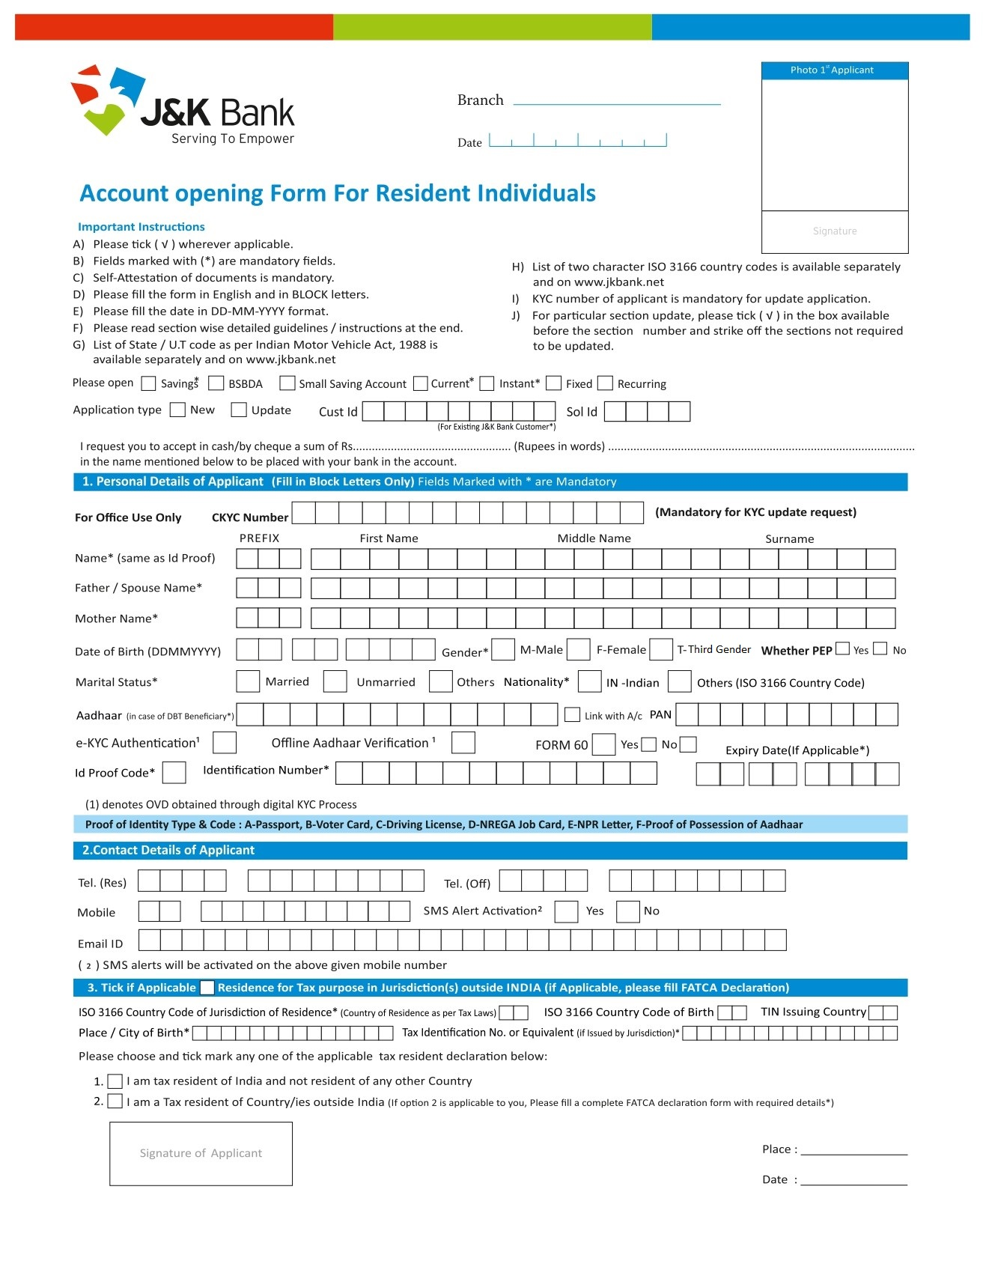

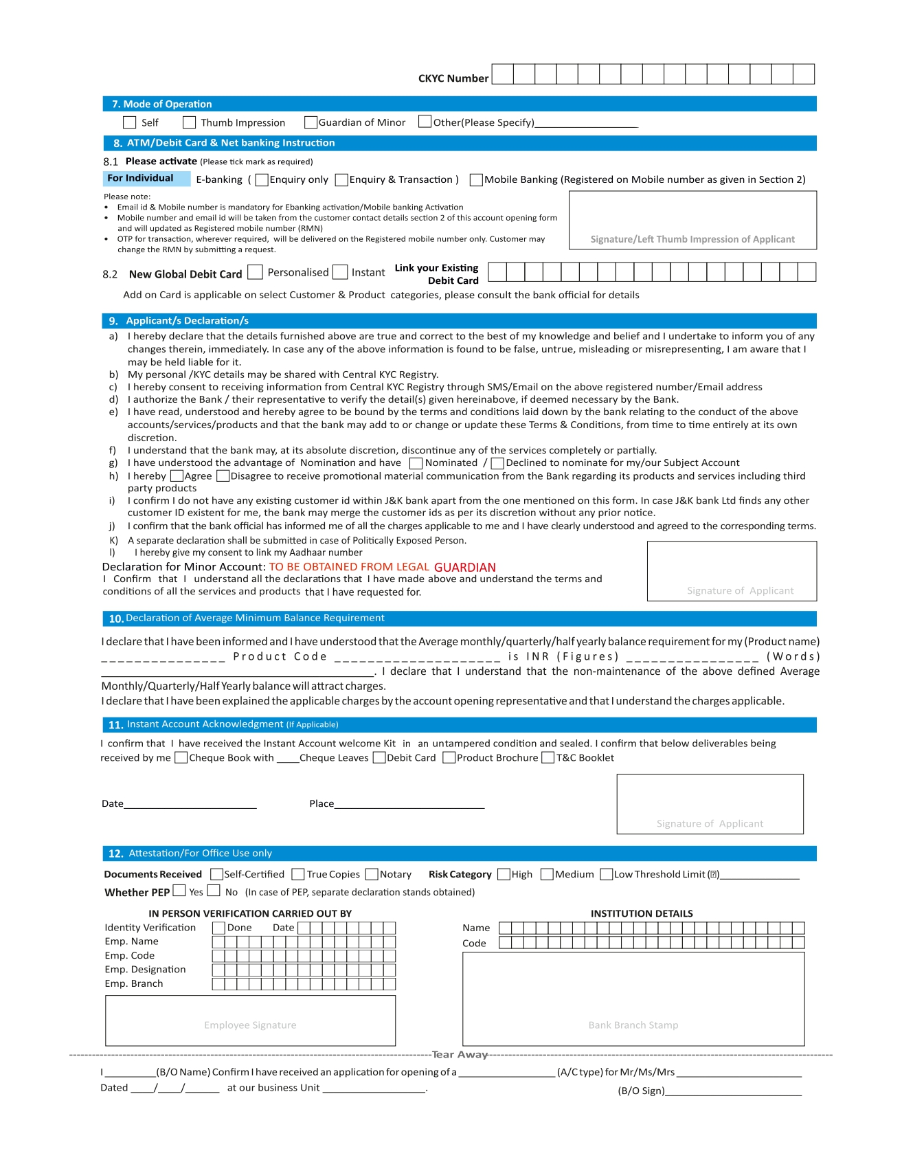

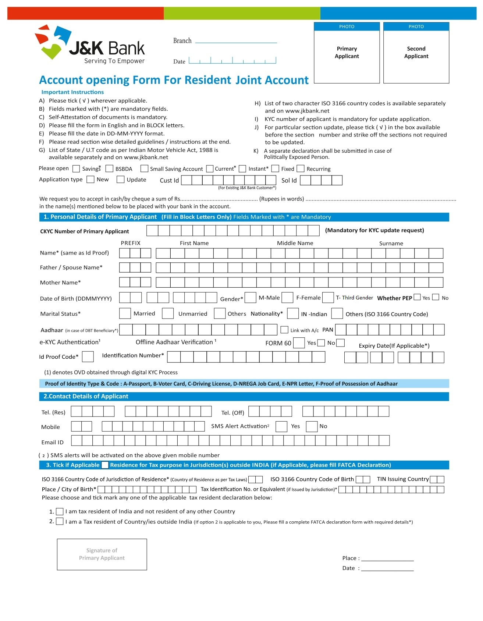

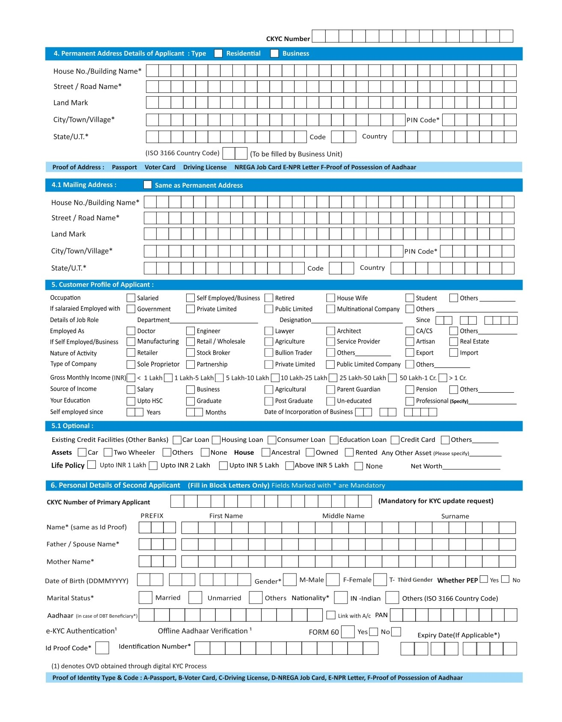

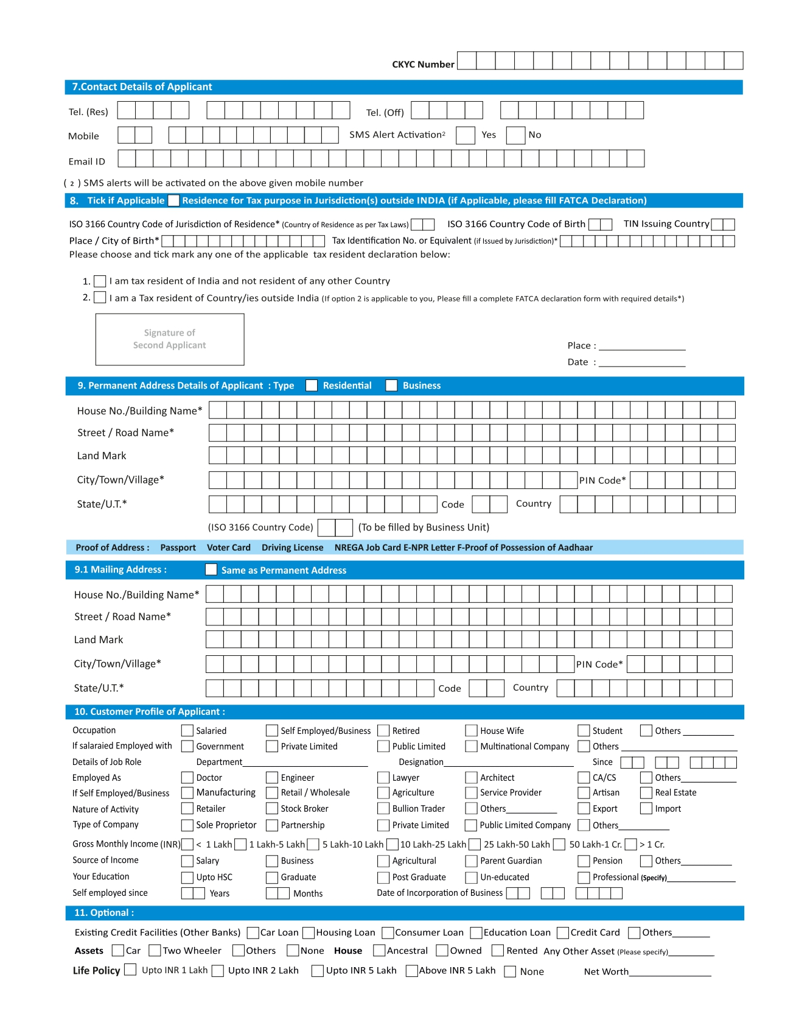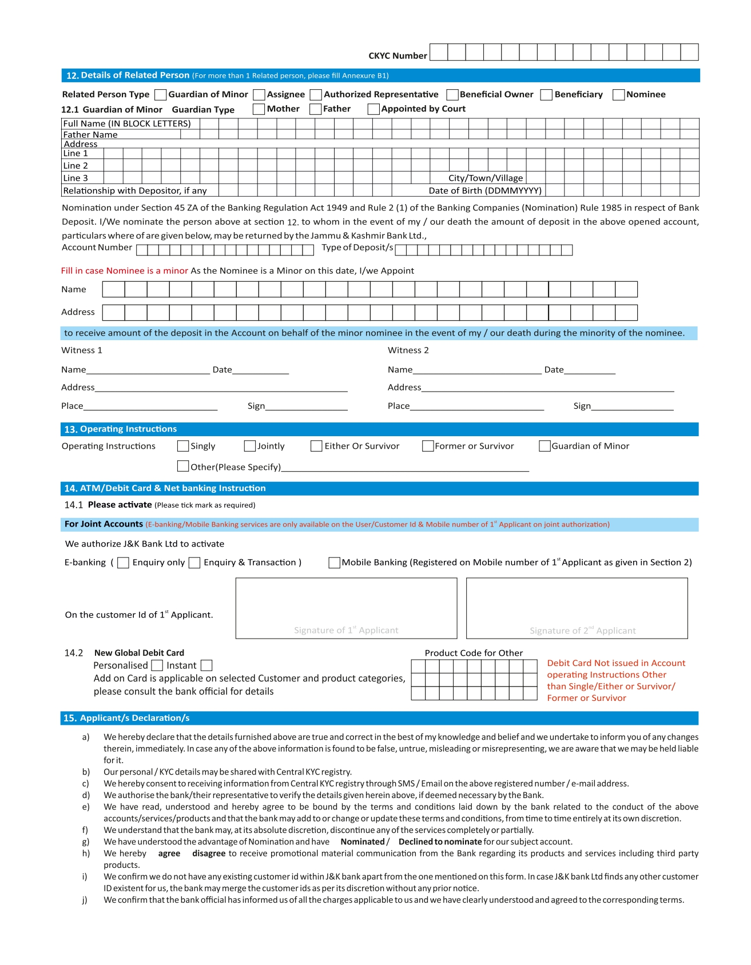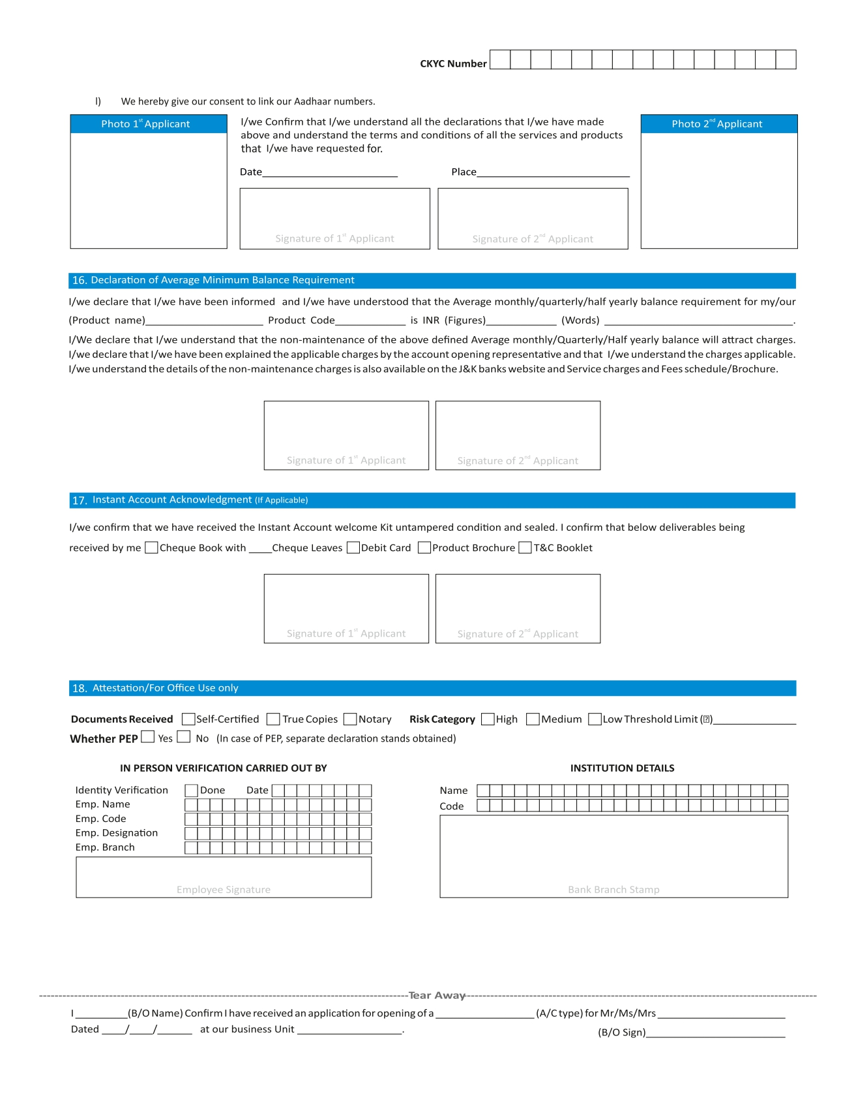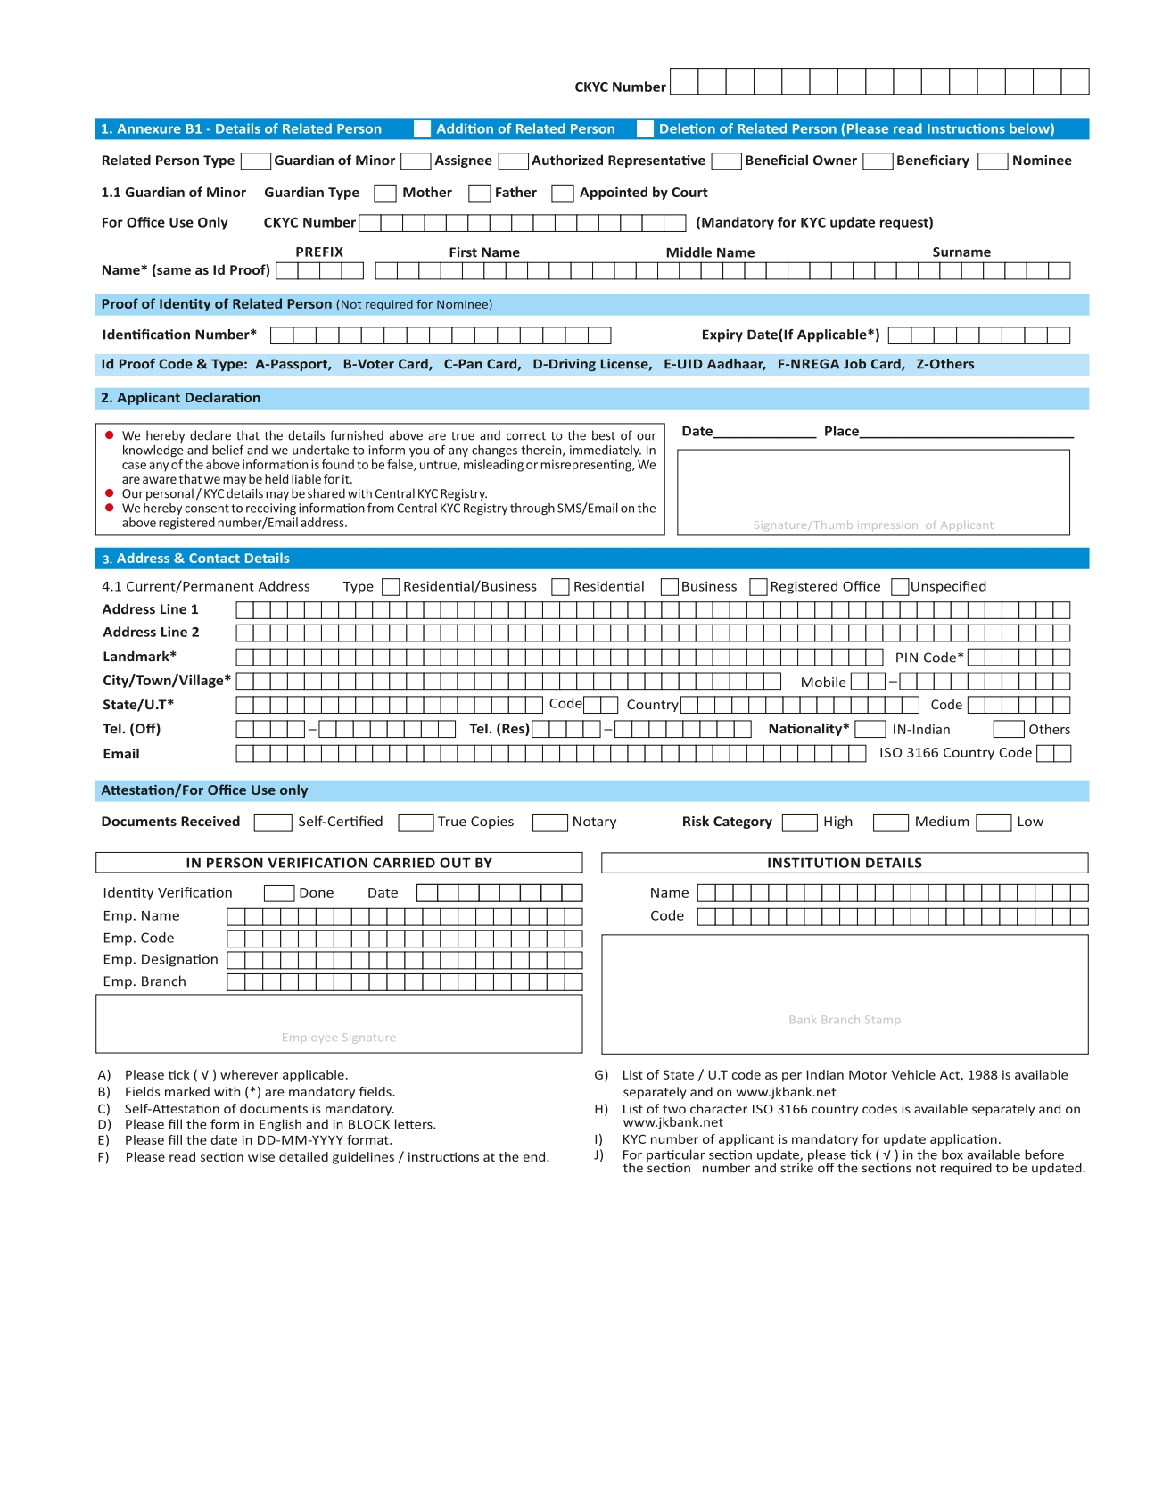

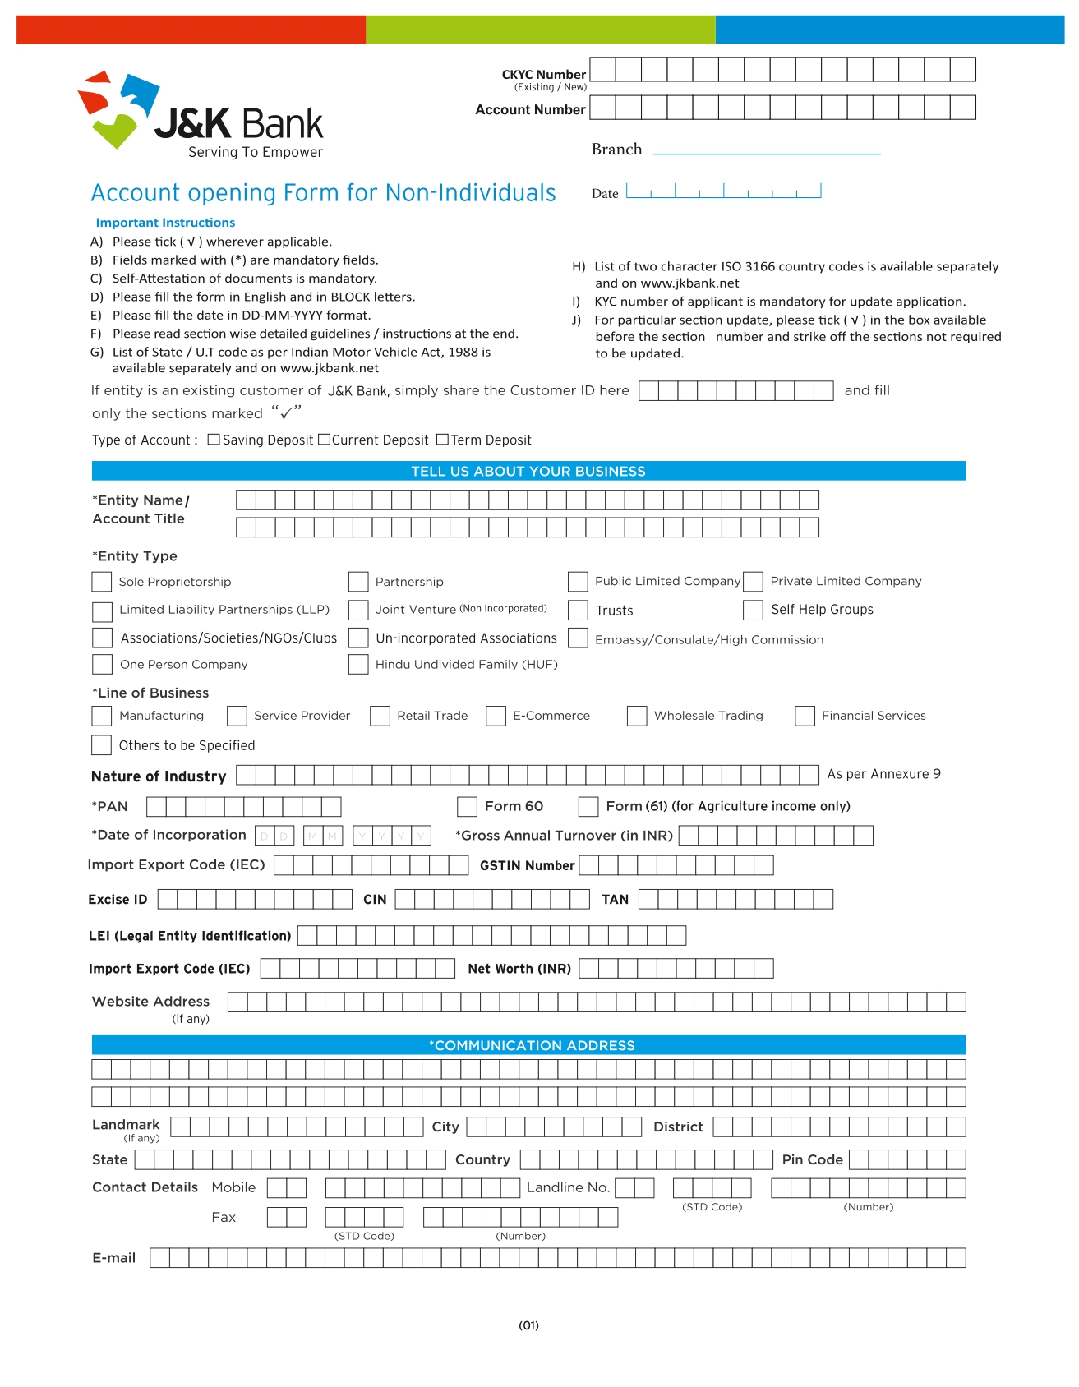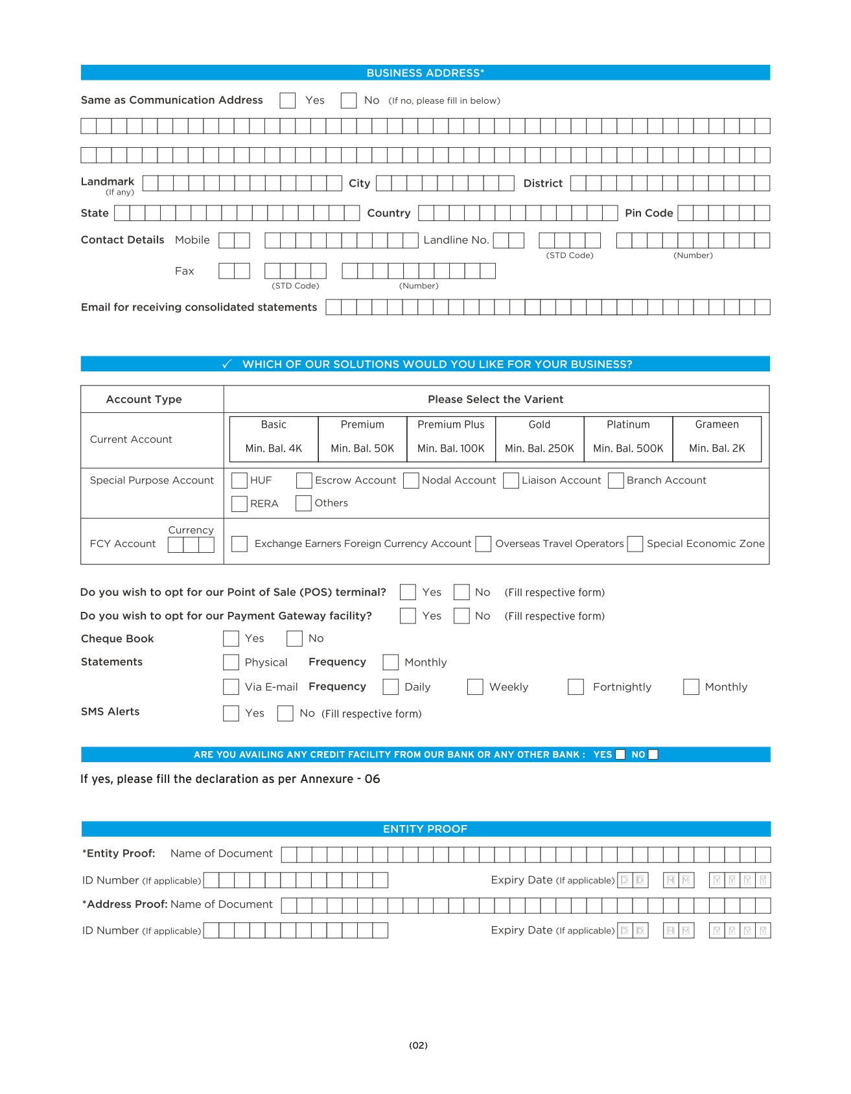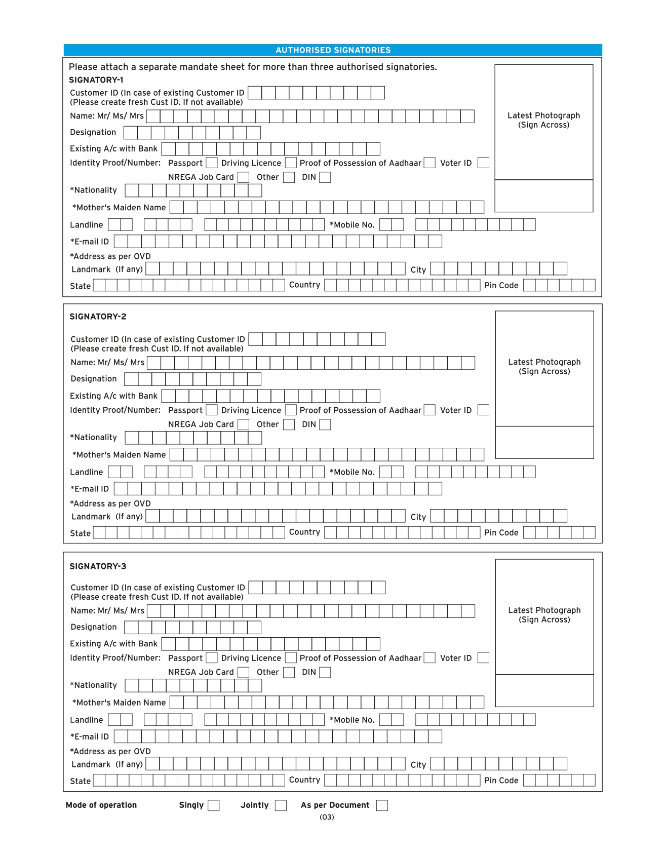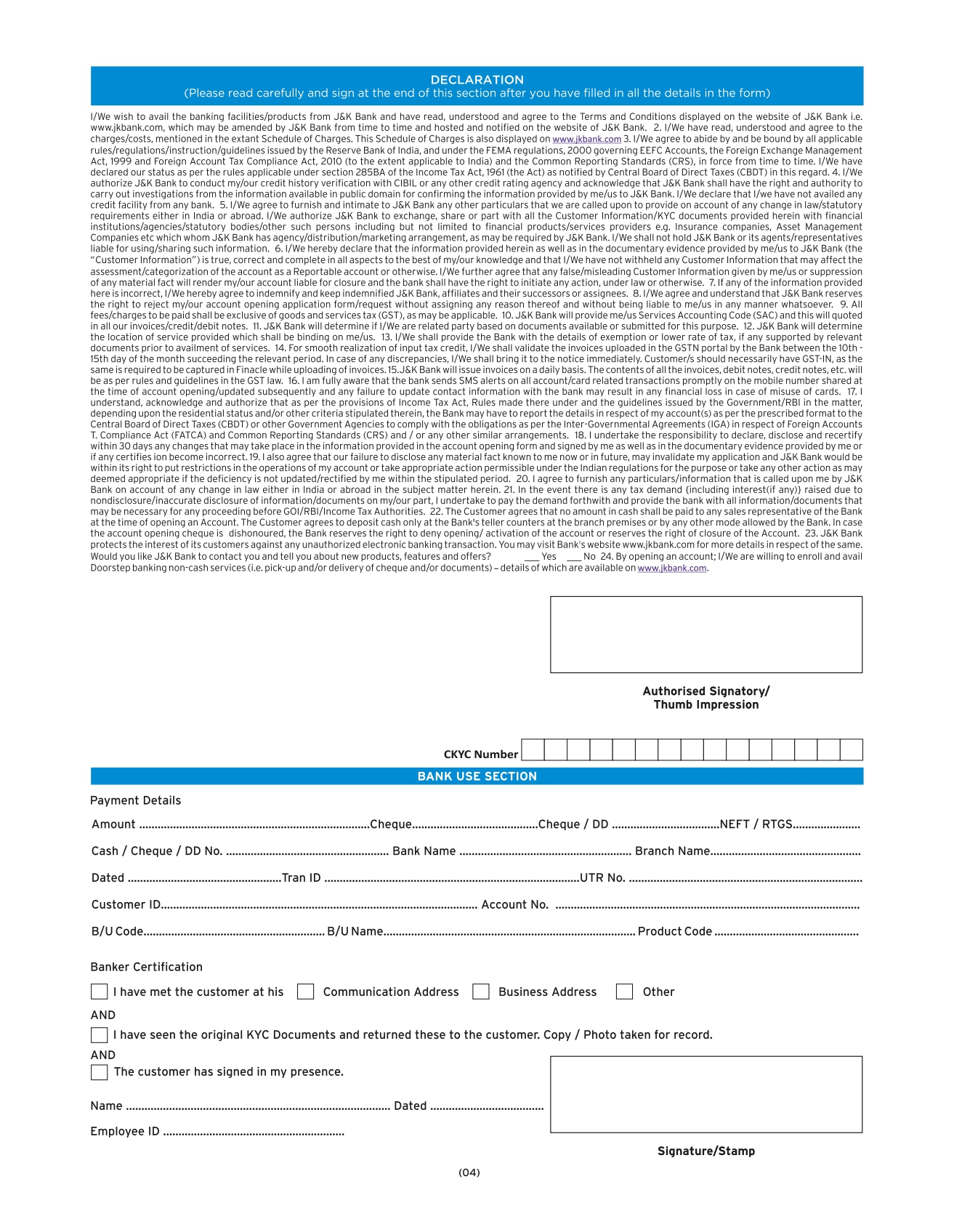

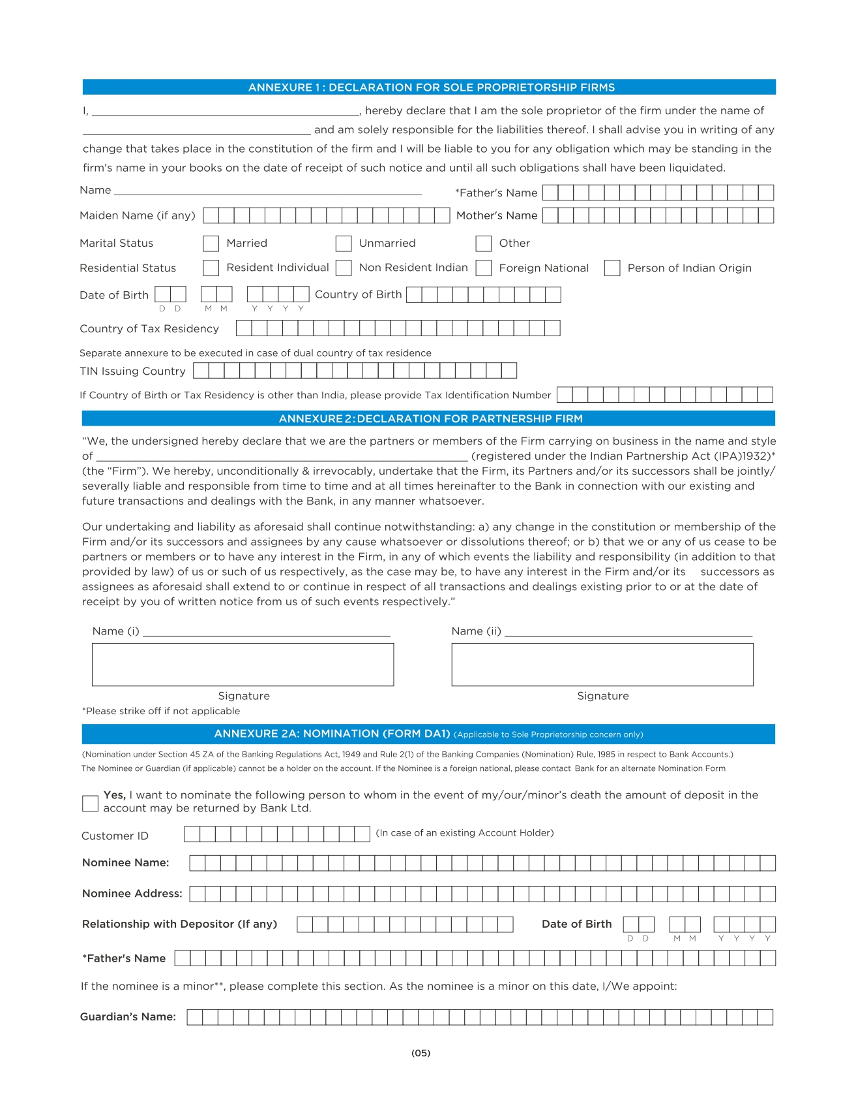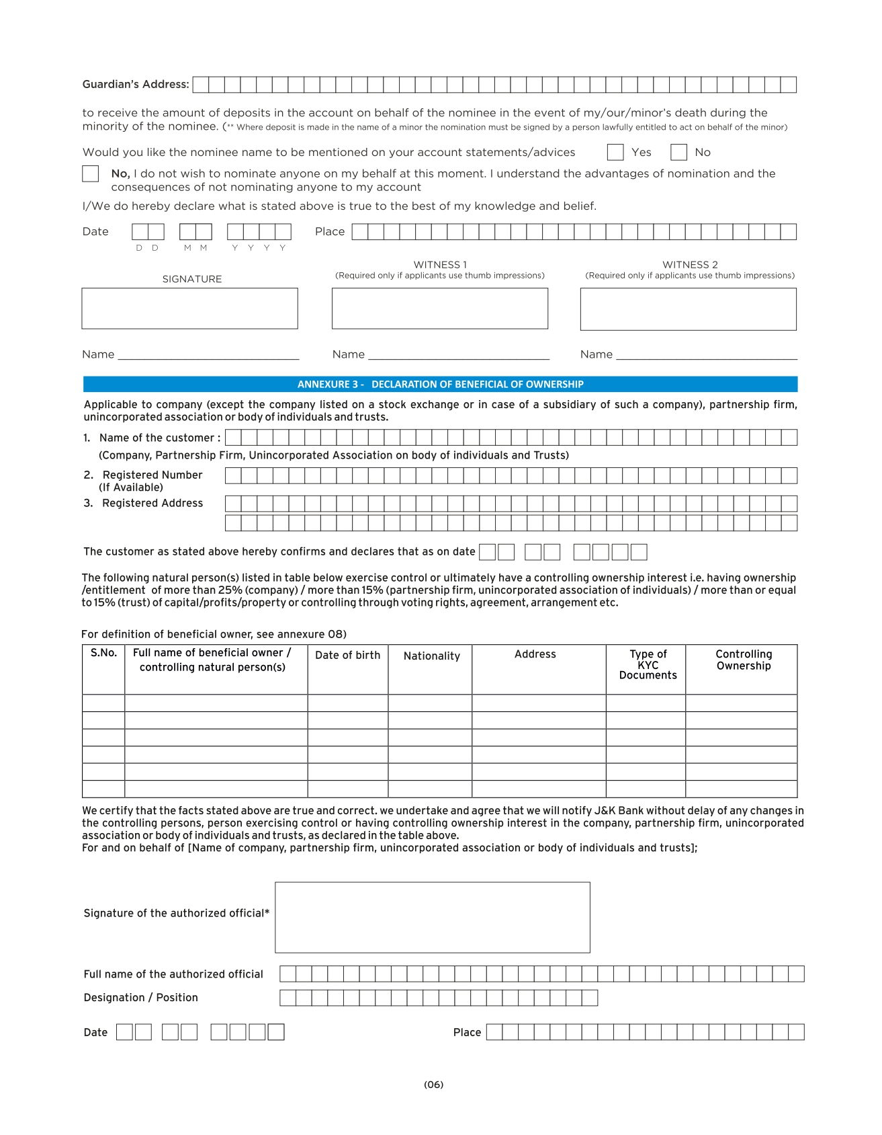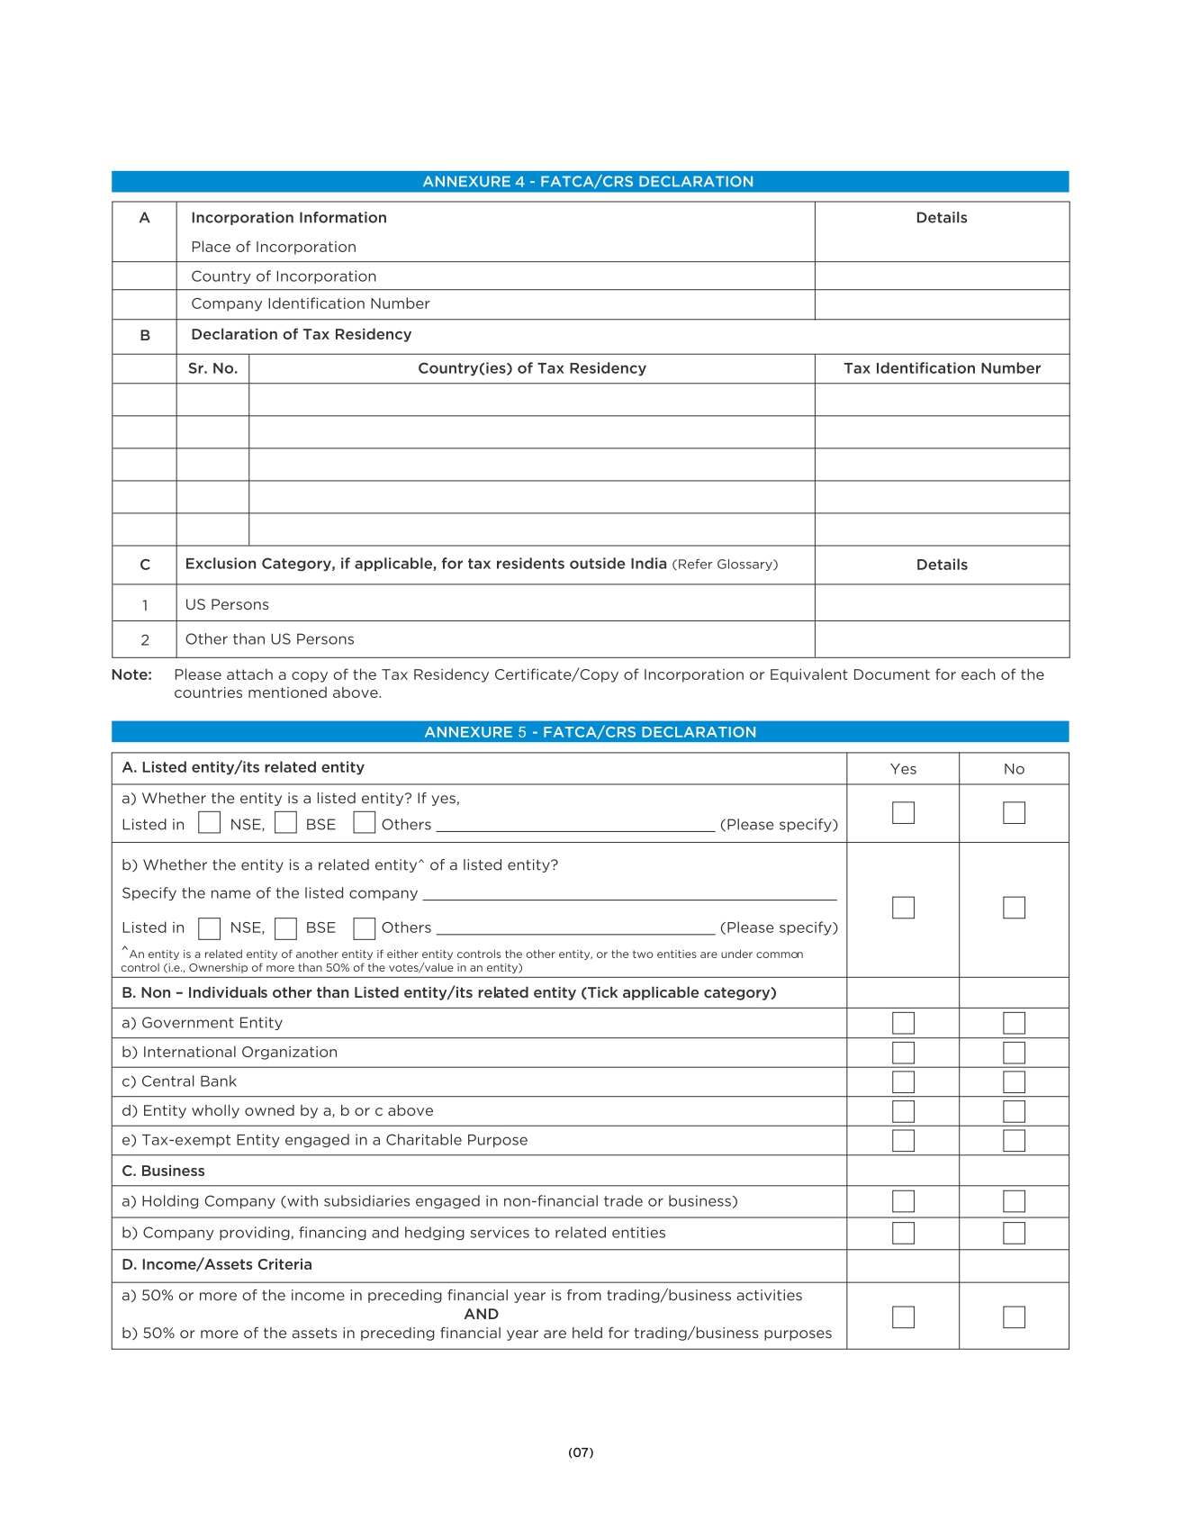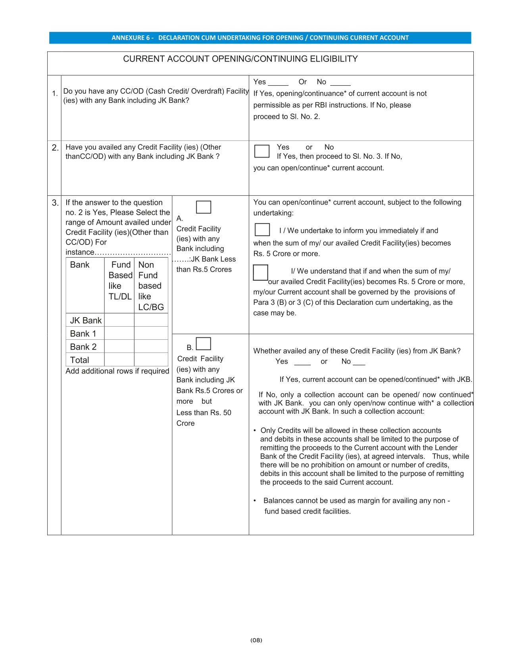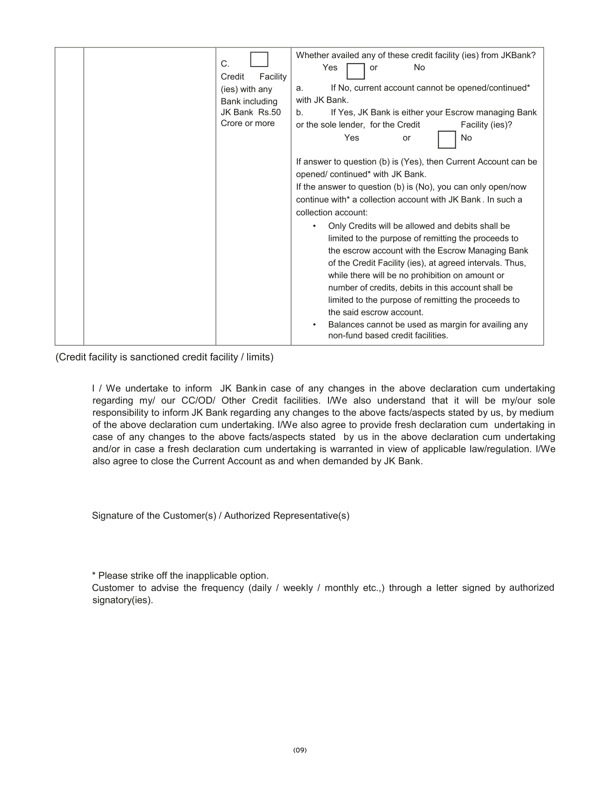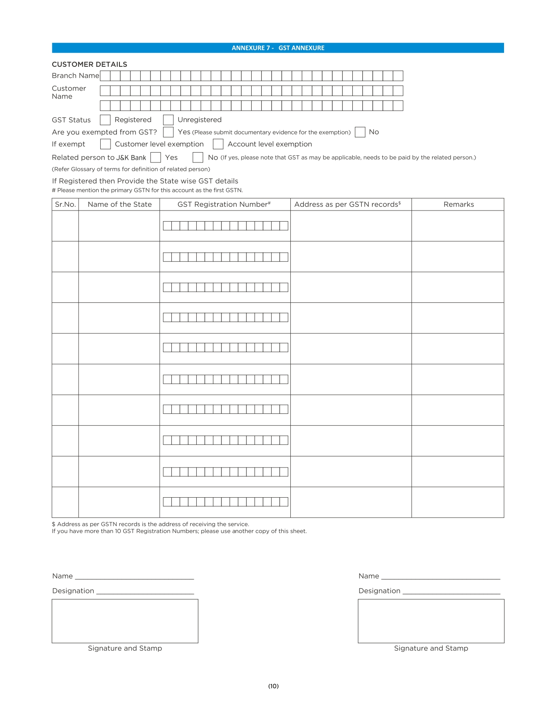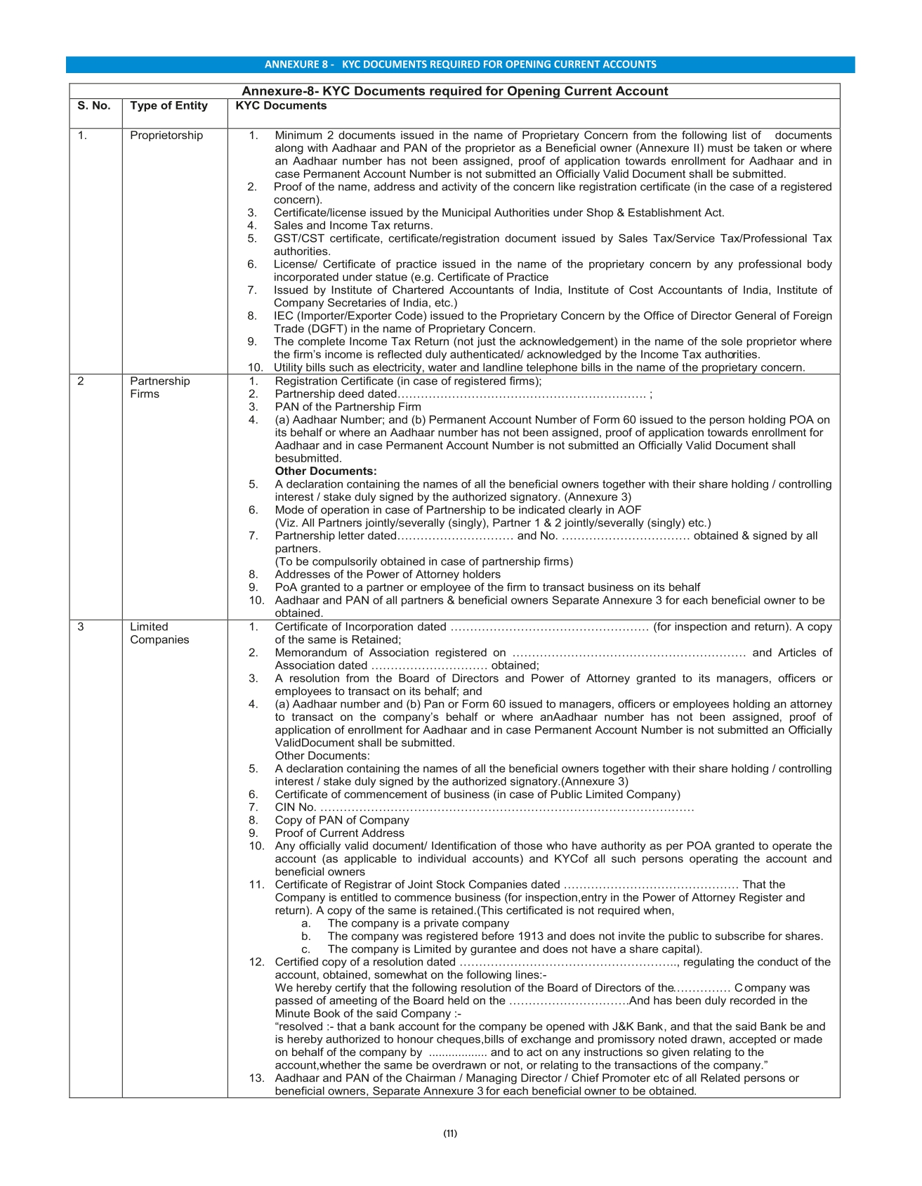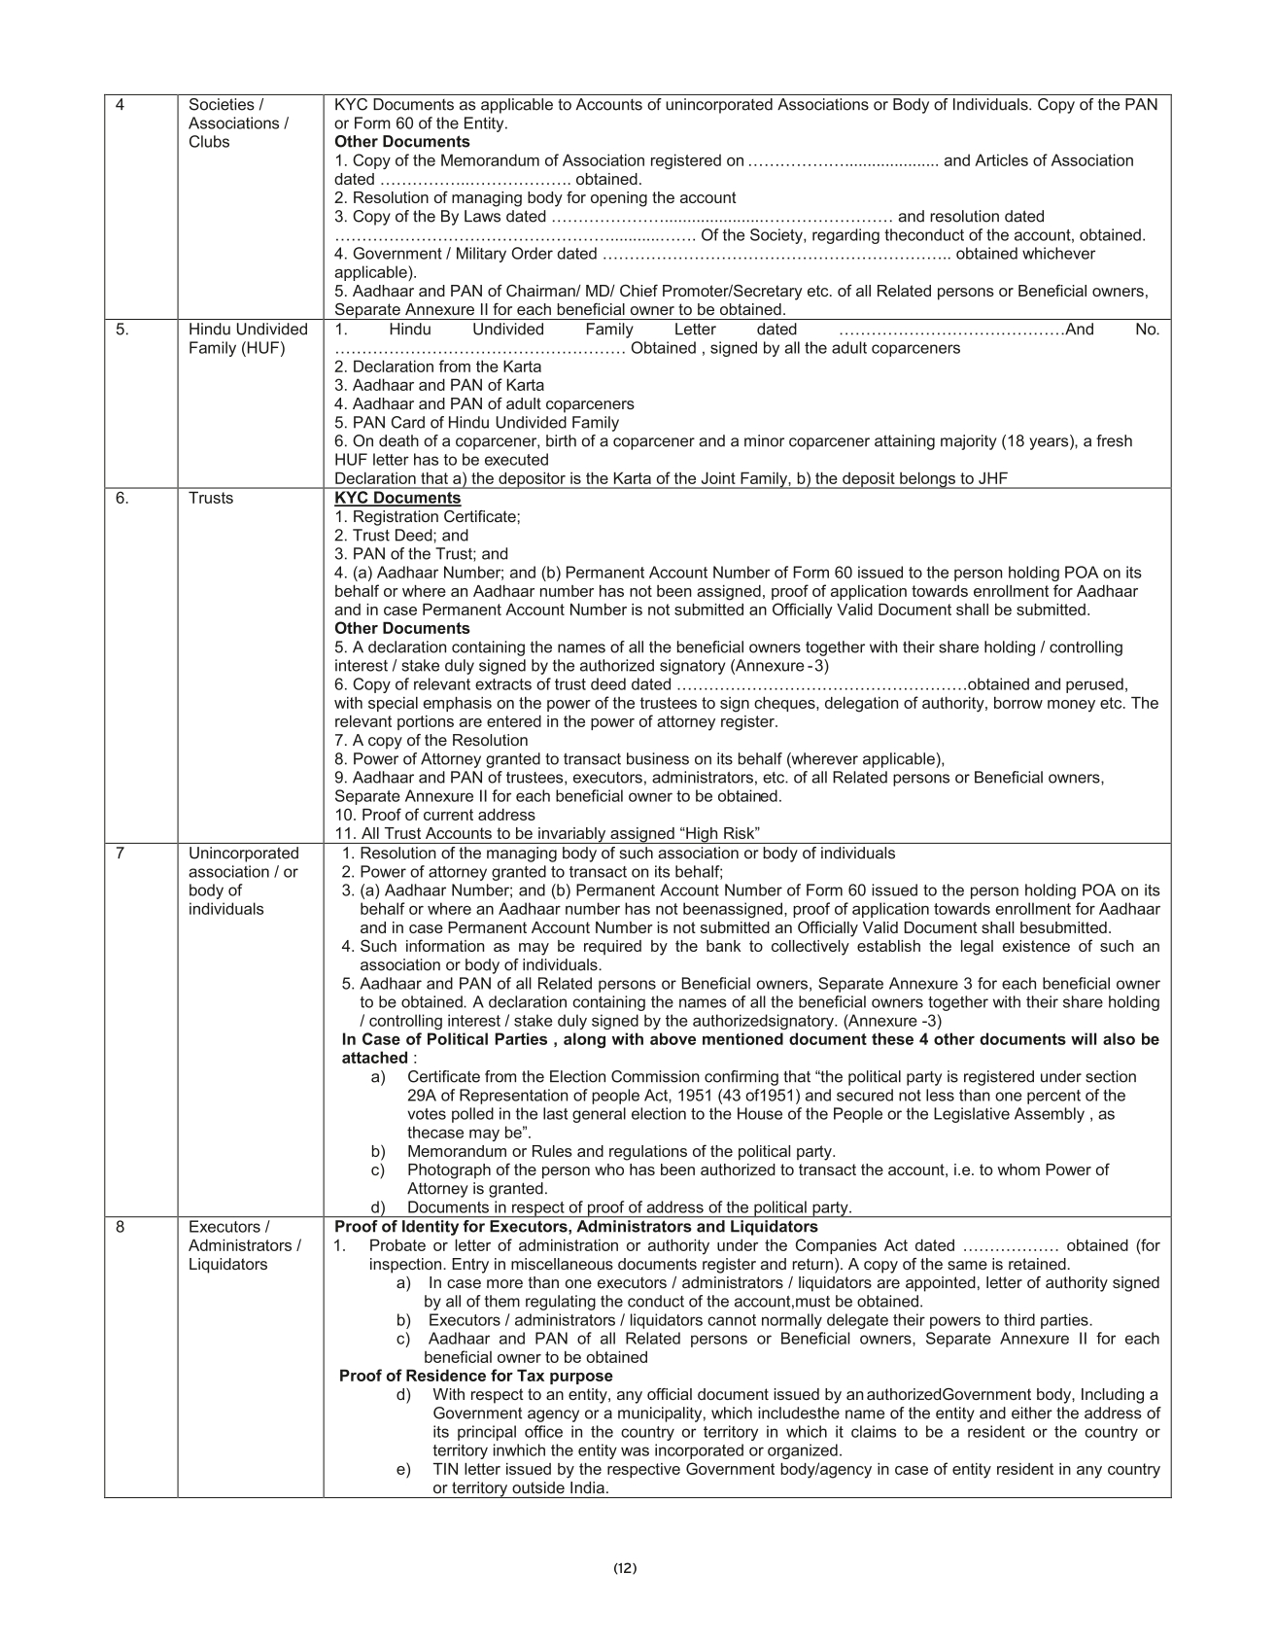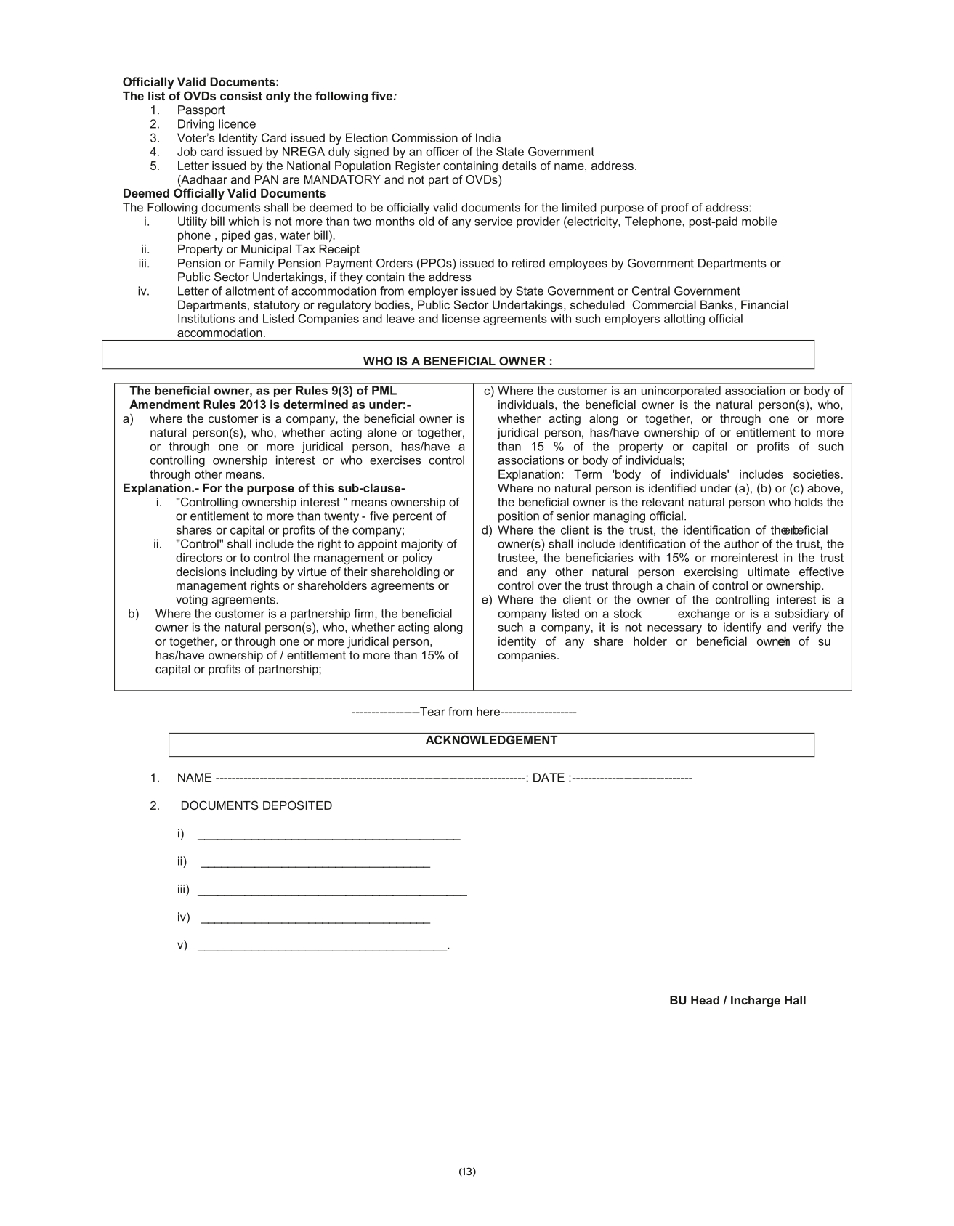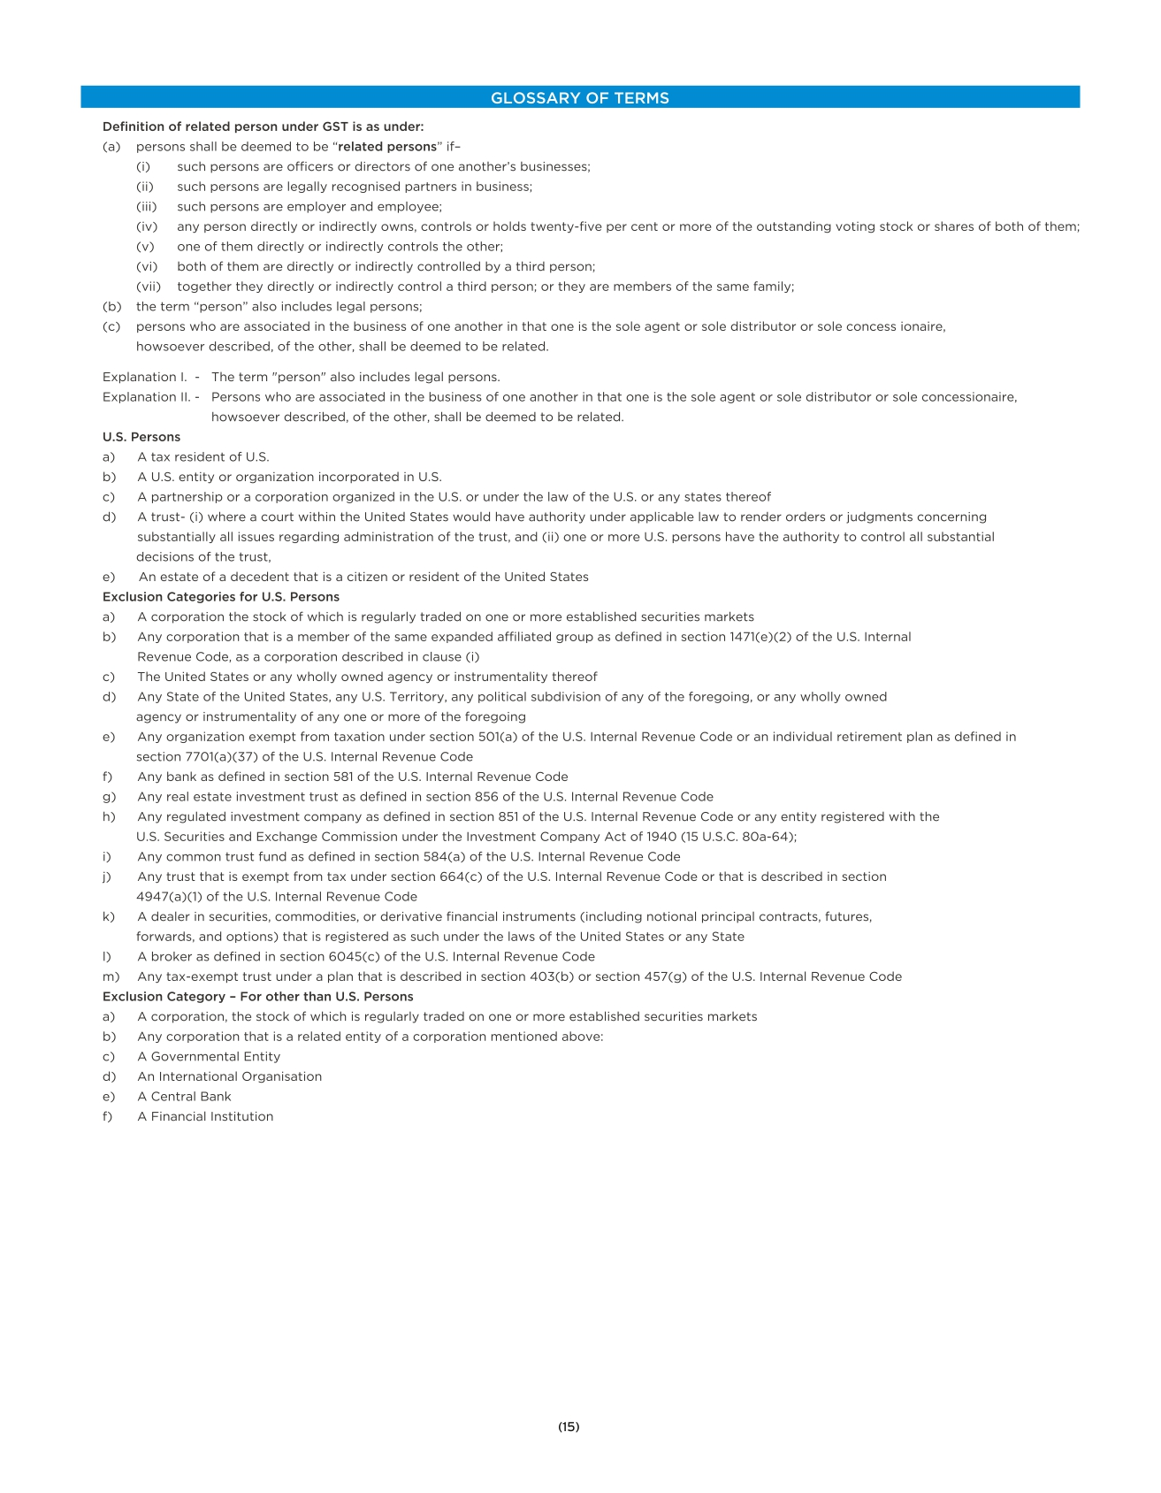

Application for opening Export Earners Foreign Currency Account (EEFC)
Instructions:
- The account can be opened for the constituents (Exporter/Importer) who maintain current Account or avail working capital facilities from The Jammu & Kashmir Bank Ltd.
- However if a new Customer is mobilized the EEFC Account can be opened only after opening a Current Account of the customer.
- The application should be completed and submitted to the AD “B” Category Branch of the Jammu & Kashmir Bank Ltd.
Documentation:
- The account opening form & required KYC documents be obtained for openingCurrent Account shall suffice for opening of Export Earners Foreign CurrencyAccount (EEFC).
- However this application/request shall be obtained from the Customer for openingExport Earners Foreign Currency Account (EEFC) apart from prescribed Account opening Form.

EEFC ACCOUNT
☐USD ☐GBP ☐EURO ☐JYP☐AUD ☐CAD
1. | Name and address of the Exporter
2. | Importer-exporter's code number
3. | Name and address of the Exporter
4. | Details of exports made last year or Projected during CFY.
5. | Details of Imports made last year or Projected during CFY.
6. | Amount of overdue Export bills and %age to export made during last FY.
7. | Whether the applicant's name has been/was placed on exporters' caution list at any time.
8. | Details of foreign currency loan raised by the exporter and their maturity patterns.
9. | Any other information that the applicant may like to provide in support of this application.

Declaration:
- I/We undertake that all the transactions in the EEFC account shall be carried out in conformity with RBI directions/notifications under FEMA, 1999 notified from time to time.

- I/We undertake that Foreign Exchange Earnings credited to the EEFC account shall be subject to the condition that the sum total of the accruals in the account during a calendar month should be converted into Rupees on or before the last day of the succeeding calendar month after adjusting for utilization of the balances for approved purposes or forward commitments or subject to latest RBI directions issued from time to time on the subject..

Place: ................................. |  |  | ........................................................................
Date: ................................. | Stamp |  | (Signature of Applicant/Authorised Official)
 |  |  | Name: ............................................................
 |  |  | Designation: ..................................................

(Space for Authorized Dealer's comments)
Comments of the branch of the bank in India with which the account is proposed to be maintained or which will monitor the operations on account maintained with a bank abroad, as the case may be.
Open Account: ☐Yes☐ No
Account Number:

Currency: ☐USD☐GBP ☐EURO☐JYP☐AUD☐CAD

Place: ................................. |  |  | ........................................................................
Date: ................................. | Stamp |  | (Signature of Applicant/Authorised Official)
 |  |  | Name: ............................................................
 |  |  | Designation: ..................................................
 |  |  | Name and Address.........................................
 |  |  | ofAuthorised Dealer: .....................................

Annexure-4
The deposit schemes’ booklet is a tailor-made product for ready reference of the staff, particularly for those who are on the operational front. The term deposit plans have been categorized into five distinct categories to facilitate the easy marketing of the products to the customers according to their requirements.
DEPOSIT PLANS
Categories of Term Deposits:
S.No | Category | Name of Scheme | Remarks
1 | Cumulative or Growth Plans | A) Cash Certificate | Lump sum deposits with benefits of reinvestment (compounding) of interest on quarterly basis resulting in higher annualized yield.
 |  | B) Mehandi Deposit Plan
 |  | C) Tax Saver Deposit Plan III
2 | Non-Cumulative Plans | A) Fixed Deposit | Lump sum deposits with an option to withdraw interest on quarterly basis.
 |  | B) Super Earner Deposit Plan
 |  | C) Tax Saver Deposit Plan I
3 | Installment Deposit Plans | A) Recurring Deposit Plan | Small installment deposits grow with reinvestment of interest to substantial proportions.
 |  | B) Flexi recurring Deposit Plan
4 | Monthly Income Plans | A) Monthly Yield Deposit Plan | Lump sum deposits conferring regular monthly interest payments on the depositors while the principal remains intact.
 |  | B) Tax Saver Deposit Plan II
5 | Hybrid Plans | A) Child-care Deposit Plan | Plans combining the features of simple deposit plans to cater to the special requirement of the target customer
 |  | B) Smart Saver Plan

1. Cumulative (Growth) Plan
Name Of Deposit Scheme | Minimum deposit | Tenure | Interest rate | Interest calculation | Interest payouts | Add-ons | Premature withdrawal | Ideal for
Cash Certificate | Rs. 1000 | 6 months to 10 years | Fixed | Quarterly compounding basis | On maturity | Loan facility upto 90% of amount deposited plus interest accrued | Allowed with penalty of 0.50% less than the rate of interest applicable for the period the deposit remains with the bank. | All types of investors-short, medium and long term.
Mehandi Deposit Plan | Depends upon the tenure and maturity amount desired | 5, 7, 10, 12 or 15 years | Fixed. | Quarterly compounding basis | On maturity Rs 25,000, Rs 50,000 or  Rs 1, 00,000 | Accidental Insurance Cover (linked to maturity amount) for parent/guardian. | As in the case of other term deposits. | Parents/  Guardians of Girl Child
Tax Saver Deposit Plan III | Rs. 1000 and multiples thereof | Minimum: 5 years. Maximum: 10 years  -----------  Maximum deposit Rs1.50lacs/- per year | Fixed | TaxBenefit: Income Tax benefit under section 80C of Income Tax Act 1961 subject to maximum deposit of Rs. 1.50 lac per year under all the options of Tax Saver Deposit Plan. | The interest on the deposit shall be paid along with the principal at the time of maturity. The term deposit shall carry compound, rate of interest. | No loan facility available against the deposit. | Not allowed before expiry of 5 years from the date of account opening | Customers desiring to place long term deposits to avail tax benefits under section 80C of Income Tax Act, 1961 and also to earn higher rate of interest. For Joint Accounts, tax benefit will be available to the first holder.

2. Non-Cumulative (Growth) Plans

Name Of Deposit Scheme | Minimum deposit | Tenure | Interest rate | Interest calculation | Interest payouts | Add-ons | Premature withdrawal | Ideal for
Fixed -Deposit Plan | Rs. 100 | 7 days to 10 years | Fixed | Simple Interest | Quarterly/,On maturity as per option of depositor | Loan facility up to 90% of amount deposited plus interest accrued | Allowed with penalty of 0.50% less than the rate of interest applicable for the period the deposit remains with the bank. | All types of investors
Tax-Saver Deposit Plan (I) | Rs. 1000 | Minimum: 5 years Maximum: 10 years  Max.  deposit  Rs1.50 lacs per year | Fixed | Tax Benefit: Income Tax benefit under section 80C of Income Tax Act 1961 subject to maximum deposit of Rs. 1.50 lac per year under all the options of Tax Saver Deposit Plan | The interest shall be applied on quarterly basis and paid to the customer in cash or credited to his/her account every quarter. | No loan facility available against the deposit. a. Automatic credit card limit equal to amount deposited. b. A discount of 1.00% on interest rates for first year to eligible customers on our housing, educational or consumer loan products provided the minimum investment in TSTDS is Rs. 50,000. The incentives shall be available to a customer for a period of 3 months from the date of opening of the TSTDS. | Not allowed before expiry of 5 years from the date of account opening. | Customers desiring to place long term deposits to avail tax benefits under section 80C of Income Tax Act, 1961 and also to earn higher rate of interest.

3. Installment Deposit Plans
Name Of Deposit Scheme | Minimum deposit | Tenure | Interest rate | Interest calculation | Interest payouts | Add-ons | Premature withdrawal | Ideal for
Recurring Deposit Plan | Rs. 50 and above in multiples of Rs. 5 | 6 months to 10 years | Fixed | Quarterly compounded interest  Delayed payment of installments: In case of installments not deposited on due dates, a penalty @ 2% per annum above the applicable deposit rate shall be imposed for the period the installment remains in arrears. The period of installments to be considered shall be the actual month from the date of opening of account and not the calendar month. However, no penalty shall be imposed if an installment is deposited within 15 days of the due date. | On maturity | Loan facility up to 90% of amount deposited plus interest accrued | · Allowed with penalty of 0.50% less than the rate of interest applicable for the period the deposit remains with the bank. | Retail LIG investors desiring regular monthly investments for accumulation of a substantial lump sum maturity amount
Flexi Recurring Deposit Plan | Base Installment: Rs. 500/= to Rs. 100000/= in the multiples of 100. Maximum monthly * deposit shall be subject to 10 times base installment. (*month is anniversary month). | 6 months to 10 years | Fixed | Quarterly compounded interest  Interest earned on FRD a/c is subject to TDS as per existing guidelines of the bank. Senior citizen staff members are eligible for 1.50% additional interest rate  Senior citizens are eligible for additional rate of interest at 0.50% as per guidelines and staff members for 1% extra. | On maturity. | Depositor shall be eligible for issuance of Credit Card subject to terms and conditions mentioned in the scheme document. Loan facility upto 90% of amount deposited plus interest accrued. However, withdrawal of units shall not be allowed till adjustment of the loan with Terms and conditions as mentioned in the scheme document | Allowed with penalty @0.50%. T&C extra | Opened with a definite base amount and the customer has the choice to step up the monthly installment every month (ten times the base instalment).

4. Monthly Income Plans
Name Of Deposit Scheme | Minimum deposit | Tenure | Interest rate | Interest calculation | Interest payouts | Add-ons | Premature withdrawal | Ideal for
Monthly Yield Deposit Plan | Rs.1000 and its multiples | 1 year to 10 years. | Fixed | Simple Interest (discounted) | Monthly. | Loan facility up to 90% of amount deposited | · Allowed with penalty of 0.50% less than the rate of interest applicable for the period the deposit remains with the bank. | Retail medium and long term investors seeking regular monthly returns
Tax-Saver Deposit Plan (II) | Minimum: 5 years Maximum: 10 years  Rs. 1000 and multiples thereof and Maximum of Rs. 1,50,000/- per year | Income Tax benefit under section 80C of Income Tax Act 1961 subject to maximum deposit of Rs. 1.50 lac per year under all the options of Tax Saver Deposit Plan | Fixed | The discounted interest shall be paid to the customer in cash or credited to his/her account at the end of every month during the term of the deposit. |  | Automatic credit card limit equal to amount deposited b. A discount of 1.00% on interest rates for first year to eligible customers on our housing, educational or consumer loan products provided the minimum investment in TSTDS is Rs. 50,000. The incentives shall be available to a customer for a period of 3 months from the date of opening of the TSTDS No loan facility available against the deposit | Not allowed before expiry of 5 years from the date of account opening | Customers desiring to place long term deposits to avail tax benefits under section 80C of Income Tax Act, 1961 and also to earn higher rate of interest.
5. Hybrid Plans
Childcare Deposit Plan | Rs 100/- and multiples thereof | 7, 9 and 10 years as recurring (Phase-I) and 5 , 7 and 10 years respectively as term deposit (Phase-II). | Fixed. Interest rates will be applied as per the rate structure prevalent at the time of beginning of the respective phases. | Quarterly compounded interest | On maturity | Insurance cover for the parent / guardian | Accidental Insurance Cover for the Parent / Guardian (linked to the size of monthly deposit amount). Delayed payment of installments  In case of installments not deposited on due dates, a penalty @ 2% per annum above the applicable deposit rate shall be imposed for the period the installment remains in arrears.  The period of installments to be considered shall be the actual month from the date of opening of account and not the calendar month. However no penalty shall be imposed if an installment is deposited within 15 days of the due date. | Parents/guardians desirous of investing over a long term with regular monthly savings for their children.
Smart Saver Deposit Plan | Rs 25,000/- and above in multiples of Rs 1000/- as core deposit (under Cash Certificate Plan ).  SB: Rs 5000 | 180 days | Fixed | Interest on the account shall be applied quarterly on cumulative basis and shall be in accordance to the term of the deposit.

Annexure-5

FORM NO. 15G
[See section 197A(1), 197A(1A) and Rule 29C]
Declaration under section 197A (1) and section 197A (1A) to be made by an individual or a Person (not being a company or firm) claiming certain incomes without deduction of tax
PART - I
1] Name of Assessee (Declarant) : |  |  |  |  |  |  |  |  |  |  |  |  | 2] PAN of the Assessee:
 |  |  |  |  |  |  |  |  |  |  |  |  | 3] Status :
 |  |  |  |  |  |  |  |  |  |  |  |  | 4] Previous Year P.Y.(for which declaration is being made):
5] Residential Status: |  |  |  |  |  |  | 6] Flat / Door / Block No. : |  |  |  |  |  | 7] Name of Premises:
8] Road / Street / Lane : |  |  |  |  |  |  | 9] Area / Locality : |  |  |  |  |  | 10] Town / City / District :
11] State : |  |  |  |  |  |  | 12] PIN:
 |  |  |  |  |  |  |  |  |  |  |  |  | 14] Telephone No.(with STD code)and Mobile No.:
 |  |  |  |  |  |  | 13] Email |  | :
15] a) Whether assessed to tax under Income Tax Act, 1961? Yes / No  b) If yes, latest Assessment Year for which assessed: |  |  |  |  |  |  | 16] Estimated income for which this declaration is made: |  |  |  |  |  | 17] Estimated total income of the P.Y. in which income mentioned in Column 16 to be included:
18] Details of Form No. 15G other than this form filed during the previous year, if any
 |  |  |  |  |  |  |  |  |  |  |  |  |  | Aggregate amount of income for which Form No. 15G filed
Total No. of Form No. 15G filed
19]Details of income for which the declaration is filed:
Sl. No. |  | Identification number of relevant investment/account, etc. |  |  |  | Nature of income |  |  |  |  | Section under which tax is deductible |  |  |  |  | Amount of income
 |  |  |  |  |  |  |  |  |  |  |  |  |  |  |  | Signature of the Declarant
Declaration/Verification
I/ We |  |  |  |  |  |  |  |  |  |  |  |  |  |  | do hereby declare that to the best of my/our
Knowledge and belief what is stated above is correct, complete and is truly stated. I /We declare that the incomes referred to in this form are not includible in the total income of any other person under section 60 to 64 of Income Tax Act, 1961. I/We further declare that the tax on my/our estimated total income including income / incomes referred to in column 16 and aggregate amount of income/incomes referred to in column 18 computed in accordance with the provisions of the Income Tax Act 1961, for the previous year ending on 31.03._____ relevant to the assessment year _____________ will be nil. I / We also declare that my / our income / incomes referred to in Column 16 and the aggregate amount of income/incomes referred to in column 18 for the previous year ending on 31.03.______ relevant to the assessment year ____________ will not exceed the maximum amount which is not chargeable to income tax.
Place :
Date : |  |  |  |  |  |  |  |  |  |  |  |  |  |  |  | Signature of the Declarant
PART - II
[To be filled by the person responsible for paying the income referred to in Column 16 of Part I]
1] Name of the person responsible for paying : |  |  |  |  |  |  |  |  |  |  | 2] Unique Identification No.:
3] PAN of the person responsible for paying: |  |  |  |  |  |  |  |  |  |  | 4] Complete Address:
5] TAN of the person responsible for paying: |  |  |  |  |  | 6] Email : |  |  |  |  | 7] Telephone No. with  STD code and  Mobile No.:
8] Amount of income paid:

9] Date on which Declaration is received : (DD/MM/YYYY) |  |  |  |  |  |  |  |  |  |  | 10] Date on which the income has been paid/credited:  (DD/MM/YYYY)
Place: |  |  |  |  |  |  |  |  |  |  | Signature of the person responsible for paying the income referred to in Column 16 of Part I
Date :

Annexure-6
FORM NO. 15H
[See section 197A(1C) and Rule 29C]
Declaration under section 197A (1C) to be made by an individual who is of the age of sixty years or more claiming certain incomes without deduction of tax
PART - I
1] Name of Assesse (Declarant) : |  |  |  |  |  |  |  |  |  |  |  |  |  | 2] PAN of the Assesse:
3] Date of Birth
(DD/MM/YYYY) :
 |  |  |  |  |  |  |  |  |  |  |  |  |  | 4] Previous Year P.Y.(for which declaration is being made):
5] Flat / Door / Block No. : |  |  |  |  |  |  |  |  |  |  |  |  |  | 6] Name of Premises:
7] Road / Street / Lane : |  |  |  |  |  |  | 8] Area / Locality : |  |  |  |  |  |  | 9] Town / City / District :
10] State : |  |  |  |  |  |  | 11] PIN:
 |  |  |  |  |  |  |  |  |  |  |  |  |  | 13] Telephone No.(with STD code)and Mobile No.:
 |  |  |  |  |  |  | 12] Email |  | :
14] a) Whether assessed to tax  Yes / No  b) If yes, latest Assessment Year for which assessed: |  |  |  |  |  |  | 15] Estimated income for which this declaration is made: |  |  |  |  |  |  | 16] Estimated total income of the P.Y. in which income mentioned in Column 15 to be included:
17] Details of Form No. 15H other than this form filed during the previous year, if any
 |  |  |  |  |  |  |  |  |  |  |  |  |  |  | Aggregate amount of income for which Form No. 15H filed
Total No. of Form No. 15H filed
18]Details of income for which the declaration is filed:
Sl. No. |  | Identification number of relevant investment/account, etc. |  |  |  | Nature of income |  |  |  |  |  | Section under which tax is deductible |  |  |  |  | Amount of income
 |  |  |  |  |  |  |  |  |  |  |  |  |  |  |  |  | Signature of the Declarant
Declaration/Verification
I _________________________ do hereby declare that I am resident in India within the meaning of section 6 of the Income Tax Act, 1961. I also hereby declare that to the best of my knowledge and belief what is stated above is correct, complete and is truly stated and that the incomes referred to in this form are not includible in the total income of any other person under section 60 to 64 of Income Tax Act, 1961. I further declare that the tax on my estimated total income including income/incomes referred to in column 15 and aggregate amount of income/incomes referred to in column 17 computed in accordance with the provisions of the Income Tax Act 1961, for the previous year ending on 31.03._____ relevant to the assessment year _____________ will be nil.
Place :
Date : |  |  |  |  |  |  |  |  |  |  |  |  |  |  |  |  | Signature of the Declarant
PART - II
[To be filled by the person responsible for paying the income referred to in Column 15 of Part I]
1] Name of the person responsible for paying : |  |  |  |  |  |  |  |  |  |  |  | 2] Unique Identification No.:
3] PAN of the person responsible for paying: |  |  |  |  |  |  |  |  |  |  |  | 4] Complete Address:
5] TAN of the person responsible for paying: |  |  |  |  |  | 6] Email : |  |  |  |  |  | 7] Telephone No. with  STD code and  Mobile No.:
8] Amount of income paid:

9] Date on which Declaration is received : (DD/MM/YYYY) |  |  |  |  |  |  |  |  |  |  |  | 10] Date on which the income has been paid/credited:  (DD/MM/YYYY)
Place : |  |  |  |  |  |  |  |  |  |  |  | Signature of the person responsible for paying the income referred to in Column 15 of Part I
Date :

Annexure-7

SCHEDULE – I
Entities permitted to open SB Accounts
Primary Co-operative Credit Society which is being financed by the bank.
Khadi and Village Industries Boards.
Agriculture Produce Market Committees.
Societies registered under the Societies Registration Act, 1860 or any other corresponding law in force in a State or a Union Territory except societies registered under the State Co-operative Societies Acts and specific state enactment creating Land Mortgage Banks.
Companies licensed by the Central Government under Section 8 of CompaniesAct,2013orSection25ofCompaniesAct,1956or under the corresponding provision in the Indian Companies Act,1913 and permitted, not to add to their names the words‘Limited’ or the words‘Private Limited’.
Institutions other than those mentioned in section 28(h) and whose entire income is exempt from payment of income-tax under the Income-Tax Act, 1961.
Government department’s /bodies/ agencies in respect of grants / subsidies released for implementation of various programmes / Schemes sponsored by Central Government/ State Governments subject to production of an authorization from the respective Central/State Government departments to open savings bank account.
Development of Women and Children in Rural Areas (DWCRA).
Self-help Groups (SHGs), registered or unregistered, which are engaged in promoting savings habits among their members.
Farmers’ Clubs – Vikas Volunteer Vahini – VVV.

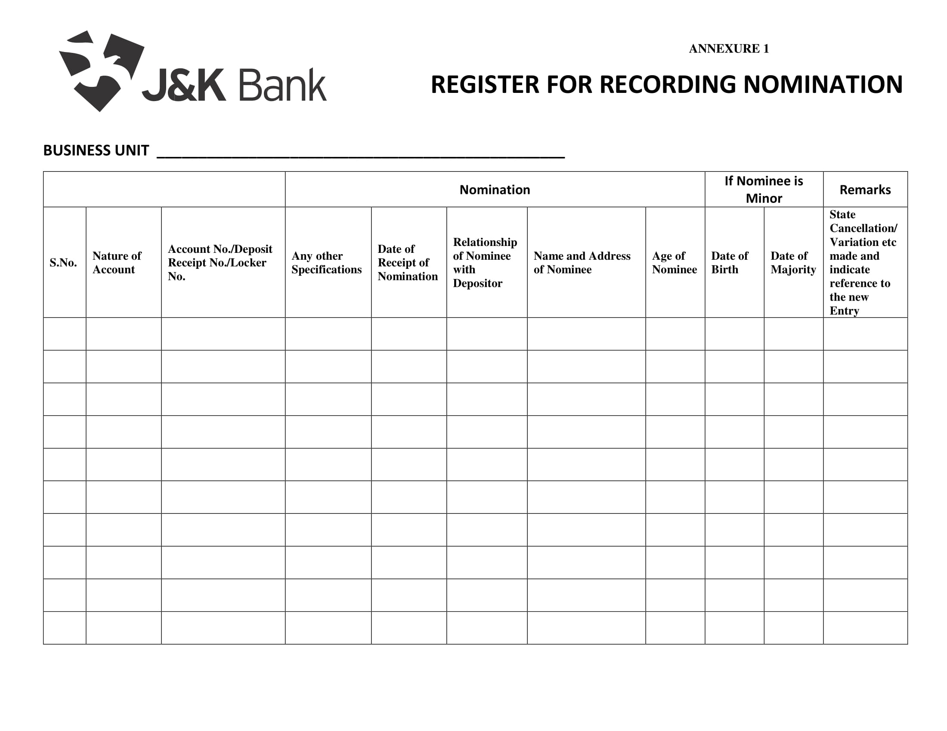
ANNEXURE- 8

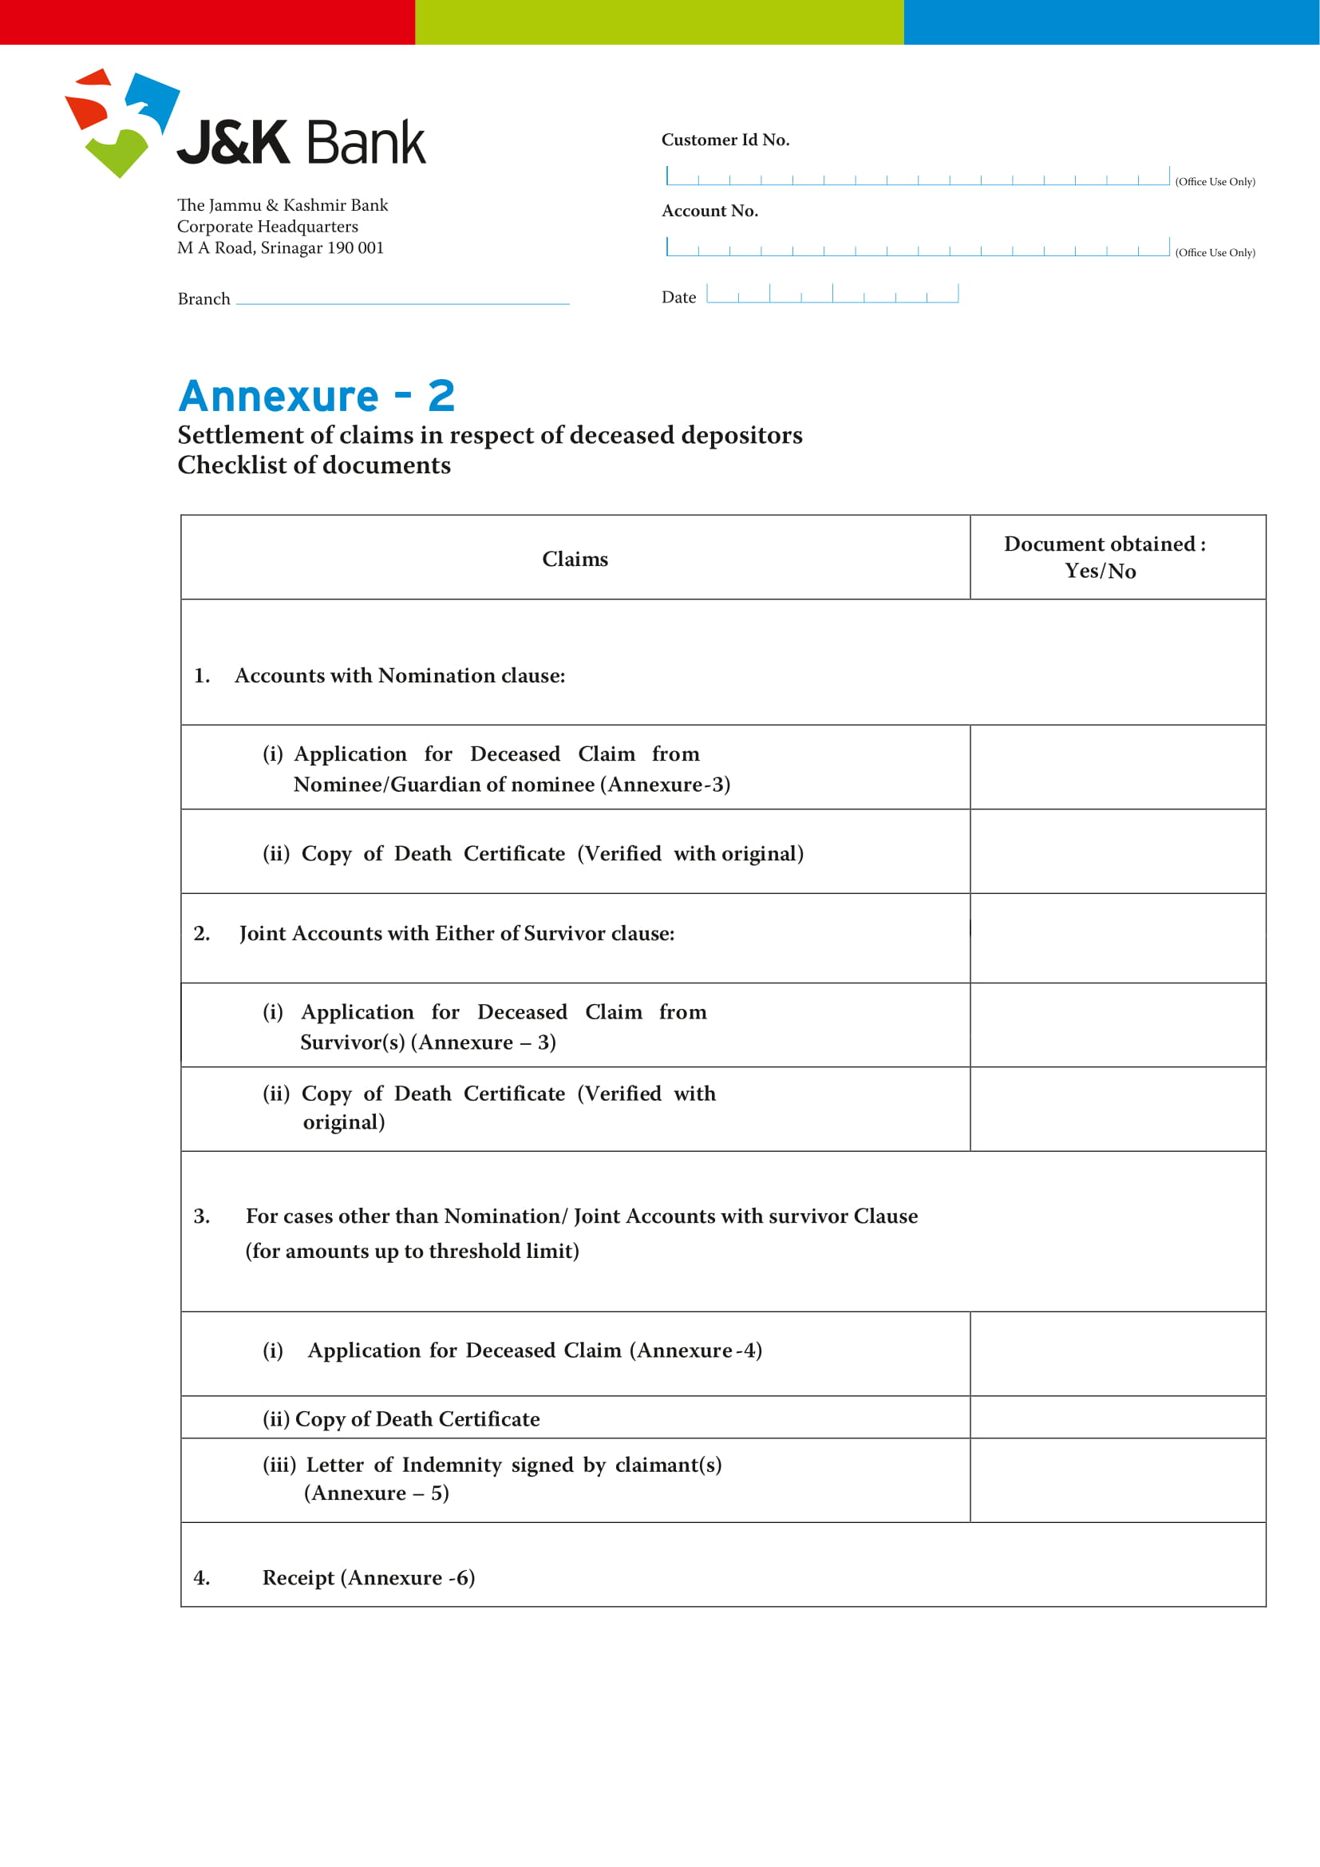

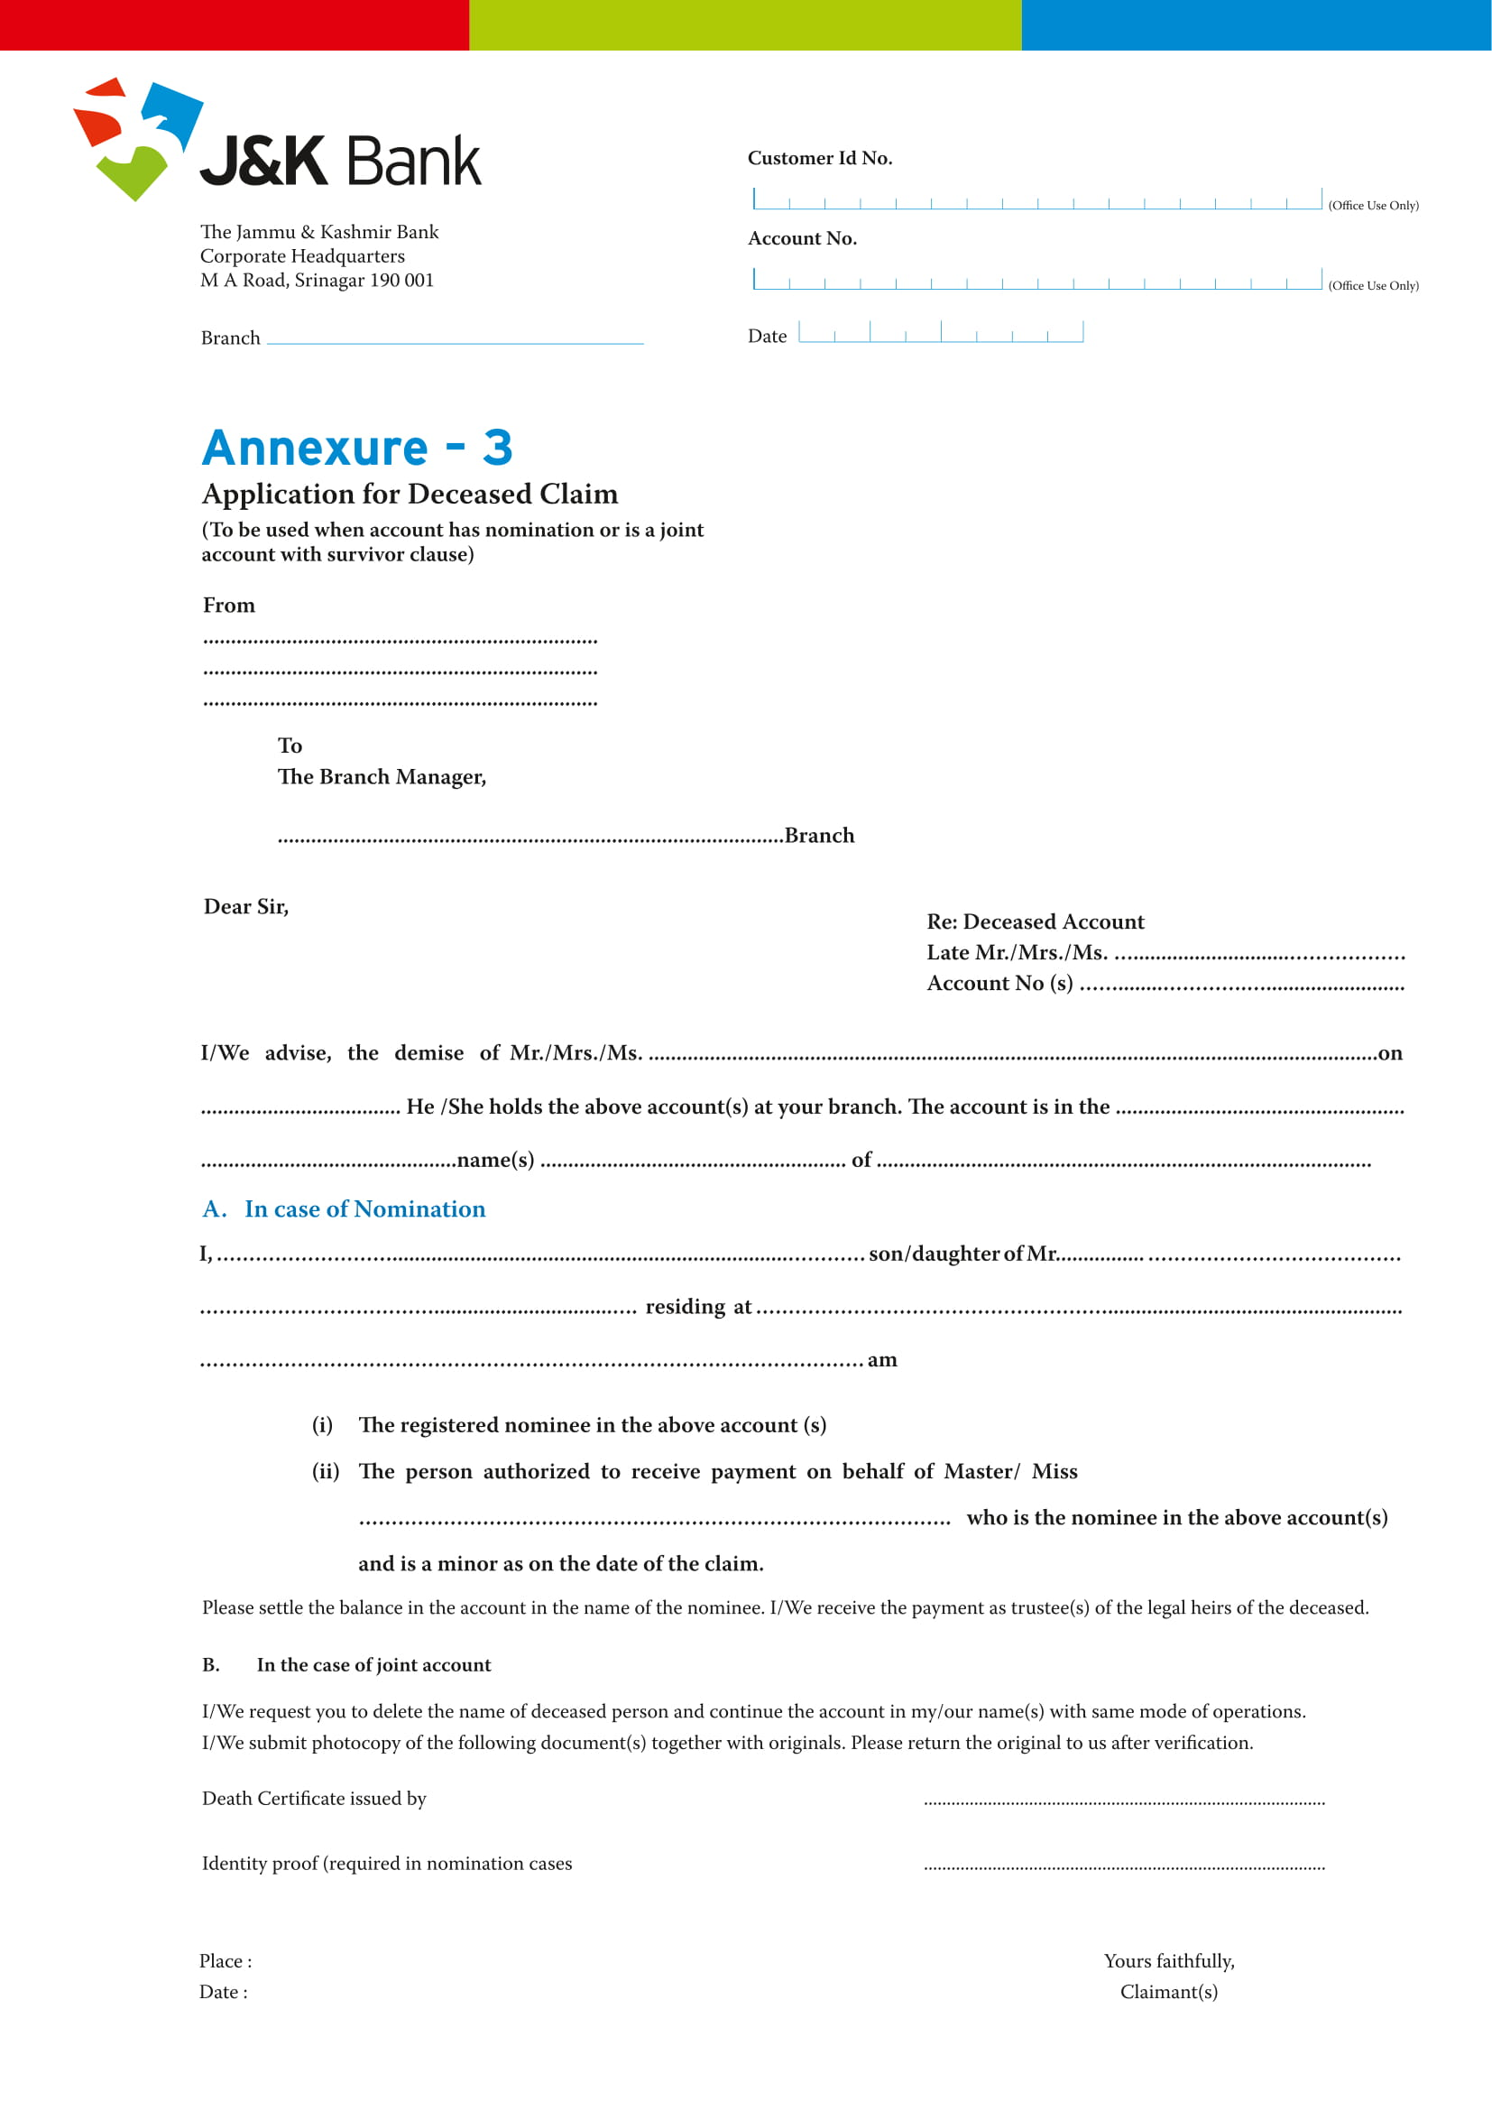

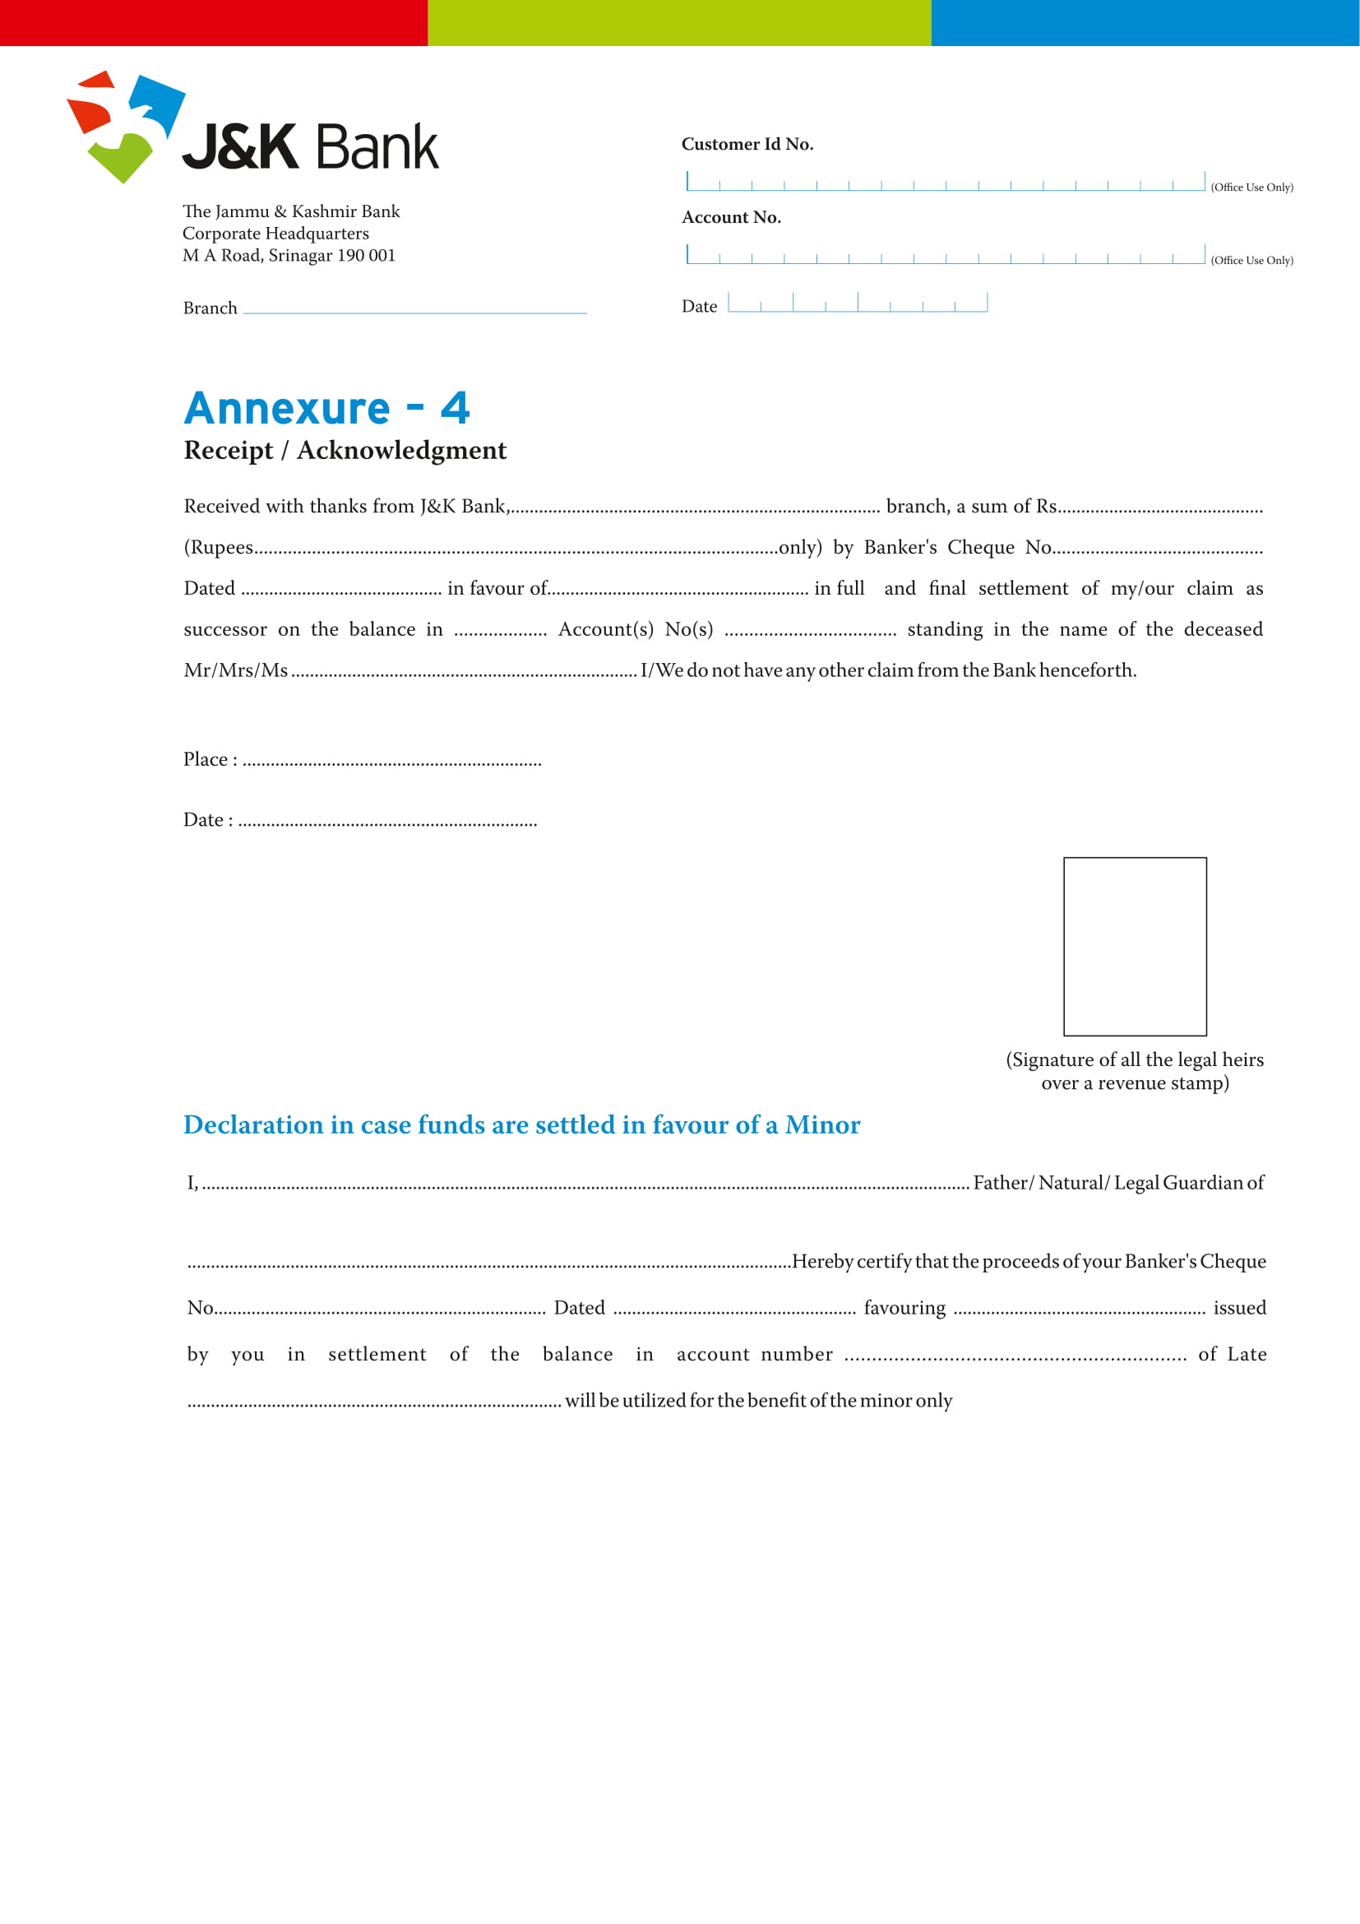
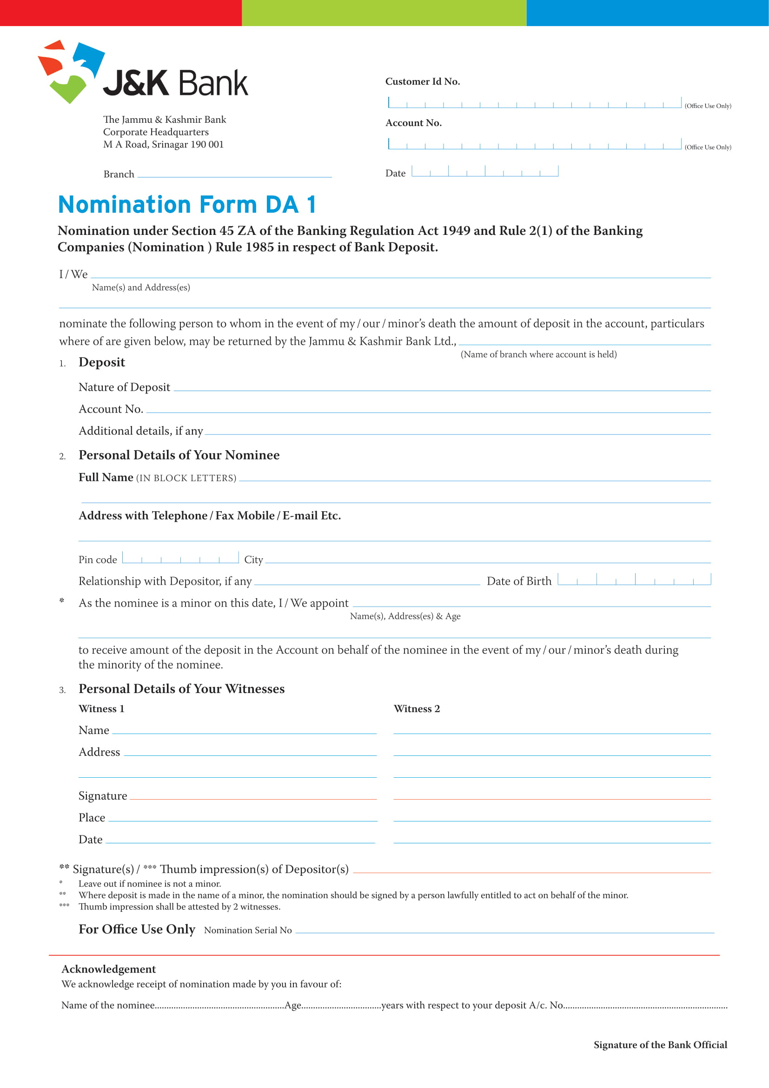
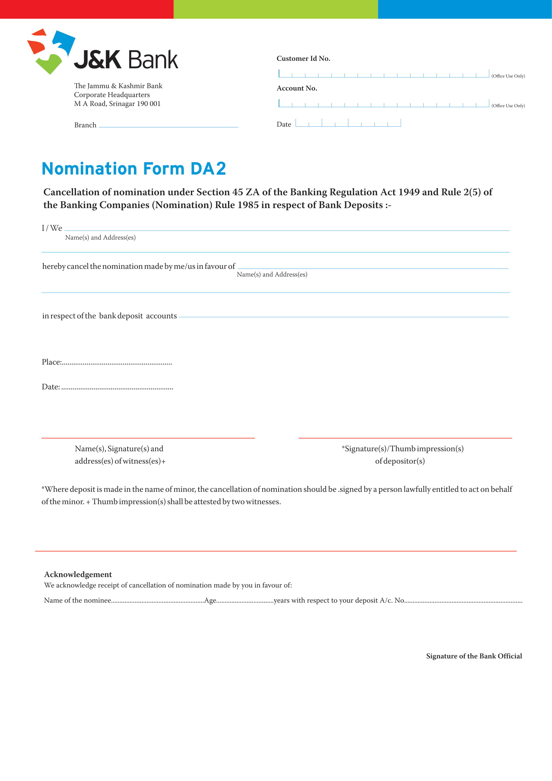
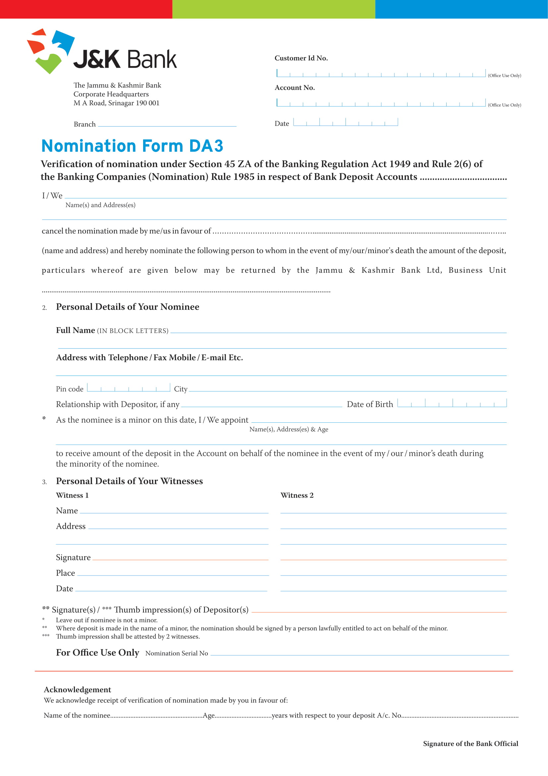

Annexure-9

Nomination

9. Nomination Facility - In Deposit Accounts
Nomination is a facility that enables deposit account holder(s) (individual / sole proprietor/ joint account holders) or safe deposit locker holder(s) to nominate an individual(s), who can claim the proceeds of the deposit account(s) or contents of the safe deposit locker(s), post demise of the original depositor(s) or locker holder(s).
Nomination is optional for bank customers, and is applicable for deposit accounts, articles kept in safe custody and the contents of safety lockers. It is therefore necessary that nomination facility is popularized and customers are made aware of its advantages while opening a deposit account or opting for the lockers.

9.1 The main objective of making a nomination is that in the event of death of an account holder(s) or locker holder(s), the Bank can release the account proceeds or contents of the locker to the nominee(s) without insisting upon a Succession Certificate, Letter of Administration or Court Order.
It needs to be understood that nomination facility has been introduced solely for the purpose of simplifying the procedure for settlement of claims of deceased depositors and it does not in any way take away the rights of legal heirs on the estate of the deceased. The Bank's liability is duly discharged on payment to the Nominee.

9.2 Acknowledgement of Nomination

BU’s will acknowledge in writing to the depositor(s) the filing of the relevant duly completed Form of nomination, cancellation and / or variation of the nomination. This acknowledgement shall be given to all the customers irrespective of whether the same is demanded by the customers. Acknowledgment is given at the end of each form annexed at Annexure-9. Further, in addition to the legend “Nomination Registered”, BU should also indicate the name of the Nominee in the Pass Books / Statement of Accounts / FDRs, in case the customer is agreeable to the same.

9.3 Registering the Nomination

BUshall register the nomination, cancellation and / or variation of the nomination. The proforma of such register is given in Annexure 9. This register is fully automated and can be extracted from Finacle using Menu Option “NOMREG”. However, Branchs are advised to fill in the nomination details at the time of account opening or modify the nominations using Menu Option “ACM” (“N” details) so that the Nomination Register is generated in Finacle. BU’s are advised to fill up all the fields so that there is automatic capturing of all the details in the said register.
The BU shall accordingly take action to register nominations or changes therein, if any, made by their depositor(s) hirer(s) of lockers. The following aspects may be adhered to while recording nominations:

- In addition to obtaining nomination form, BUs may provide for mentioning name and address of the nominee in the account opening form. Publicity about nomination facility is needed, including printing compatible message on chequebook, passbook and any other literature reaching the customer as well as launching periodical drives to popularize the facility.

- In case of joint deposits, after the death of one of the depositors, BU may allow variation/cancellation of a subsisting nomination by other surviving depositor (s) acting together. This is also applicable to deposits having operating instructions “either or survivor”. It may be noted that in the case of a joint deposit account, the nominee’s right arises only after the death of all the depositors.

- BU may introduce a practice of recording on the face of the pass book the status regarding availment of nomination facility with the legend ‘Nomination Registered’. This may be done in the case of term deposit receipts also.

9.4 Nomination facility is provided by the bank in deposit accounts and for safe deposit lockers. In the unfortunate event of the death of a depositor, nomination enables the bank to make payment to the nominee of a deceased depositor, of the amount standing to the credit of the depositor. Similarly, in case of death of a locker hirer bank can release to the nominee of the hirer, the contents of a safe deposit locker. In such cases bank shall not insist on a succession certificate or probate of the will from the legal heirs of the deceased account holder/customer.

- Bank account holders having deposit accounts in their individual names or in joint names of two or more individuals can appoint a nominee to their accounts.

- A sole proprietor can appoint a nominee to the sole proprietorship account with the bank.

- In the case of a deposit account in the name of a minor, nomination shall be made by a person lawfully entitled to act on behalf of the minor in respect of a deposit account. Safe deposit locker holder(s) can appoint nominee(s) for their safe deposit locker(s).

- A nomination can be made only in respect of a deposit account which is held in the individual capacity of the depositor and not in any representative capacity such as the holder of an office like Director of a Company, Secretary of an Association, partner of a firm, or Karta of an HUF.

9.5 Nomination Facility in Single/ Joint Deposit Accounts / Sole Proprietorship Account

- Nomination facility is available in all type of Deposit Accounts opened by the individual/s (Single / Joint). Nomination is also available to a Sole Proprietorship Concern Account.

- Nomination facility can be extended to pension accounts as well.

- Nomination can be made in favour of one person only irrespective of the type of deposit account i.e. single / joint / sole proprietorship concern. Nominee cannot be an Association, Trust, Society or any other Organization or any office-bearer thereof in his official capacity. Nomination other than in favour of an individual is not valid.

- Nomination favouring the minor is permitted on the condition that the account holder, while making the nomination, appoints another individual a major, to receive the amount of the deposit on behalf of the nominee in the event of the death of the depositor during the minority of the nominee.

- In the case of a deposit made in the name of a minor, nomination shall be made by a person lawfully entitled to act on behalf of the minor.

- A nomination shall continue to be in force even on renewal of a term deposit, unless specifically cancelled or changed.

- Variation/cancellation of existing nomination can be made by the depositor or by all the surviving depositor(s) as the case may be, acting together. This is also applicable to deposits having operating instructions "either or survivor"

- In the case of a joint deposit account, the nominee's right arises only after the death of all the depositors.
- The name of the Nominee shall be indicated in the Pass Book/Statement of Accounts / FDRs, CCRs in case the customer is agreeable to the same. This would enable the relatives of the customer to know from the pass book that the nomination facility has been availed of by the deceased depositor.

- Branchs shall generally insist deposit account holder to make a nomination in the account. In case the person(s) opening an account declines to make a nomination, letter to the effect should be obtained from him/her/them that he/she/they do not want to make a nomination, BUs shall record the fact on the account opening form and proceed with opening of the account. Under no circumstances shall the Branch refuse to open an account solely on the ground that the person opening the account declines to make a nomination.

9.6Operational Parameters

- In the case of deposit accounts where the depositor had utilized the nomination facility and made a valid nomination or where the account was opened with the survivorship clause ("either or survivor", or "anyone or survivor", or "former or survivor “or "latter or survivor"), the payment of the balance in the deposit account to the survivor(s)/nominee of a deceased deposit account holder represents a valid discharge of the bank's liability provided that

i. the BU has exercised due care and caution in establishing the fact of death of the account holder and identity of the survivor(s) / nominee, by way ofappropriate documentary evidence like Death Certificate from Municipality, or any other authorized person.

ii. there is no order from the competent court restraining the Bank/BU from making the payment from the account of the deceased.

- it has been made clear to the survivor(s) / nominee that he/she/they would be receiving the payment from the BU as a trustee/trustees of the legal heirs of the deceased depositor, i.e. such payment to him shall not affect the right or claim which any person may have against the survivor(s) / nominee to whom the payment is made.

b)It is reiterated that since payment made to the survivor(s) / nominee, subject to the foregoing conditions, would constitute a full discharge of the bank's liability, insistence on production of legal representation is superfluous and unwarranted and only serves to cause entirely avoidable inconvenience to the survivor(s) / nominee and would, therefore, invite serious supervisory disapproval. In such case, therefore, while making payment to the survivor(s) / nominee of the deceased depositor, BUs should desist from insisting on production of succession certificate, letter of administration or probate, etc., or obtain any bond of indemnity or surety from the survivor(s)/nominee, irrespective of the amount standing to the credit of the deceased account holder.

9.7 Legal Aspects of Nomination

The legal aspects of nomination are covered in the Banking Regulation Act, 1949 (Act no.10) which was subsequently amended and named as Banking Companies (Nominations Rule 1985)by introducing new Sections 45ZA to 45ZF, which provide, inter alia, for the following matters:

- To enable a banking company to make payment to the nominee of a deceased depositor, of the amount standing to the credit of the depositor.

- To enable a banking company to return the articles left by a deceased person in its safe custody to his nominee, after making an inventory of the articles in the manner as directed by the Reserve Bank of India.

- To enable a banking company to release the contents of a safe deposit locker to the nominee of the hirer of such locker, in the event of the death of the hirer, after making an inventory of the contents of the safe deposit locker in the manner as directed by the Reserve Bank of India.

9.8 Sections of Banking Laws (Amendment) Act, 1983– 45ZA & 45ZB for Deposits
Section 45ZA: Nomination for payment of depositors' money

- Where a deposit is held by a banking company to the credit of one or more persons, the depositor or, as the case may be, all the depositors together, may nominate, in the prescribed manner, one person to whom, in the event of the death of the sole depositor or the death of all the depositors, the amount of deposit may be returned by the banking company.

- Notwithstanding anything contained in any other law for the time beingin force or in any disposition, whether testamentary or otherwise, in respect of such deposit, where a nomination made in the prescribed manner purports to confer on any person the right to receive the amount of deposit from the banking company, the nominee shall, on the death of the sole depositor or, as the case may be, on the death of all the depositors, become entitled to all the rights of the sole depositor or, as the case may be, of the depositors, in relation to such deposit to the exclusion of all other persons, unless the nomination is varied or cancelled in the prescribed manner.

- Where the nominee is a minor, it shall be lawful for the depositor making the nomination to appoint in the prescribed manner any person to receive the amount of deposit in the event of his death during the minority of the nominee.

- Payment by a banking company in accordance with the provisions of section 45ZA shall constitute a full discharge to the banking company of its liability in respect of the deposit:

Provided that nothing contained in sub-section 45ZA shall affect the right or claim which any person may have against the person to whom any payment is made under this section.

9.9Section 45ZB: Notice of claims of other persons regarding deposits not receivable

No notice of the claim of any person, other than the person or persons in whose name a deposit is held by a banking company shall be receivable by the banking company, nor shall the banking company be bound by any such notice though even expressly given to it.

Provided that where any decree, order, certificate or other authority from a court of competent jurisdiction relating to such deposit is produced before a banking company, the banking company shall take due note of such decree, order, certificate or other authority.

9.10Treatment of inflows in the name of the Deceased Depositor

In order to avoid hardship to the survivor(s) / nominee of a deposit account, the BU shall obtain appropriate agreement / authorization from the survivor(s) / nominee with regard to the treatment of inflows which may bein pipeline in the name of the deceased account holder. In this regard, BU can adopt either of the following two approaches depending upon the authorization received from survivor(s) / nominee:

BUs can be authorized by the survivor(s) / nominee of a deceased account holder to open an account styled as 'Estate of Mr./Mrs./Ms XYZ, the Deceased' where all the pipeline inflows in the name of the deceased account holder could be allowed to be credited, provided no withdrawals are made.
OR
BU’s can be authorized by the survivor(s) / nominee to return the pipeline inflows to the remitter with the remark "Account holder deceased" and to intimate the survivor(s) /nominee accordingly. The survivor(s) / nominee / legal heir(s) could then approach the remitter to effect payment.

9.11Settlementof Claims In Respect Of Missing Persons

BU shall follow the following procedure in case a claim is received from a nominee / legal heirs for settlement of claim in respect of missing persons:

The settlement of claims in respect of missing persons is governed by the provisions of Section 107 / 108 of the Indian Evidence Act, 1872. Section 107 deals with presumption of continuance and Section 108 deals with presumption of death. As per the provisions of Section 108 of the Indian Evidence Act, presumption of death can be raised only after a lapse of seven years from the date of his/her being reported missing. As such, the nominee / legal heirs have to raise an express presumption of death of the subscriber under Section 107/108 of the Indian Evidence Act before a competent court. If the court presumes that he/she is dead, then the claim in respect of a missing person can be settled.

BU shall settle the claims of a missing person after considering the legal opinion and taking into account the facts and circumstances of each case. Further, keeping in view the imperative need to avoid inconvenience and undue hardship to the common person, BU shall settle the claims up to an amount of Rs.10000/- in respect of missing persons without insisting on production of any documentation other than (i) FIR and the non-traceable report issued by police authorities and (ii) letter of indemnity. The Bank's liability is duly discharged on payment to the Nominee.

9.12 Witnesses in Nomination Forms
The nomination forms are prescribed in the nomination rules like DA1, DA2 and DA3 for Bank Deposits which are attached to this policy at Annexure-9 In such forms, only Thumb-impression(s) shall be attested by two witnesses. Signatures of the account holders need not be attested by witnesses.

Annexure -10

CASE STUDIES (Nomination)

Following Case Studies would make the understanding of the above mentioned clauses easy:

- Accounts Operated Singly

- Savings Bank Account/Current Deposit Account with Nomination:
The balance available will be paid to the nominee on verification of his/her identity (by submission of officially valid documents (OVD) under KYC norms) and proof of death of the depositor.

- Savings Bank Account/Current Deposit Account Without Nomination:
The balance available will be paid to the legal heirs (or any one of them as mandated by all of the legal heirs) on verification of the authority of the legal heirs and proof of death of the depositor.

- Term Deposit Account with Nomination:
The balance available will be paid to the nominee on verification of his/her identity (by submission of officially valid documents (OVD) under KYC norms) and proof of death of depositor on maturity of deposit.

- Term Deposit Account Without Nomination:
The balance available will be paid to the legal heirs (or any one of them as mandated by all the legal heirs) on verification of the authority of the legal heirs and proof of death of depositor on maturity of deposit.

- Premature termination of Term Deposit Account with Nomination:

Premature termination of term deposit account as per terms of contract will be permitted at the request of the nominee on verification of his/her identity (by submission of officially valid documents (OVD) under KYC norms) and proof of death of depositor.

f) Premature termination of Term Deposit Account Without Nomination:
Premature termination will be permitted on joint request by all legal heirs (or any of them as mandated by all the legal heirs) as per the terms of the contract on verification of the authority of the legal heirs and proof of death of depositor.

- Accounts opened jointly/ with mode of Operation Jointly

a) Savings Bank Account/Current Deposit Account with Nomination:
In the event of death of one (or more but not all) of the joint account holders, the balance available will be paid jointly to survivor(s) and the legal heirs of the deceased joint account holder (or any of them as mandated by all the legal heirs) against their joint claim on verification of the authority of the legal heirs and proof of the death of the depositors.

In the event of death of both / all joint account holders, the balance available at the time of death of the depositors will be paid to the nominee on verification of his identity (by submission of officially valid documents (OVD) under KYC norms) and proof of death of depositors.

- Savings Bank Account/Current Deposit Account without Nomination:

In the event of death of one (or more but not all) of the joint account holders, the amount available will be paid jointly to survivor(s) and the legal heirs of the deceased account holder (or any one of them as mandated by all the legal heirs) against their joint claim on verification of the authority of legal heirs and proof of death of depositor.

In the event of death of both/ all joint account holders, the balance available will be paid jointly to the legal heir(s) of all the deceased depositors (or any of them as mandated by all the legal heirs) on verification of authority of the legal heirs and proof of death of the depositors.

- Term Deposit Account with Nomination:

In the event of death of one (or more but not all) of the joint account holders, the balance available will be paid jointly to survivor(s) and the legal heirs of the deceased joint account holder (or any one of them as mandated by all the legal heirs) on verification of identity of the legal heirs and proof of death of the depositor on maturity of the deposit.

In the event of death of both / all the joint account holders, the balance available at the time of death of the depositors will be paid to the nominee on verification of his/her identity (by submission of officially valid documents (OVD) under KYC norms) and the proof of death of depositors on maturity of the deposit.

- Term Deposit Account Without Nomination:

In the event of death of one (or more but not all) of the joint account holders, the balance available will be paid jointly to the survivor(s) and the legal heir(s) of the deceased joint account holders (or any of them as mandated by all the legal heirs) against their joint claim on verification of authority of the legal heirs and proof of death of the depositor on maturity of the deposit.

In the event of death of both / all the joint account holders, the balance available will be paid jointly to the legal heirs of all the deceased depositors (or any one of them as mandated by all legal heirs) on verification of authority of the legal heirs and proof of death of depositors on the maturity of the deposit.

- Premature termination of Term Deposit Account with Nomination:
In the event of death of one (or more but not all) of the joint account holders, premature termination will be permitted against joint request of the survivor(s) and the legal heir(s) of the deceased depositor (or any one of them as mandated by all legal heirs) as per the terms of contract on verification of identity of the legal heirs and proof of death of depositor.

In event of death of all the account holders, premature termination of term deposit account as per the terms of contract will be permitted at the request of the nominee on verification of his/her identity (by submission of officially valid documents (OVD) under KYC norms) and proof of the death of all the depositors.

- Premature termination of Term Deposit Account without Nomination:
In the event of death of one (or more but not all) of the joint account holders, premature termination will be permitted against joint request by the survivor(s) and the legal heir(s) of all the deceased depositors (or any one of them as mandated by all legal heirs) as per the terms of contract on verification of authority of legal heirs and proof of death of depositor.

In the event of death of both / all the joint account holders, premature termination will be permitted against joint request by all legal heirs of the deceased depositors (or any one of them as mandated by all legal heirs) as per the terms of contract on verification of authority of legal heirs and proof of death of depositors.

3. Accounts opened with mode of operation as “Either Or Survivor” / “Former Or Survivor” / “Anyone Or Survivors” / “Latter Or Survivor”

- Savings Bank Account / Current Deposit Account with Nomination:

In the event of death of one (or more but not all) of the depositors, the balance available will be paid to survivor (s) on verification of proof of death of the depositor.

In the event of death of both/all the joint depositors, the balance available will be paid to the nominee on verification of his/her identity (by submission of officially valid documents (OVD) under KYC norms) and proof of death of depositors.

- Savings Bank Account / Current Deposit Account without Nomination:

In the event of death of one (or more but not all) of the depositors, the balance available will be paid to survivor on verification of proof of death of the depositor.

In the event of death of both/all the joint depositors, the balance available will be paid jointly to the legal heirs (or any one of them as mandated by all the legal heirs) on verification of authority of legal heirs and proof of death of depositors.

- Term Deposit Account with Nomination:

In the event of death of one (or more but not all) of the depositors, the balance available will be paid to survivor(s) on verification of proof of death of the depositors on maturity of deposit or as agreed at the time of opening of deposit.

In the event of death of all joint depositors, the balance available will be paid to the nominee on verification of his/her identity (by submission of officially valid documents (OVD) under KYC norms) and proof of death of depositors on maturity of deposit or as agreed at the time of opening of deposit.

d) Term Deposit Account Without Nomination:

In the event of death of one of the depositors (or more, but not all), the balance available will be paid to the survivors on verification of proof of death of the depositor on maturity of deposit or as agreed at the time of opening of deposit.

In the event of death of all joint depositors, the balance available will be paid to the legal heir(s) of all the deceased depositors (or any one of them as mandated by all the legal heirs of joint holders) on verification of authority of legal heirs and proof of death of depositors on maturity of deposit.

e) Premature termination of Term Deposit Account with Nomination:
In the event of death of one (or more but not all) of the depositors, the survivor(s) will have the right to seek premature termination of term deposit account as per the terms of contract on verification of proof of death of the depositor.

In the event of death of all the joint depositors, the nominee will have right to seek premature termination of term deposit account as per the terms of the contract on verification of his/her identity (such as Election ID Card, PAN Card, passport etc.) and proof of death of depositors.

f) Premature termination of Term Deposit Account without Nomination

In the event of death of one (or more but not all) of the depositors premature termination will be allowed against request from surviving depositor(s) as per the terms of the contract on verification of the proof of the death of the depositor.

In the event of death of all joint depositors, premature termination will be permitted against joint request by all legal heirs of the deceased depositors (or any one of them as mandated by all the legal heirs) as per the terms of contract on verification of authority of legal heirs and proof of death of depositors.

Settlement of Claims For Various Types Of Operational Instructions in Deposit Accounts With Nomination

Account in the Name of | Operational Instructions | Nominee | Situation | What is to be done
A | Self | X | X dies | A can change the nomination
A | Self | X | A dies | X will receive the availableBalance
A, B | Either or Survivor | X | A dies | Balance available will be payable to B.
A, B | Either or Survivor | X | B dies | Balance available will be payable to A.
A,B | Either or Survivor | X | A & B die | X will receive the available
A,B | Jointly | X | A dies | Payable to B and legal heirs of A jointly
A,B | Jointly | X | B dies | Payable to A and legal heirs of B jointly
A,B | Jointly | X | A & B die | Payable to X

Settlement of Claims for Various Types Of Operational Instructions in Deposit Accounts Without Nomination

Account in the Name of | Operational Instructions | Situation | What is to be done
A | Self | A dies | Balance Available will be payable to the legal heirs or any one of them mandated by all of the legal heirs
A, B | Either or Survivor | A dies | Balance Available will be payable to B
A,B | Either or Survivor | B dies | Balance Available will be payable to A
A,B | Either or Survivor | A & B die | Jointly payable to legal heirs of A & B (or any of them mandated by all the legal heirs)
A,B | Jointly | A dies | Jointly payable to B and legal heirs of the A (or any one of them mandated by all the legal heirs).
A,B | Jointly | B dies | Jointly payable to A and legal heirs of the B (or any one of them mandated by all the legal heirs)
A,B | Jointly | A & B die | Jointly payable to legal heirs of A & B (or any of them mandated by all the legal heirs)

